IMA to EASE Differences

Purpose | The purpose of this document is to provide the differences between the IMA and EASE ordering systems for LSR order entry. Specifics regarding the EASE LSR system, EASE system navigation and EASE Pre-Order / Order entry details can be found in the EASE LSR User Guide.

PRE-ORDER 5
ALL Pre-Order Headers 5
Address Validation by WTN 5
Raw Loop Data By TN 5
Raw Loop Data RESULTS 6
Appointment Scheduler 6
Listing for Telephone Numbers 7
EASE VFO ORDERING 9
IMA to EASE field swaps 9
Modified Field lengths 10
IMA fields no longer utilized 12
UOM specific modifications 12
RSID Management in EASE 14
Multiple RSID issue 14
Option 1 14
Option 2 14
REQTYP 16
ACT 18
Hunting Sequence Entry in EASE 18
Hunting 18
HUNT_GROUP_ID 19
Establishing a Hunt Group with 4 members 19
Removing a member from an existing hunt group 20
SAMPLE Product Order Examples 22
Overview 22
AB - LOOP 22
LSR Form 22
EU Form 23
LS Form 24
DL Form 25
AB - Shared Loop 26
LSR Form 27
EU Form 28
LS Form 29
DL Form 30
BB – LOOP with Number Portability 31
LSR Form 31
EU Form 32
LNSP Form 33
DL Form 34
BB – Loop with Number Port with multiple numbers 35
LSR Form 35
EU Form 36
LSNP Form 37
DL Form 40
CB - Number Portability 41
LSR Form 42
EU Form 43
NP Form 44
DL Form 45
EB – Resale/Data Unified – WBSA DSL 46
LSR Form 47
EU Form 48
HGI Form 49
RS Form 50
DL Form 51
EB - Resale/Data Unified - VFO EB and IMA EB - Resale POTS 51
LSR Form 51
EU Form 52
HGI Form 52
RS Form 53
DL Form 55
EB - Resale/Data Unified -Resale POTS with more USOCs 56
LSR Form 57
EU Form 58
HGI Form 59
RS Form 60
DL Form 63
JB - Directory listing and assistance 64
LSR Form 65
EU Form 66
DL Form 67
KB - Resale private line 68
LSR Form 69
EU Form 70
RPL Form 71
DL Form 73
MB – Centrex 21 74
LSR Form 75
EU Form 76
HGI Form 77
RS Form 77
CRS Form 79
DL Form 80
MB – UNE POTS 80
LSR Form 81
EU Form 82
HGI Form 82
RS Form 83
CRS Form 84
DL Form 85
NB - DID/DOD/PBX 86
LSR Form 87
EU Form 88
HGI Form 88
DDPS Form 89
DL Form 90
PB - CENTREX RESALE 91
LSR Form 92
EU Form 93
HGI Form 93
CRS Form 94
DL Form 97
QB - ISDN 97
LSR Form 99
EU Form 100
HGI Form 100
IBPS Form 101
DL Form 102
ZB - Bulk 103
LSR Form 104
EU Form 105
RS Form 106
ZB - Bulk 107
LSR Form 108
EU Form 109
RS Form 110
Response Type Matrix 111
TOS Matrix 113
Custom BRMS Rules 116

Modifications to document

4/26/2022 | QW056: CC is Required  Rule to require SUP 1 PONs containing version 00 to populate the CC field.
2/10/2021 | Modification to SPEC field to define TEST options  - Changes to IMA to EASE field differences  - Modification to IMA to EASE Product Mapping – Miscellaneous updates  - Modification to specific order examples to add note
3/4/2021 | QW014: Modification to NAME field to add EU form. Existing limitation from IMA for 25 characters.  Additional of Block Values to job aid
3/5/2021 | QW019: NP Form LNUM cannot exceed 4 characters. EDIT will be effective on 4/1/2021. In the meantime, customers will receive System unavailable.
07/14/2021 | Modification from REQTYP NB to REQTYP EB for Resale Design Trunks / PBX Trunks
08/16/2021 | Consolidated all existing edits into list to ensure complete list
08/16/2021 | Added QW077 - AN must contain 16 digit fully qualified account number
ReqTypes for trunks have been verified. Please use the values that have been updated in the Matrices to process the following trunk values. A summary of the direct changes is below.

From:
IMA | EASE | DESCRIPTION
MB | NB | CLSP PBX Designed Trunks
MB | NB | CLSP PBX DID
MB | NB | CLSP DID TRUNK
NB | EB | RESALE DID TRUNK
SB | NB | CLSP PBX SPLIT
To :

IMA | EASE | DESCRIPTION | P Field
MB | MB | CLSP PBX Designed Trunks | C
MB | MB | CLSP PBX DID | C
NB | NB | CLSP DID TRUNK | C
NB | NB | RESALE DID TRUNK | A
SB | MB | CLSP PBX SPLIT | C

08/25/2021 | Addition of QW078 and QW079 edits
11/11/2021 | Addition of QW068 and QW080 edits

PRE-ORDER

Introduction | This section will address differences between the stand-alone pre-order functions between IMA and EASE.

ALL Pre-Order Headers | All Pre-Orders in EASE must contain the CCNA and State values populated in the header section of each pre-order option.  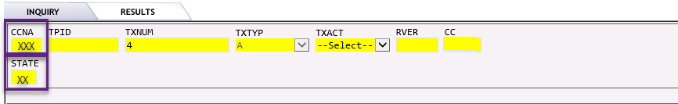

Address Validation by WTN | IMA Field EASE Field Modification  WTN WTN WTN field can be entered with or without dashes
EASE Screen:
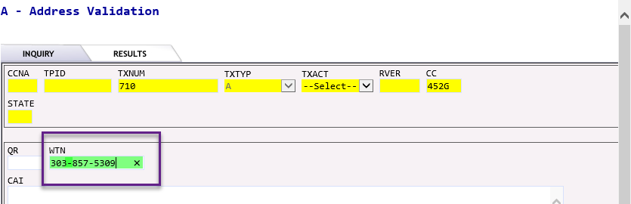

Raw Loop Data By TN | IMA Field EASE Field Modification  TN WTN WTN field can be entered with or without dashes.
EASE Screen:

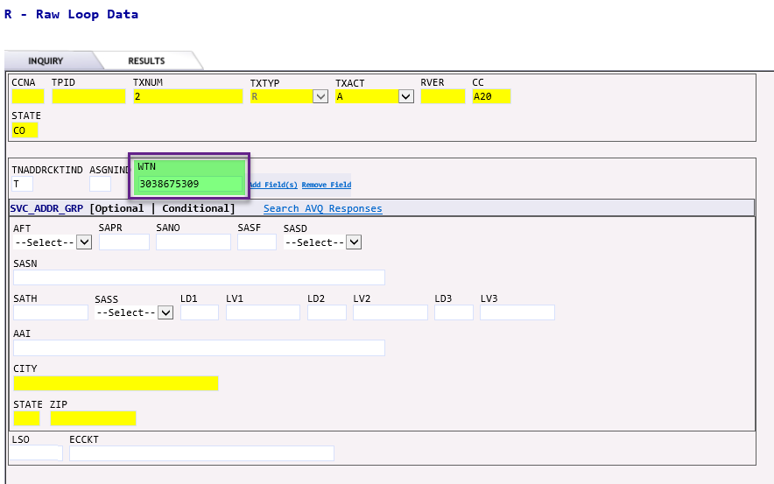

Raw Loop Data RESULTS | IMA Value EASE Response Section Displayed as:  CABLE NAME SEGMENT_GRP [#] CA  PAIR GAIN TYPE SEGMENT_GRP [#] TRMED  PAIR NUMBER SEGMENT+GRP [#] CHAN_PAIR
EASE SCREEN:

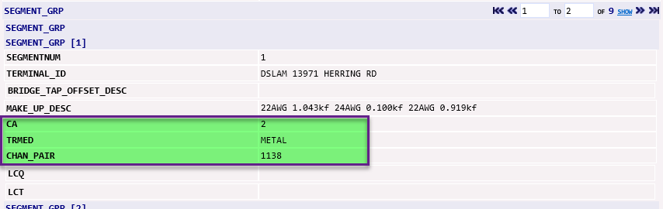

Appointment Scheduler | IMA Field EASE Field Modification  Enter Other Work Required USOC FEAT_PP Enter USOCs in the FEAT_PP field.  Please Note: USOCs are not required to schedule an appointment. However, the addition of USOCs ensure that the allotted time can accommodate the order request.
EASE SCREEN:

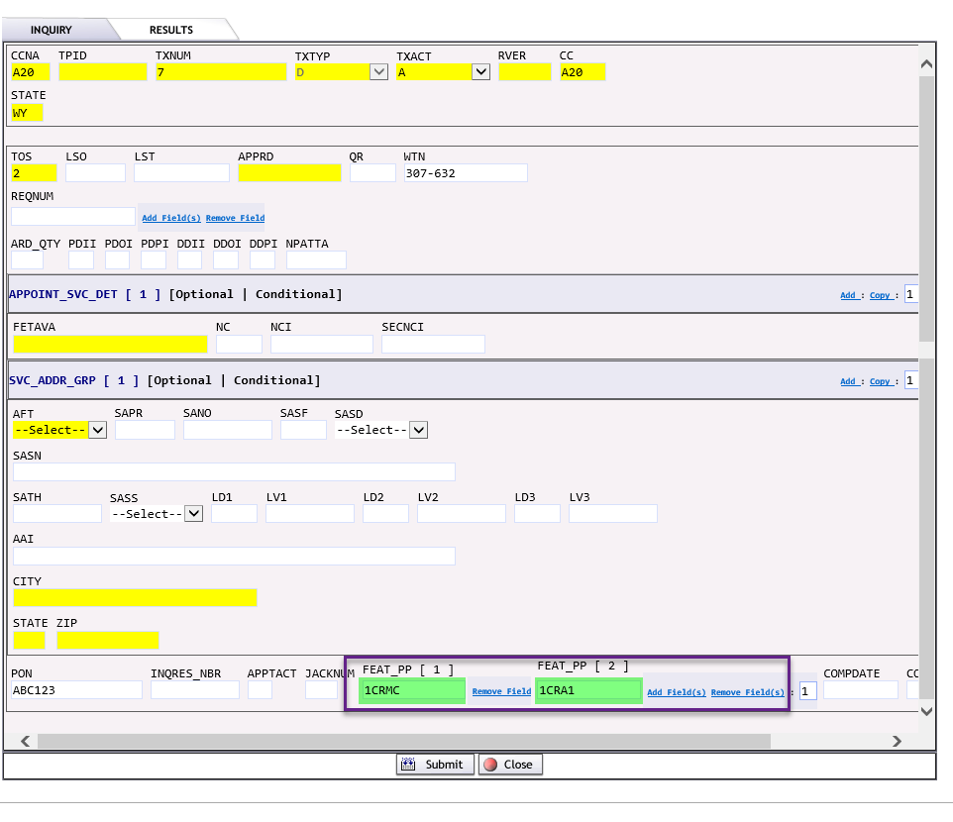
Please Note: To adjust the quantity of USOC fields, click on the fields,

Listing for Telephone Numbers | IMA Field EASE Field Modification  TXACT TXACT (Header) Will only support a value of A (New Inquiry). Values B, H and S are derived by EASE.  CITY DIRNAME CITY will be displayed in DIRNAME  SLU LTN When TXACT is S, Straight Line Under TNs will be placed in the LTN field when doing an inquiry.  TXTYP TXACT (in-body) TXACT field (contained in the body of the pre-order request) will hold the Transaction Type Values Value Meaning A = Account Telephone Number C = Caption Listing N = Non-Standard Telephone Number S = Straight Line Under T = Listed Telephone Number
EASE SCREEN:

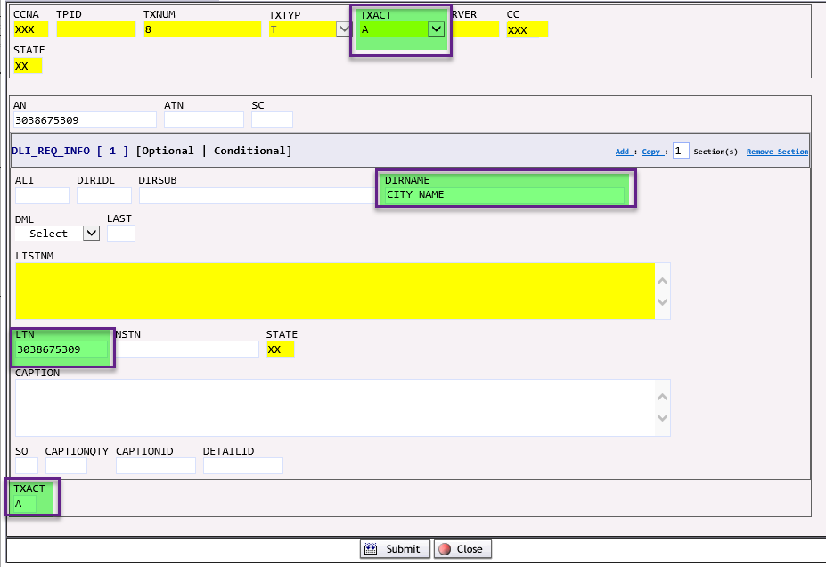

EASE VFO ORDERING

IMA to EASE field swaps | The following fields have been modified to conform to ATIS LSOG2Q19 ordering schemas.  IMA EASE Modification  Field Form Field  BA CR DDPSEU ISDN LSNP LSR NP PS RS BA IMA value of E will become value of A  CHC CHC IMA value of N will become value of A IMA value of Y will remain Y IMA value of B will remain B  DDQTY DL N/A This field will be derived internally.  DGOUT DDPS DO Replaced by DO field  DLEC CCNA LSR OCCNA Replaced by OCCNA field  DIDNUM DDPS RNUM RNUM defines set of USOCs for that line (FEATURE GRP(s) defines USOC needed for that one line)  DPULSE CRS DDPS PS RS PULSE Replaced by PULSE field  DRTI DDPS RIN Replaced by RIN field  DSGNL RS SSIG REQTYP EB: RESALE DID TRUNK  DSGNL DDPS SSIG REQTYP NB: CLSP DESIGNED TRUNKS  DTGN DDPS TGN Replaced by TGN field  DTK DDPS TKQ Replaced by TKQ field  DTKACT DDPS TACT Replaced by TACT field  DTKID DDPS TKID Replaced by TKID field  DTLI DDPS LTLI Replaced by LTLI field  DTNR DDPS TNS Replaced by TNS field  DTNRACT DDPS TNA Replaced by TNA field  DTNRQ DDPS QN Replaced by QN field  FA FA IMA value of C will become to value of C (change) or O (out) IMA value of T will become Value of I (in)  FBDL CC (DL) LSR OCC Replaced by OCC field  FBDL CCNA (DL) LSR OCCNA Replaced by OCCNA field  Line Shared TN LSR SLTN Replaced by SLTN field and limited to 10 characters  LNA DDPS TNA DID/DOD GROUP  LNA DDPS TACT TRUNK GROUP  LNUM RS RNUM Value will be placed in RNUM field on the RS form.  MANUAL IND LSR NRI MANUAL IND represented thru NRI value of Y  NPDI (value of V) LSR NPDI NPDI entered as value of A  NPI CRS DDPS IBPS LSNP PS RS NPI IMA value of Z now value of E for Port Within  PMI LSR MI  PON PON PON values cannot contain a dash (-)  REMARKS CRS IBPS RS RS remarks will be derived from LSR remarks section  SAN RPL REMARKS Enter SAN in remarks with SAN: value  SCA LSR CONDITIONING_OPTIONS Enter SCA values of Y, 1, 2 or 3 in the CONDITIONING_OPTIONS field.  TEST LSR SPEC Enter SPEC value of A, B, N or I to indicate requested TEST VALUE - A (Performance Testing) - B (Cooperative Testing) - N (No Testing) - I (Cooperative Testing)  WSOP TEL NO REMARKS Enter WSOP TN NO in remarks with WSOP TN NO: value  USA (USE SHIPPING ADDRESS) EU SHAI Indicates if the shipping address should be used in lieu of the service address. Values: Y / N

Modified Field lengths | The following fields have been modified to conform to ATIS LSOG2Q19 ordering schemas and the length has been reduced.  IMA EASE Modification  Field Form Field  AACTEL RPL AACTEL 17 characters to 14  AAI EU RPL (PRILOC) RPL (SECLOC) AAI 100 characters to 60  ACC EU RPL (PRILOC) RPL (SECLOC ACC 255 characters to 45  ACTELNO RPL (PRILOC) RPL (SECLOC ACTEL NO 17 characters to 14  BLOCK CRS DDPS IS LSNP NP PS RS BLOCK 32 characters to 16  CB CRS HGI IBPS CB 18 characters to 8  CFA IBPS LS PS RFR RPL RS CFA 54 characters to 42  CKR CR DDPS IBPS LS LSNP RFR RPL RS CKR 44 characters to 41  DISC ECCKT EU RPL DISC ECCKT 42 characters to 36  DISC NBR EU LS DISC NBR 12 characters to 10  ECCKT DDPS HGI IBPS LS LSNP PS RFR RPL RS ECCKT 42 characters to 36  FAX NO LSR FAX NO 12 characters to 10  FEATURE DETAIL CRS DDPS IBPS PS RPL RS FEATURE DETAIL 512 characters to 200  FLOOR EU LSR RPL FLOOR 15 characters to 10  HTSEQ HGI IBPS HTSEQ 512 characters to 10  ISPID IBPS ISPID 15 characters to 14 (no dash required)  Line Shared TN LS SLTN 12 characters to 10  LTC CRS LTC 3 characters to 2  OTN CRS DDPS HGI IBPS PS RS OTN 12 characters to 10  PAGE NO HEADER PAGE_NO 4 Character limitation  PORTED NBR NP PORTED NBR 17 Characters to 15  REMARKS DDPS DL LS LSNP PS RFR RPL REMARKS 255 characters to 160  REMARKS1 LSR REMARKS1 255 characters to 250  REMARKS2 LSR REMARKS2 255 characters to 250  ROOM/MAILSTOP EU LSR RPL ROOM/MAILSTOP 15 characters to 10  TC TO PER CR DDPS EU IBPS LS LSNP PS RS TC PER 12 characters to 10  TC TO SEC CRS DDPS EU IBPS LS PS RS TC TO SEC 12 characters to 10  TEL NO EU LSR RPL TEL NO 17 characters to 14  TLI DDPS HGI RS LTLI 12 characters to 10

IMA fields no longer utilized | IMA Field Modification  LRRO Will not be utilized  RSTTYP Discontinue use of RSTTYP – RS form LNA field data will be used  CIP Will not be utilized  CSO1 Will not be utilized  CSO2 Will not be utilized  PENDING ORDER  NIDR For Centrex services, If needed information to be placed in REMARKS  MEGACENTNM This value will be defaulted to USWNET thru internal mapping.

UOM specific modifications | EASE will require the support of the CenturyLink specific version LSOG2Q19 UOM schemas. The information for that schema is available on the CMP site.  Please Note: It is important to remember that the following specific fields must be provided when utilizing UOM ordering.  Modification  Form Field  LSR SC Required on UOM orders.  LSR VER Required on UOM orders.

RSID Management in EASE

Multiple RSID issue | In IMA some CLEC customers utilize multiple RSIDs.  Example: CLEC ABC, may have the IMA RSIDs of ABC, BCD, CDE, I29, Z32 and the associated OCNs.  Option 1) A CLEC could choose to obtain sign-on into EASE for each RSID. That would limit the visibility of order information to only that RSID and the associated OCNs.  Option 2) To provide a CLEC view to see all RSIDs, the CLEC would obtain a combined sign-on that represents all the RSIDs and OCN combinations.

Option 1 | This method is discussed in the EASE LSR User Guide. The user would sign into EASE, Select the RSID in the ESP drop-down and enter the needed EASE fields for the request.

Option 2 | The following steps should be used to create an order in EASE when the CLEC has multiple RSIDs.  Step Action  1 Log into EASE using the assigned user ID for the combined RSID. In this example, we are going to use the user ID of USER1 for RSID ABC (representing combined ordering for ABC, BCD, CDE, I29 and Z32)  2 Begin the EASE order by selecting the appropriate fields. The remaining fields would be selected for the service / activity being requested.  3 From the main screen of EASE, CC field will be auto populated automatically. The CCNA field will be blank. Please Note: When doing JB and PORT OUT (This is the SPID you want to PORT out to) orders – this field must contain the correct CC value.  4 The CCNA field will be used to represent the IMA ownership. In most cases, this will be the RSID that the order will be associated with.

REQTYP | For ease of reference ALL REQTYPES have been provided by Product. The table is alphabetical by IMA REQTYP.  IMA EASE PRODUCT P field value Miscellaneous updates  AB AB Unbundled Loop Enter SPEC value of A, B, N or I to indicate requested TEST VALUE - A (Performance Testing) - B (Cooperative Testing) - N (No Testing) - I (Cooperative Testing)  AB AB Line Sharing Pot Split LOC Field: Populated  AB AB Unbundled Feeder Loop  AB AB Unbundled Distribution Loop  BB BB Loop WITH Number Port Enter SPEC value of A, B, N or I to indicate requested TEST VALUE - A (Performance Testing) - B (Cooperative Testing) - N (No Testing) - I (Cooperative Testing)  BB BB Unbundled Distribution Loop with Number Port  CB CB Local Number Portability  DB BB Loop with Number Port Split Pot Split LOC Field: Populated Enter SPEC value of A, B, N or I to indicate requested TEST VALUE - A (Performance Testing) - B (Cooperative Testing) - N (No Testing) - I (Cooperative Testing)  EB EB Private Access Line Enter SPEC value of A, B, N or I to indicate requested TEST VALUE - A (Performance Testing) - B (Cooperative Testing) - N (No Testing) - I (Cooperative Testing)  EB EB Resale POTS  EB EB Resale Designed Trunks A SPEC FIELD: DESIGN  EB EB Resale PBX/Trunks A  EB QB Resale PRI ISDN Trunk A  EB QB Resale ISDN BRI A  HB JB HB (Listings Only) will use the alpha numeric (A##) RSID.  JB JB Facility Based Directory (Listings Only) CCNA will only use Alpha value (AAA).  KB KB Resale PRI ISDN Facility  MB KB Enhanced Extended Loop (EEL) SPEC FIELD: LOOPEEL  MB KB Loop Mux Combo (LMC) SPEC FIELD: LOOPEEL  MB MB CLSP Centrex 21 CBFA = N / CB_FEATURE = COS / CB_FEATURE_DETAILS COS = RH2XX  MB MB Centrex Plus and UNI P Centron CBFA = N / CB_FEATURE = COS / CB_FEATURE_DETAILS COS = RHCXX or RHBXX  MB MB CLSP POTS – UNI POTS P/*  MB MB CLSP PBX Designed Trunks C SPEC FIELD: DESIGN  MB MB CLSP PBX DID C  MB QB CLSP ISDN BRI C  NB NB CLSP DID TRUNK C  NB NB RESALE DID TRUNK A  PB PB RESALE CENTREX 21 CBFA = N / CB_FEATURE = COS / CB_FEATURE_DETAILS COS = C21XX  PB PB RESALE CENTREX PLUS AND CENTRON CBFA = N / CB_FEATURE = COS / CB_FEATURE_DETAILS COS != C21XX  SB MB CLSP POTS Split Pot Split LOC Field: Populated  SB MB CLSP Centrex 21 Split Pot Split LOC Field: Populated CBFA = N / CB_FEATURE = COS / CB_FEATURE_DETAILS COS = RH2XX  SB MB CLSP PBX Split C Pot Split LOC Field: Populated  UB AB Unbundled Loop Split Enter SPEC value of A, B, N or I to indicate requested TEST VALUE - A (Performance Testing) - B (Cooperative Testing) - N (No Testing) - I (Cooperative Testing)  ZB ZB BULK

ACT | IMA EASE Modification MI Field  T T Partial Move A or B  IMA EASE Modification ELT FIELD  Z V Information placed on EU form A  Service Activity requested IMA ACT EASE ACT RS form - LNA Field  Resale / CLSP POTS Deny Y S S  Resale CLSP / Centrex 21 Deny Y S Y  - Resale / CLSP POTS - Resale CLSP / Centrex 21 Restore from Deny B B B or Blank  Resale/CLSP POTS Suspend - Seasonal Service L L L  Resale/CLSP POTS Restore from Seasonal Service B L B

Hunting Sequence Entry in EASE

Hunting | Hunting information is placed on the HGI form in EASE.  EASE will contain two sections:  - HUNT_GROUP_ID: used to describe the hunt group  - HUNT_DET: used to describe the members of the hunt group  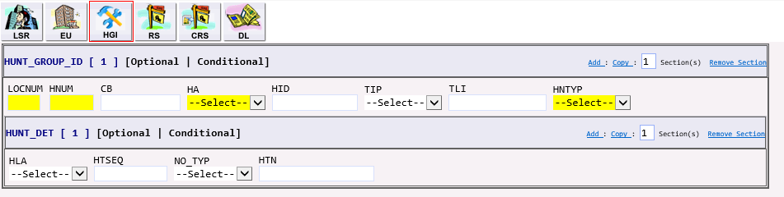

HUNT_GROUP_ID | The EASE order can contain more than one HUNT group. To add/copy additional sections, click on the hyperlinks in the HUNT_GROUP_ID section.  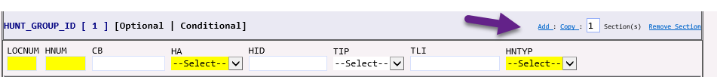  Adding at the HUNT_GROUP_ID level will repeat both the HUNT_GROUP_ID and the HUNT_DET sections.  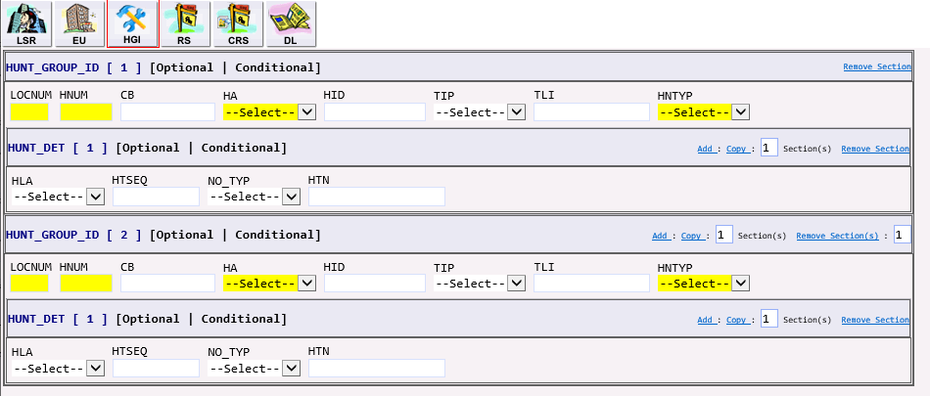

Establishing a Hunt Group with 4 members | To create a new HUNT GROUP the following fields are used:  HUNT_GROUP_ID Section:  FIELD ENTRY  LOCNUM 001  HNUM Up to 5 characters long. Identifies the Hunt Group as a unique number. Each additional occurrence as a unique number.  HA HUNT ACTIVITY: N New Hunt Group E Existing / No Change D Disconnect C Change to Hunt Group Sequence  HNTYP Type of hunting involved 1 Preferential (multiline) 2 Sequential (regular series completion) 3 Circular (regular) 4 Multiline series completion with terminal or maintenance numbers 5 Combination (CENTREX) 6 Circular multiline 7 Circular preferential 8 Automatic call distribution 9 Distributed line hunt 10 Multiple position hunt 11 Uniform call distribution 12 Directory Number hunt  Hunt_Detail  FIELD ENTRY  HLA HUNT ACTIVITY: N New Hunt Group E Existing / No Change D Disconnect  HTSEQ Identifies the desired hunting sequence or range of hunt sequence  NO_TYP Type of Telephone Number B ISDN BRI Directory Number L Terminal Number M Maintenance Number R Line Number T Telephone Number  HTN Identifies the hunting number for this sequence in the hunt group.  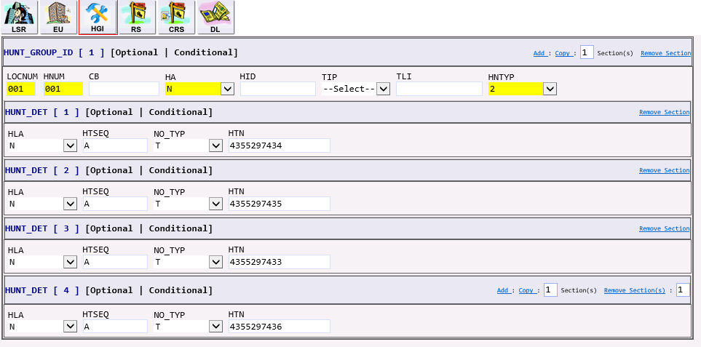

Removing a member from an existing hunt group | When removing a member from the hunt group, the entire hunt group must be reiterated. Members that are remaining in the group will have a HLA value of E for Existing/No Change. Members being removed from the group will have a HLA of D.  The remaining members will be re-sequenced according to their appearance on the order.  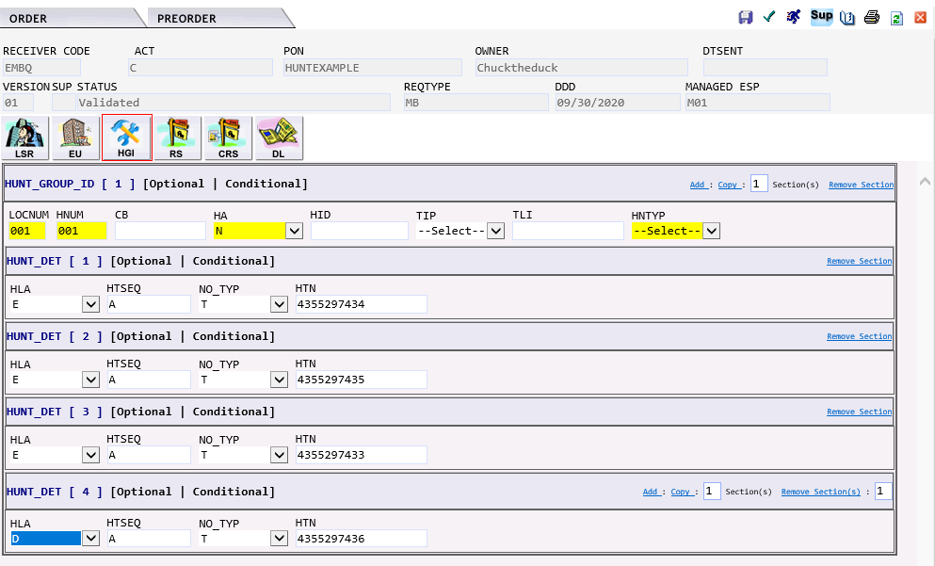

SAMPLE Product Order Examples

Overview | The orders below are samples of basic Product Order Types. The differences between IMA and EASE have been identified to assist with order creation. In most cases, orders would represent how a new request for the product would be submitted.  Please Note: The orders below are for illustrative purposes only. All order data is fictitious and any resemblance to production data is purely coincidental.

AB - LOOP | The AB Loop request would generate the following forms in EASE:  - LSR  - EU – END USER  - LS – LOOP SERVICE  - DL – DIRECTORY LISTING  IMA Field EASE Form EASE Field MODIFICATION TO ORDER  LSR SPEC Enter SPEC value of A, B, N or I to indicate requested TEST VALUE - A (Performance Testing) - B (Cooperative Testing) - N (No Testing) - I (Cooperative Testing)

LSR Form
EU Form | 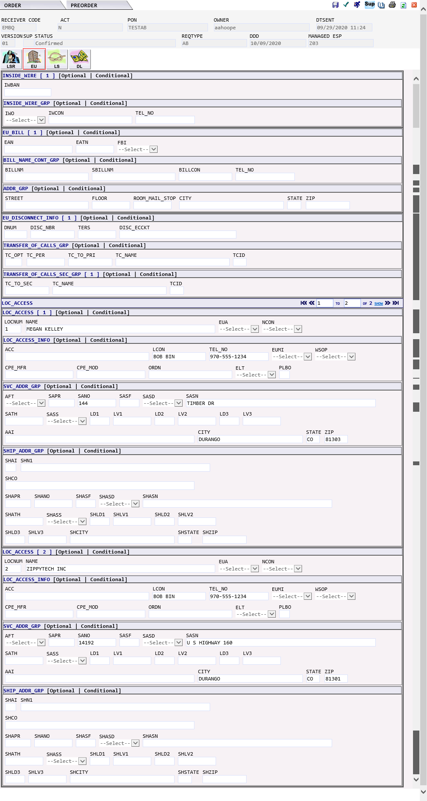

LS Form | 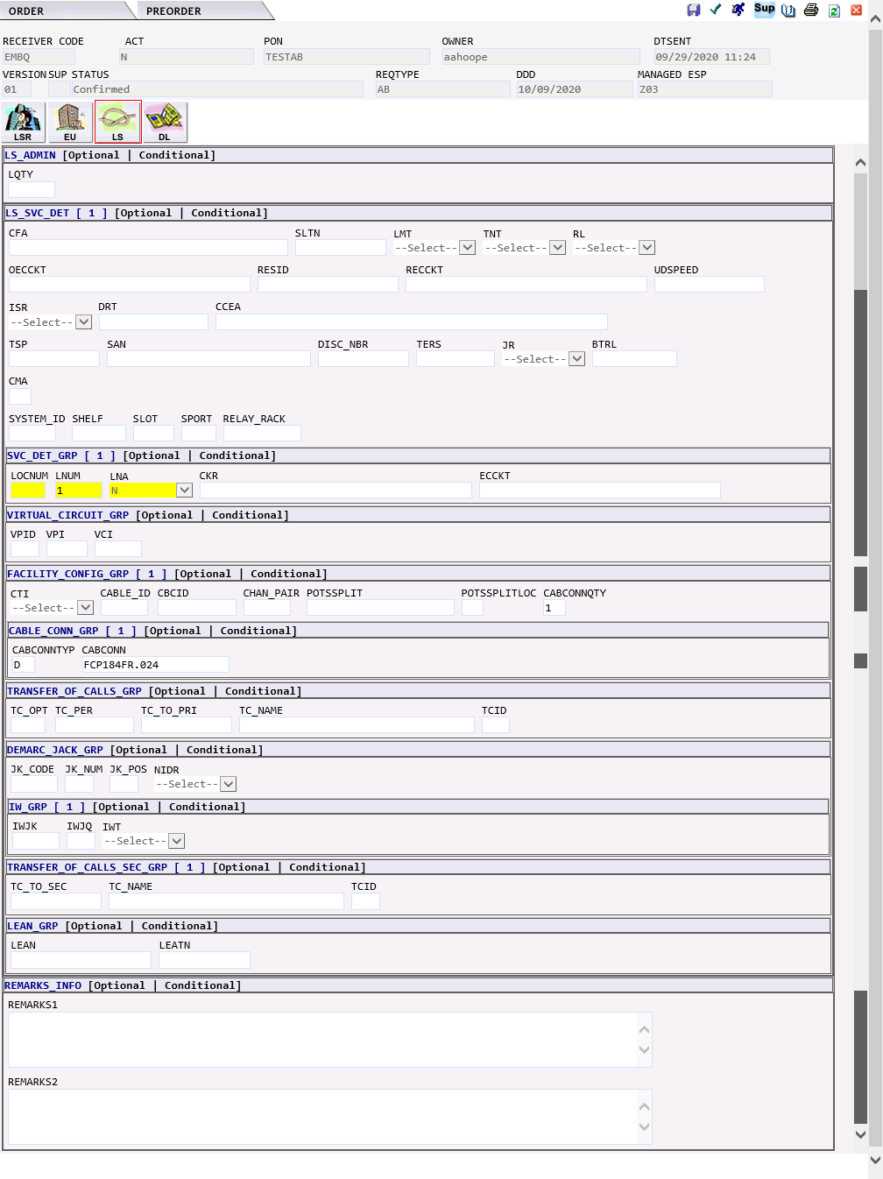

DL Form | 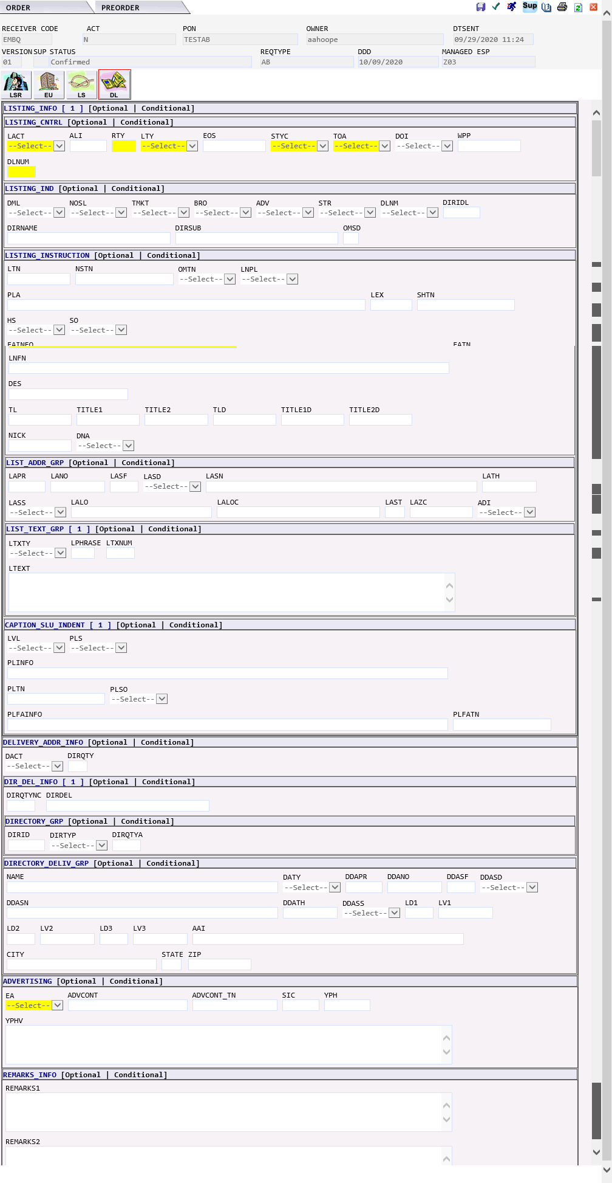
AB - Shared Loop | The AB Loop request would generate the following forms in EASE:  - LSR  - EU – END USER  - LS – LOOP SERVICE  - DL – DIRECTORY LISTING

LSR Form | 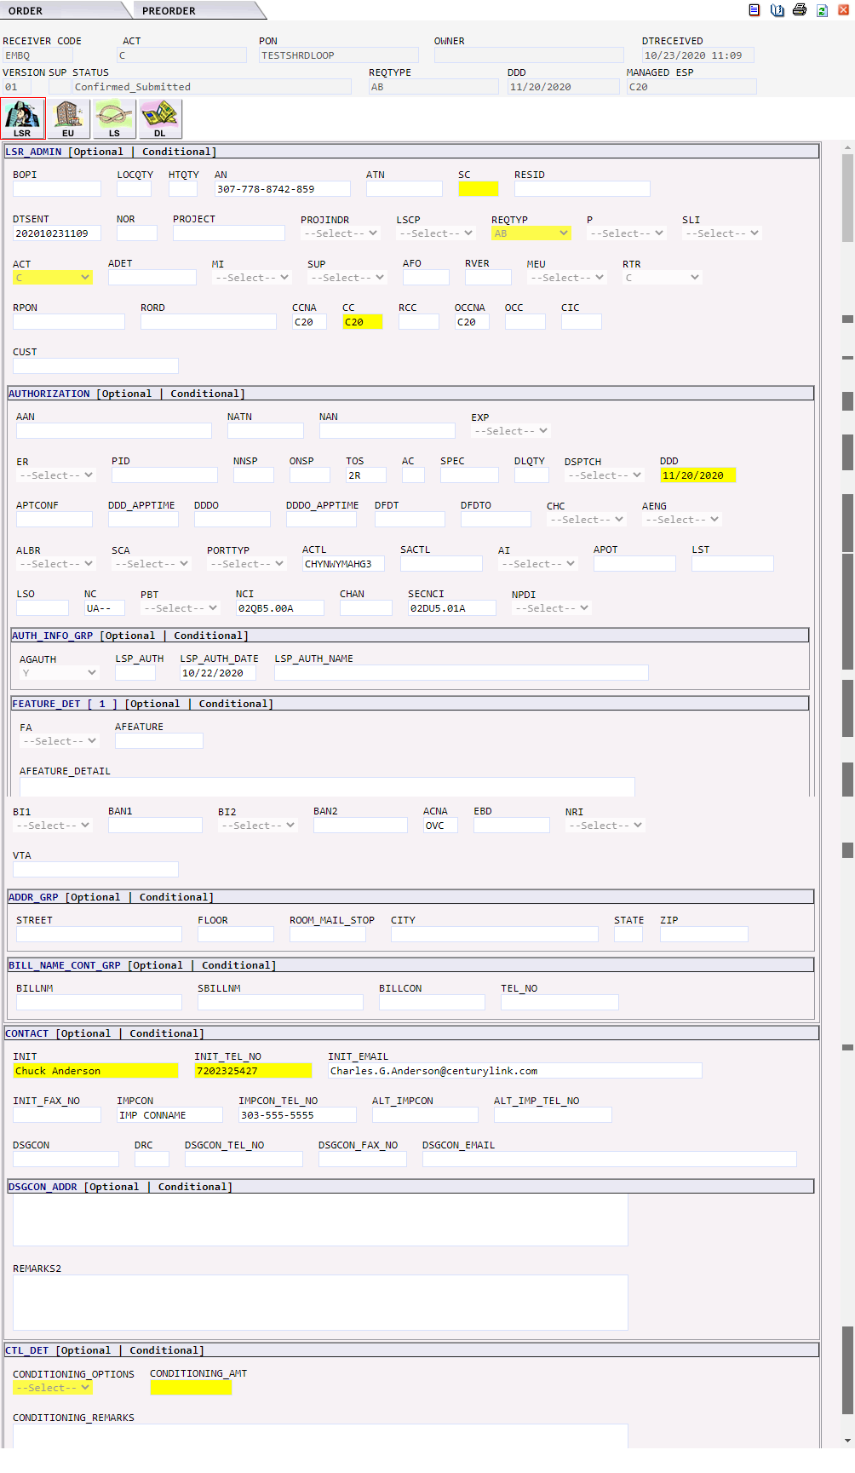

EU Form | 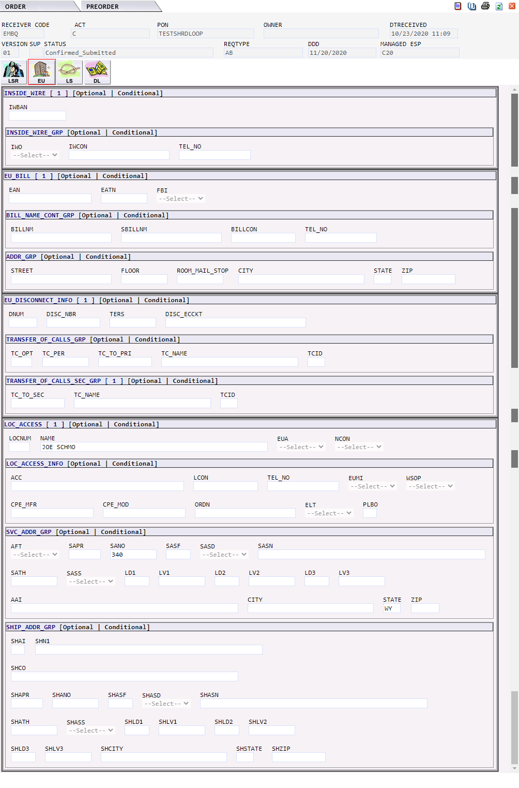

LS Form | 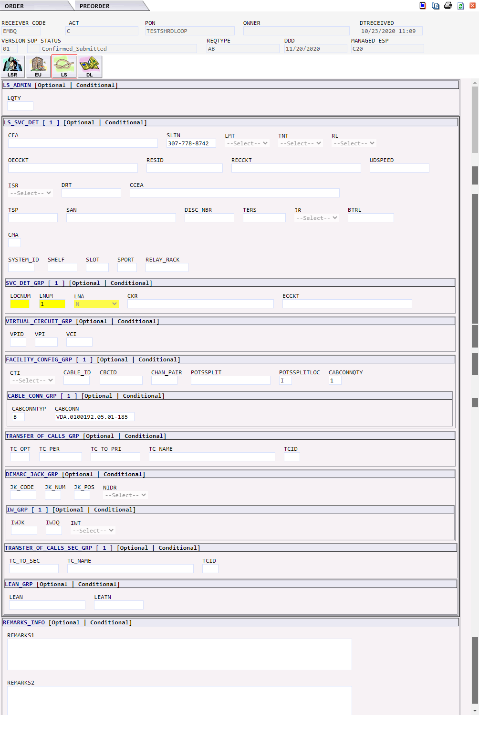

DL Form | 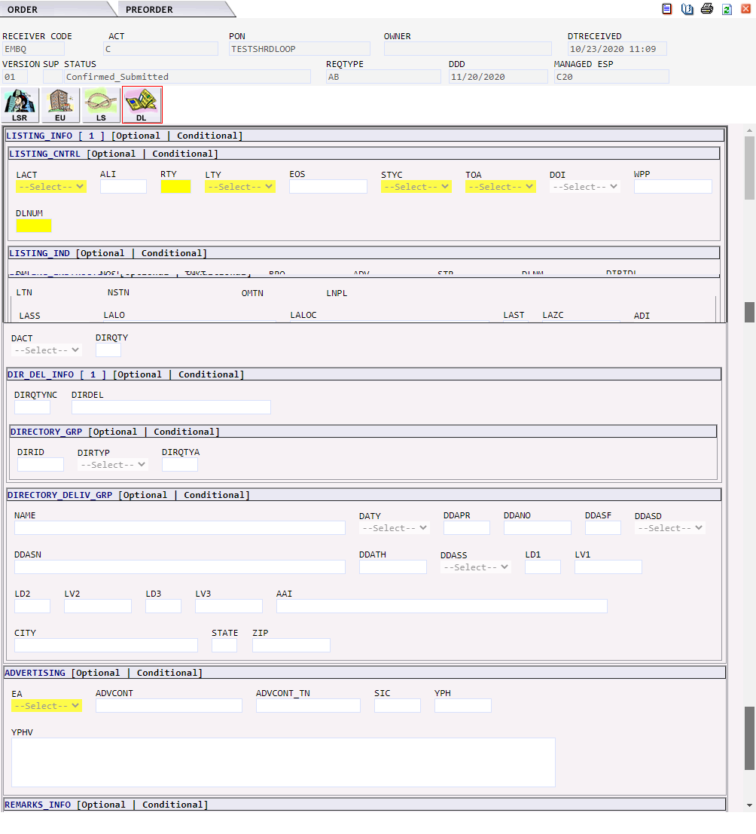

BB – LOOP with Number Portability | The BB Loop with Number Portability request would generate the following forms in EASE:  - LSR  - EU – END USER  - LSNP – LOOP SERVICE NUMBER PORTABILITY  - DL – DIRECTORY LISTING  IMA Field EASE Form EASE Field MODIFICATION TO ORDER  LSR SPEC Enter SPEC value of A, B, N or I to indicate requested TEST VALUE - A (Performance Testing) - B (Cooperative Testing) - N (No Testing) - I (Cooperative Testing)

LSR Form

EU Form | 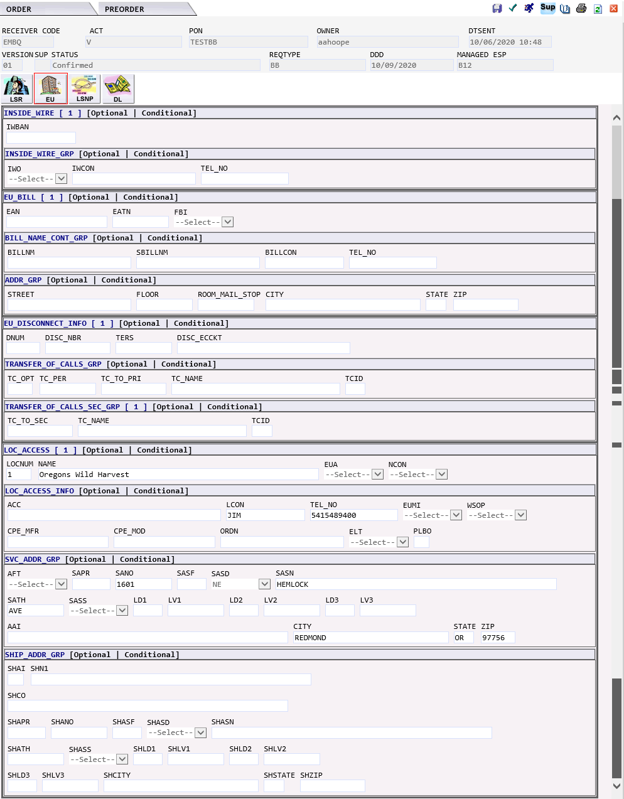

LNSP Form | 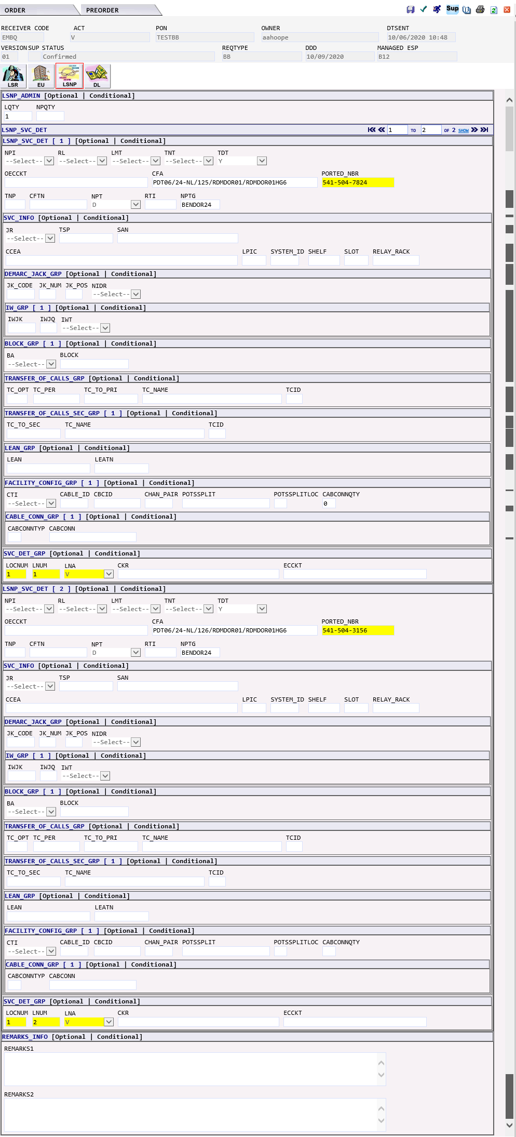

DL Form | 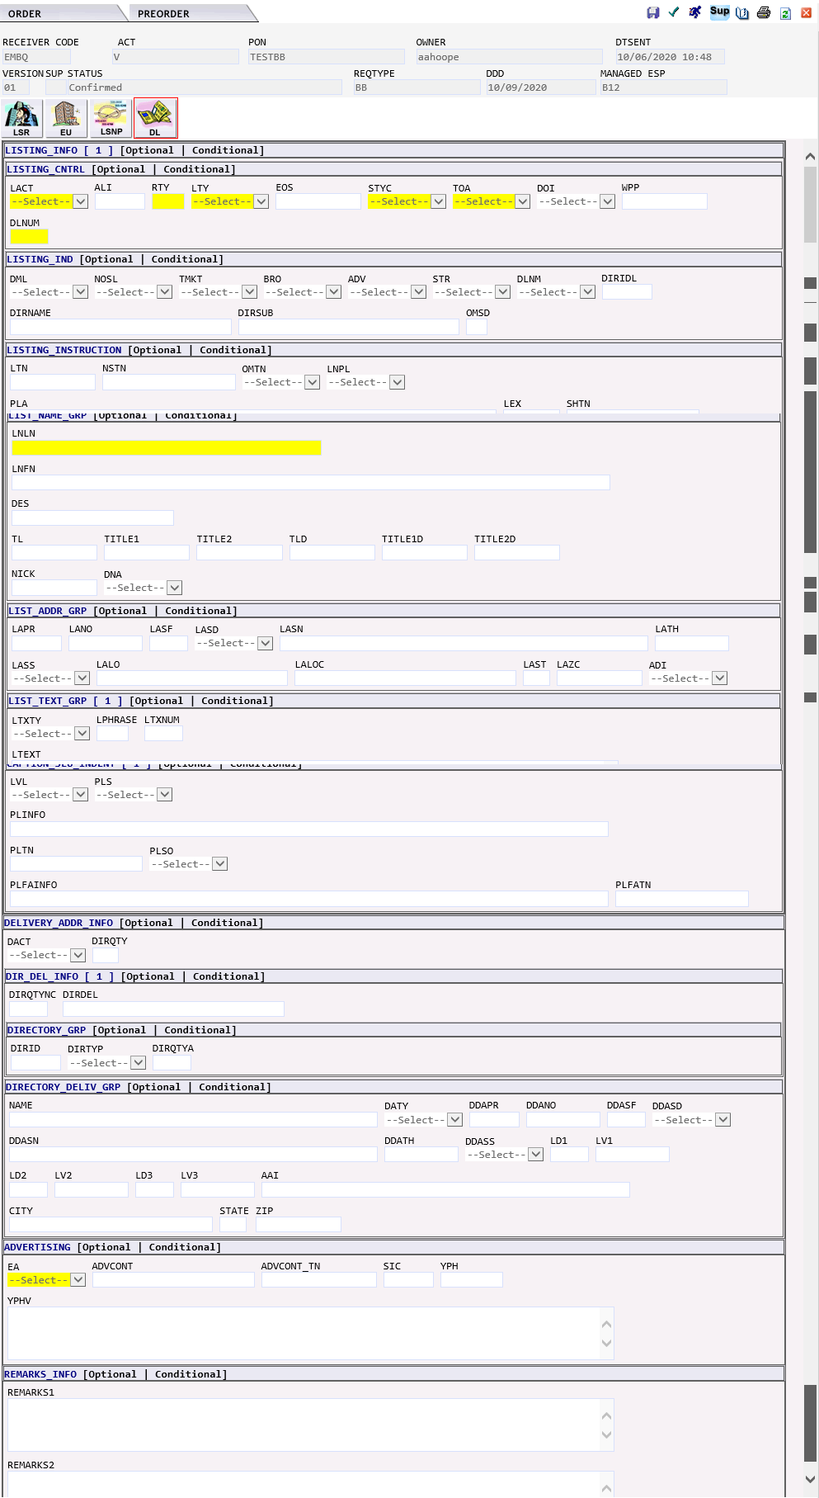

BB – Loop with Number Port with multiple numbers | The BB Loop with Number Portability (multiple numbers) request would generate the following forms in EASE:  - LSR  - EU – END USER  - LSNP – LOOP SERVICE NUMBER PORTABILITY  - DL – DIRECTORY LISTING  IMA Field EASE Form EASE Field MODIFICATION TO ORDER  LSR SPEC Enter SPEC value of A, B, N or I to indicate requested TEST VALUE - A (Performance Testing) - B (Cooperative Testing) - N (No Testing) - I (Cooperative Testing)

LSR Form

EU Form | 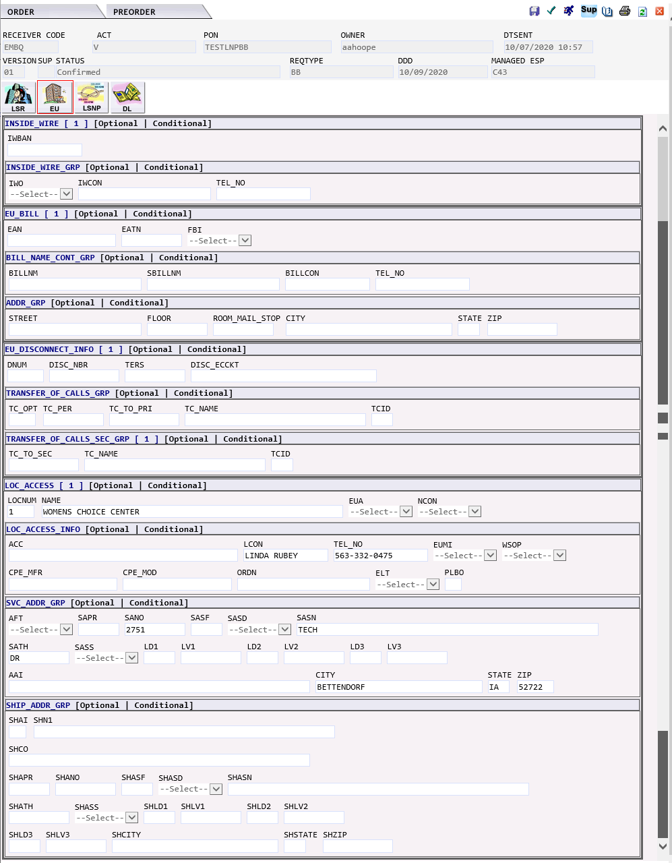

LSNP Form | 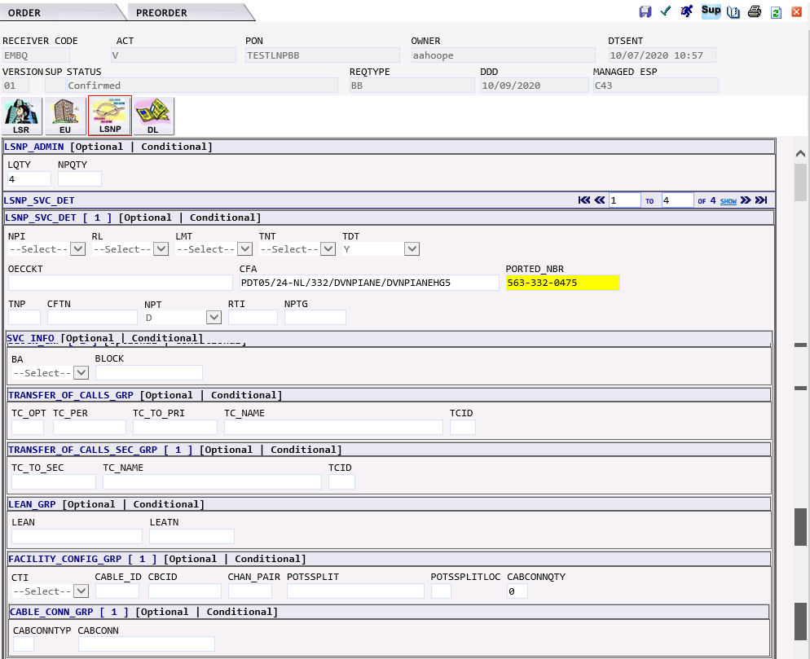  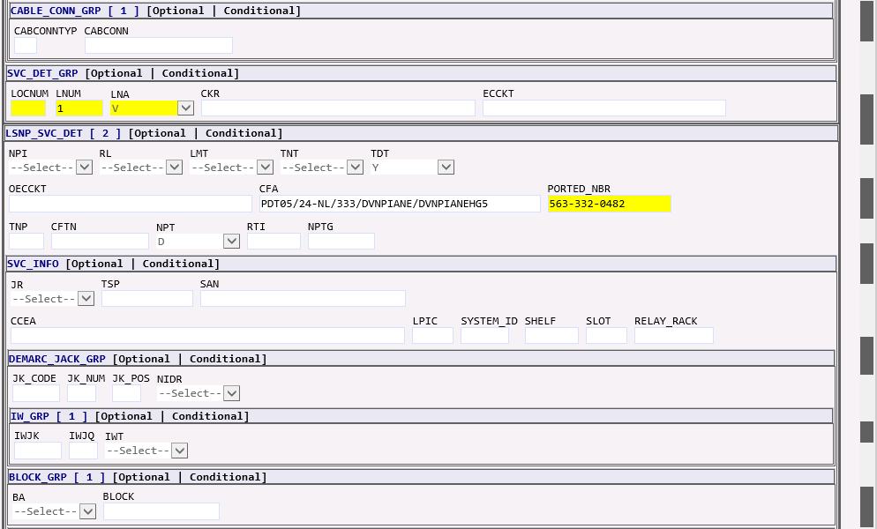  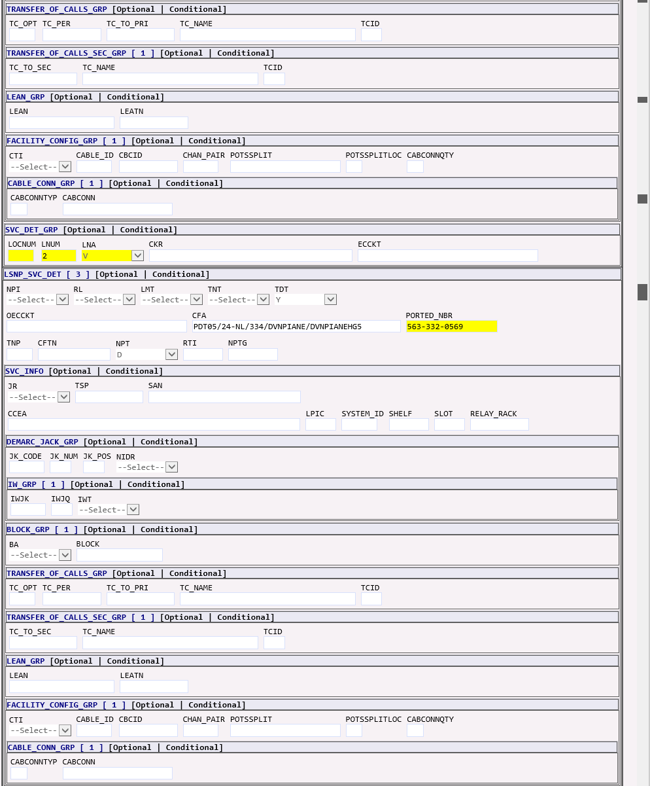  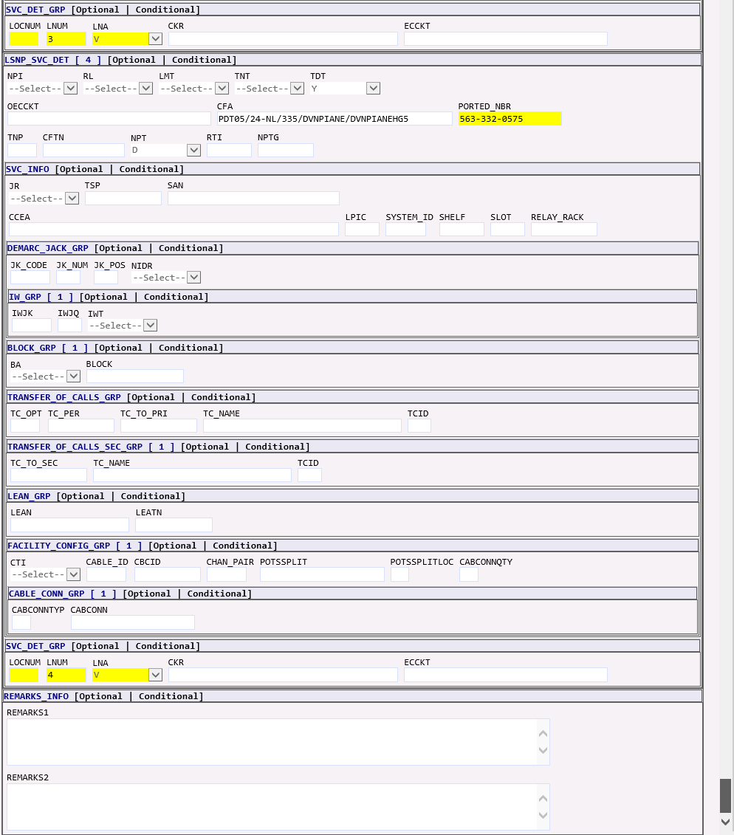

DL Form | 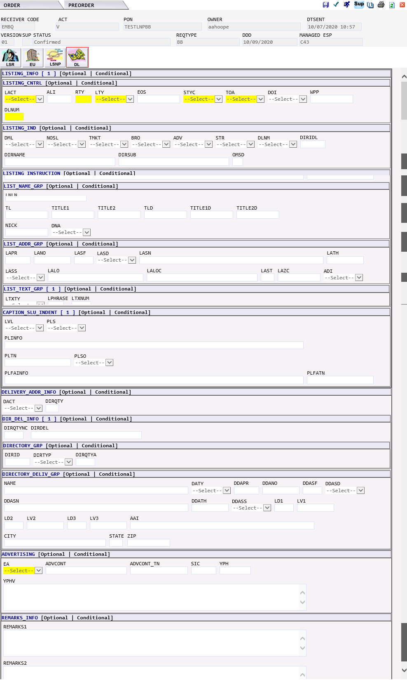

CB - Number Portability | The CB – Number Portability request would generate the following forms in EASE:  - LSR  - EU – END USER  - NP – NUMBER PORTABILITY  - DL – DIRECTORY LISTING

LSR Form | 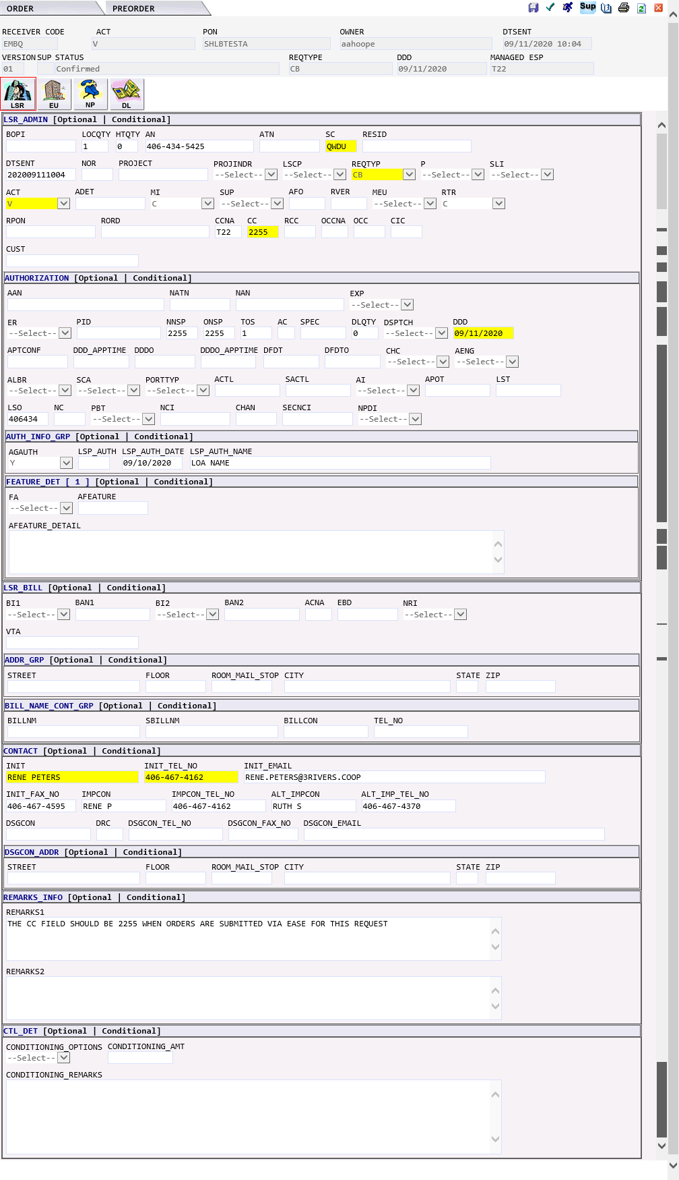

EU Form | 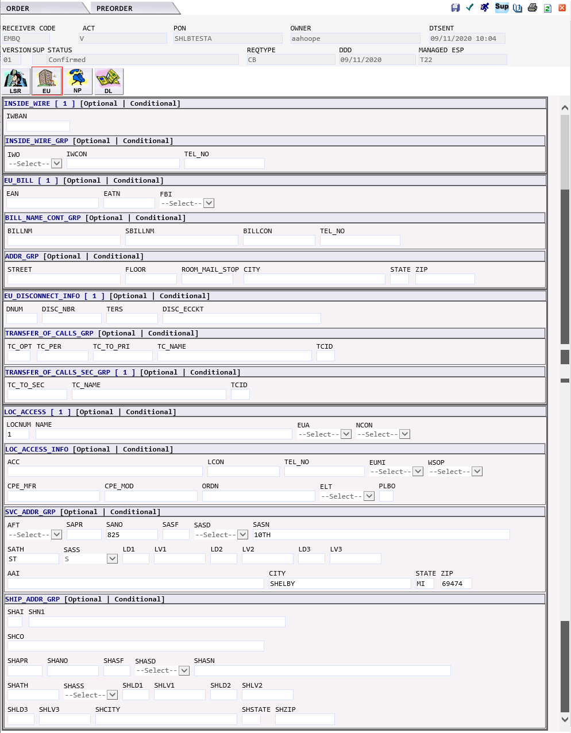

NP Form | 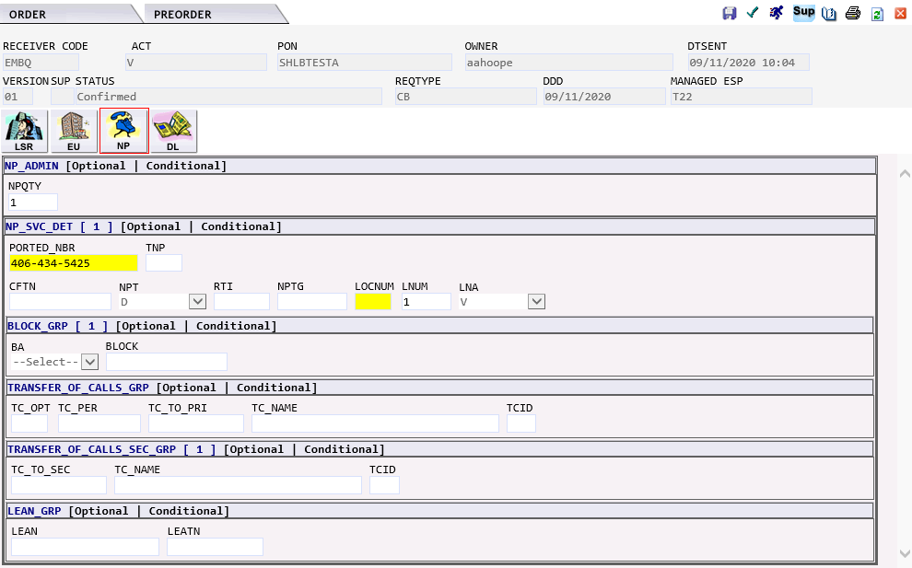

DL Form | 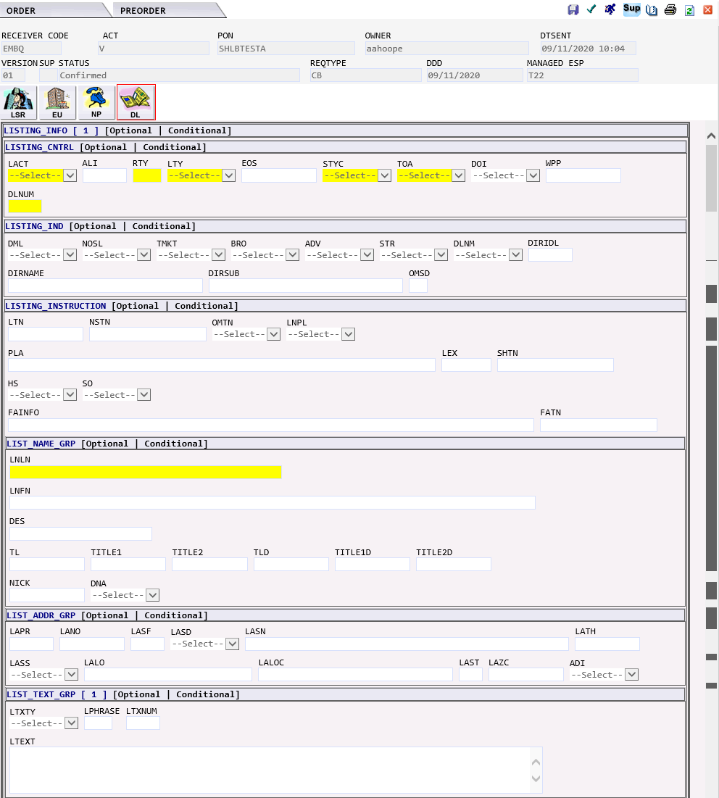  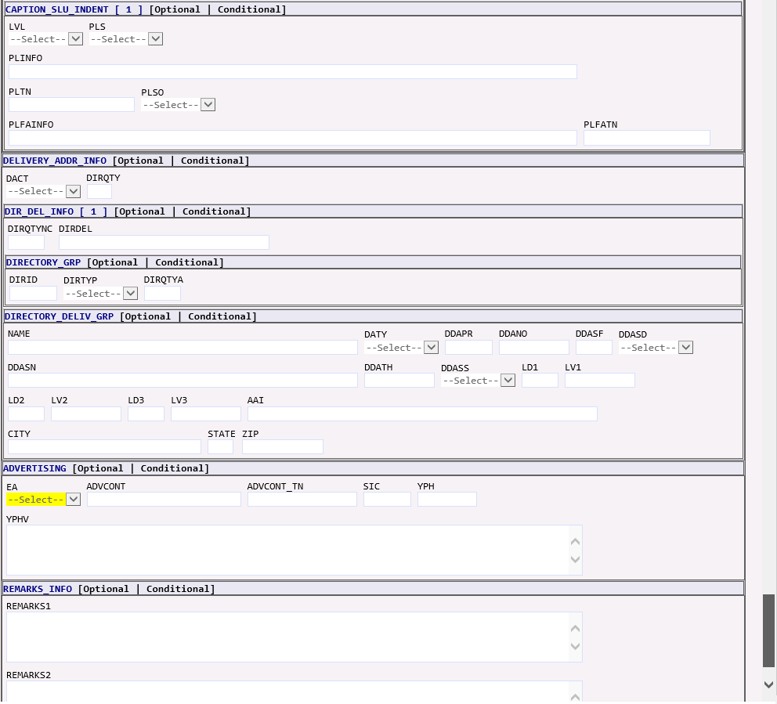

EB – Resale/Data Unified – WBSA DSL | The EB – Resale/Data Unified – WBSA DSL request would generate the following forms in EASE:  - LSR  - EU – END USER  - HGI – HUNT GROUP INFORMATION  - RS – RESALE SERVICE  - DL – DIRECTORY LISTING  - DU – DATA UNIFIED (NOT USED)

LSR Form | 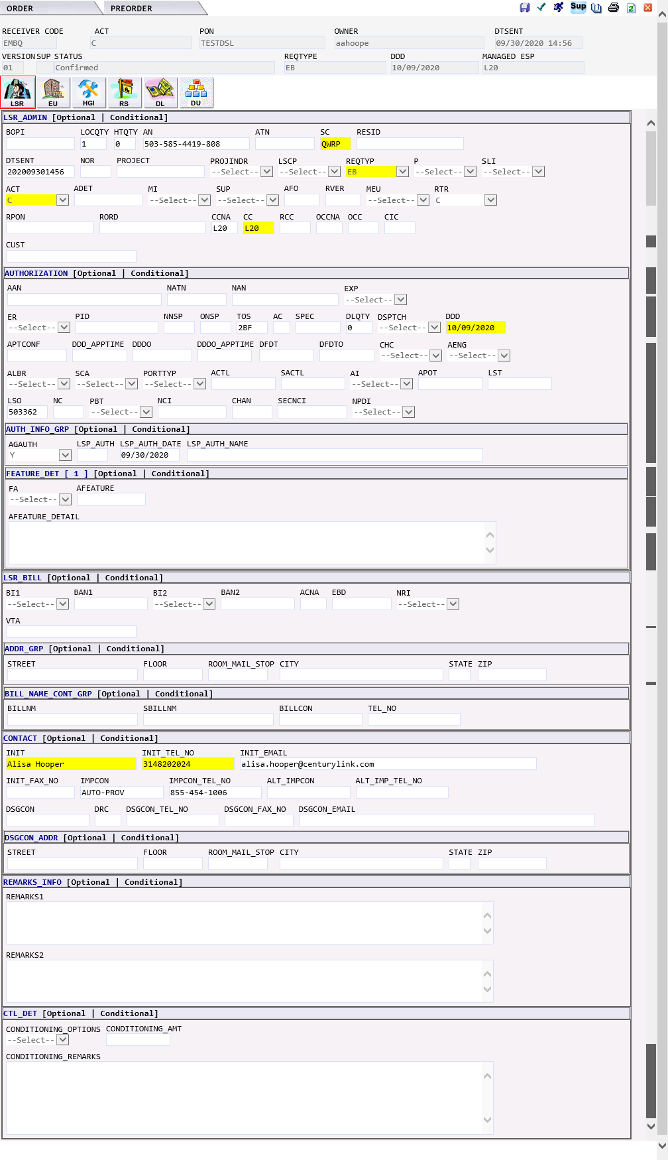

EU Form | 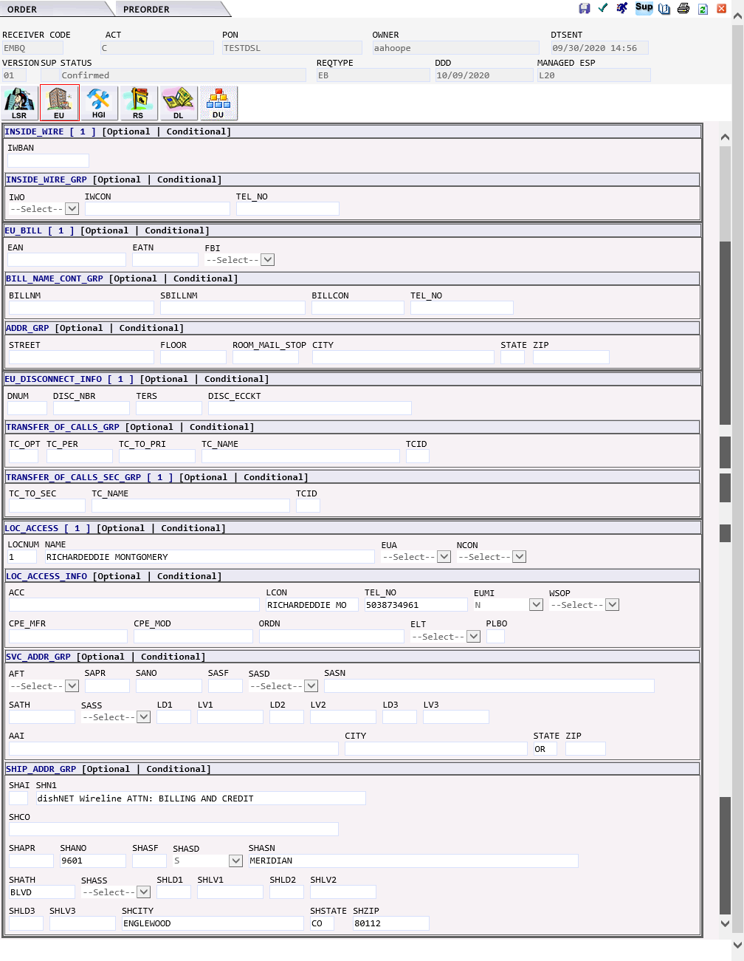

HGI Form | 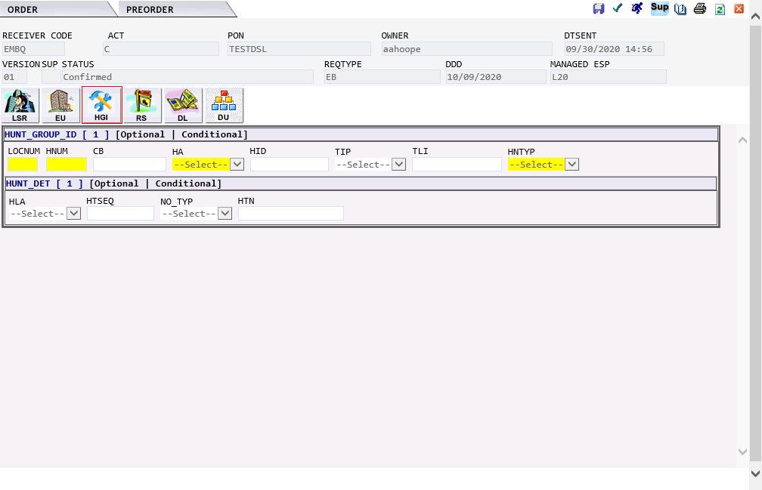

RS Form | 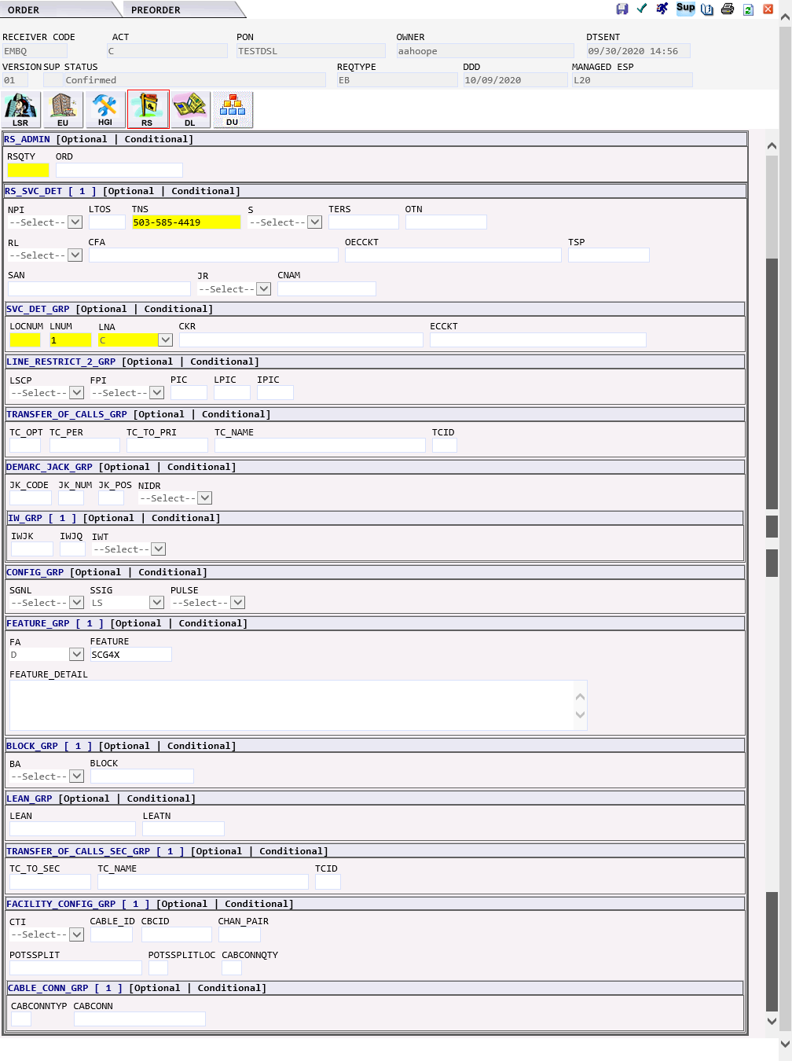

DL Form | 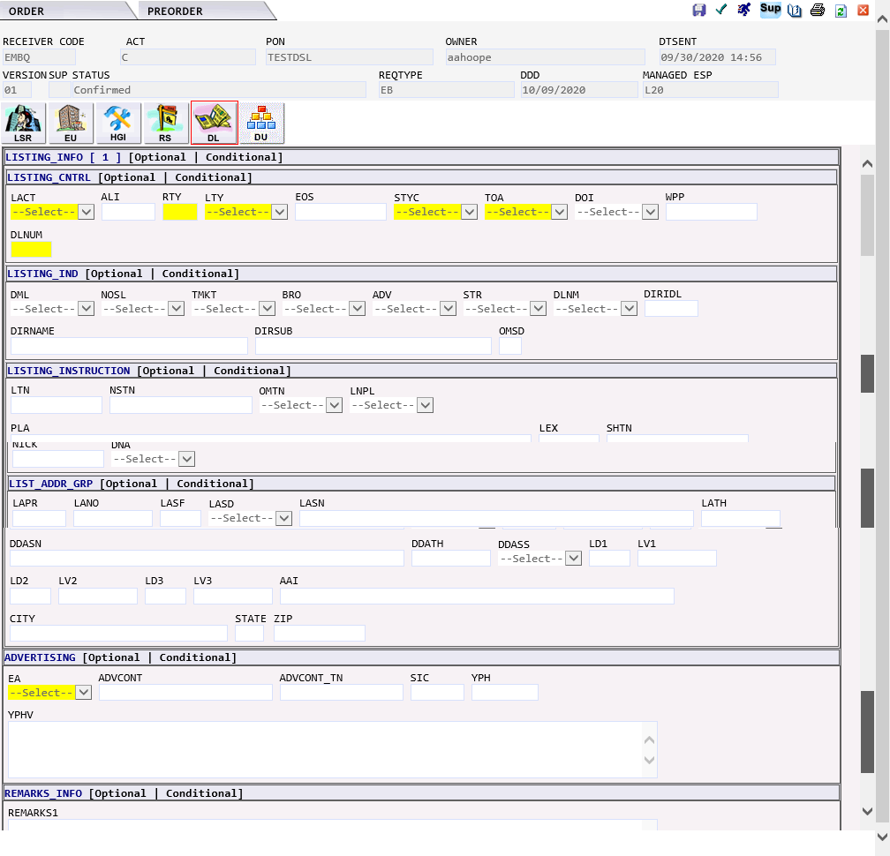

EB - Resale/Data Unified - VFO EB and IMA EB - Resale POTS | The EB Resale/Data Unified – VFO EB and IMA EB Resale POTS request would generate the following forms in EASE:  - LSR  - EU – END USER  - HGI – HUNT GROUP INFORMATION  - RS – RESALE SERVICE  - DL – DIRECTORY LISTING  - DU – DATA UNIFIED (NOT USED)

LSR Form

EU Form | 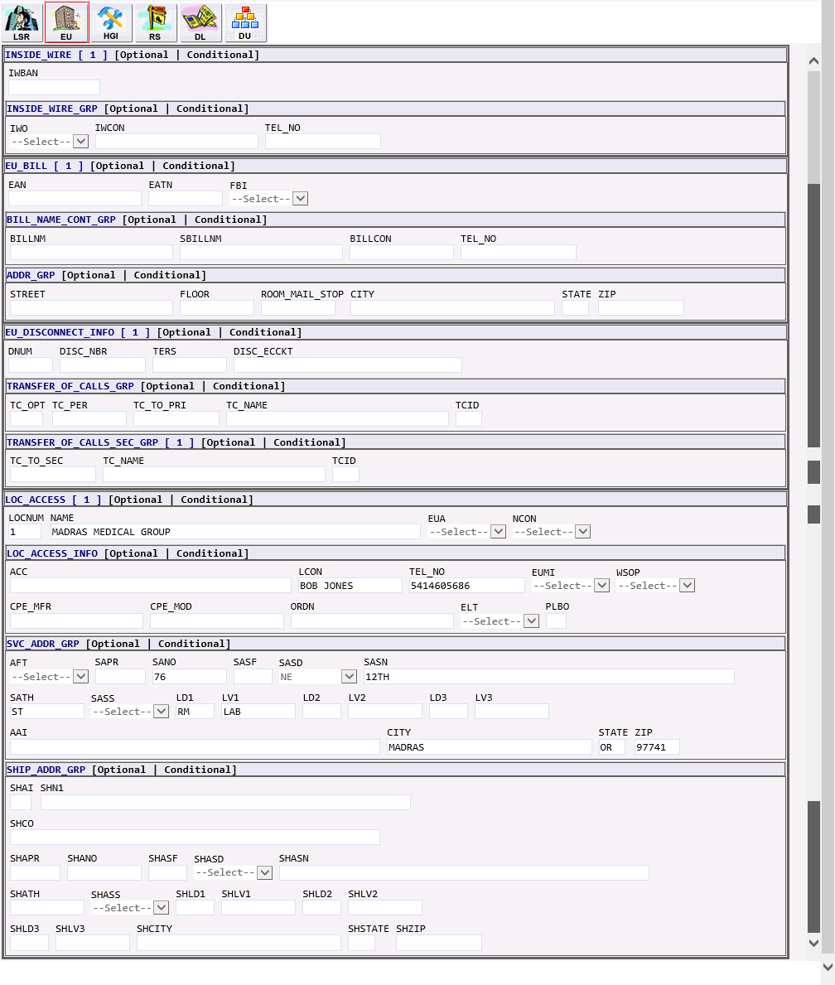

HGI Form | 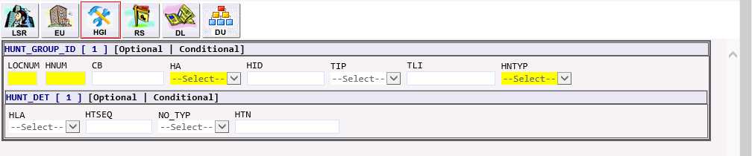

RS Form | 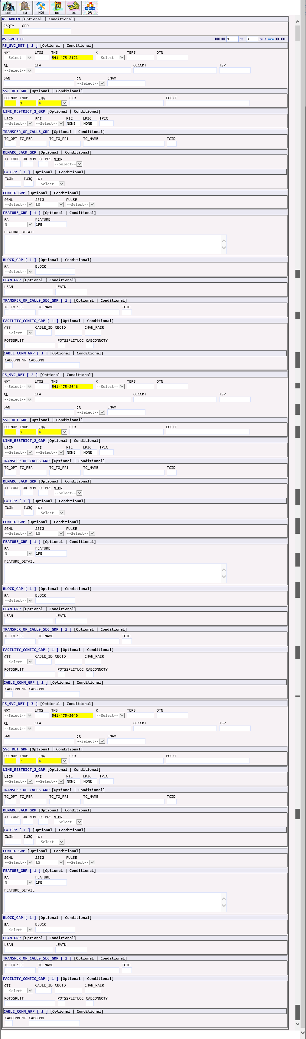

DL Form | 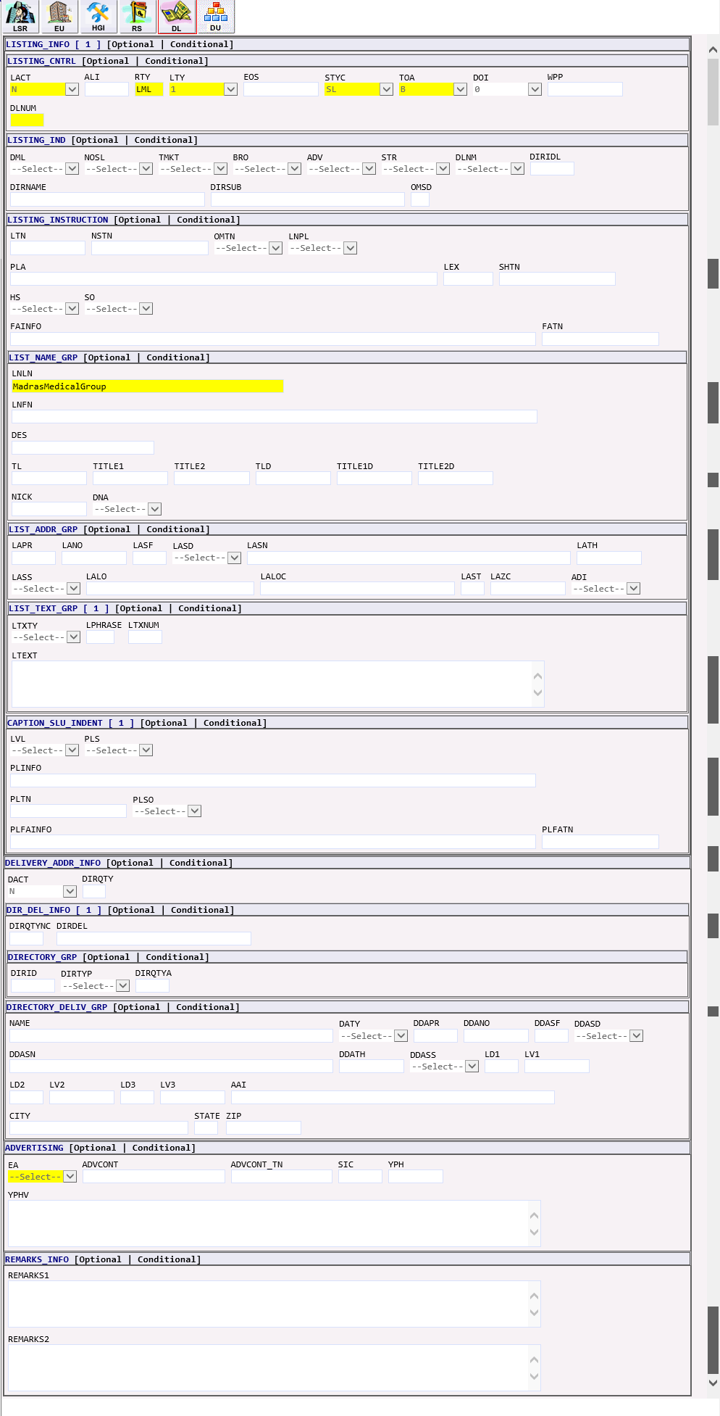

EB - Resale/Data Unified -Resale POTS with more USOCs | The EB Resale/Data Unified – Resale POTS with more usocs request would generate the following forms in EASE:  - LSR  - EU – END USER  - HGI – HUNT GROUP INFORMATION  - RS – RESALE SERVICE  - DL – DIRECTORY LISTING  - DU – DATA UNIFIED (NOT USED)

LSR Form | 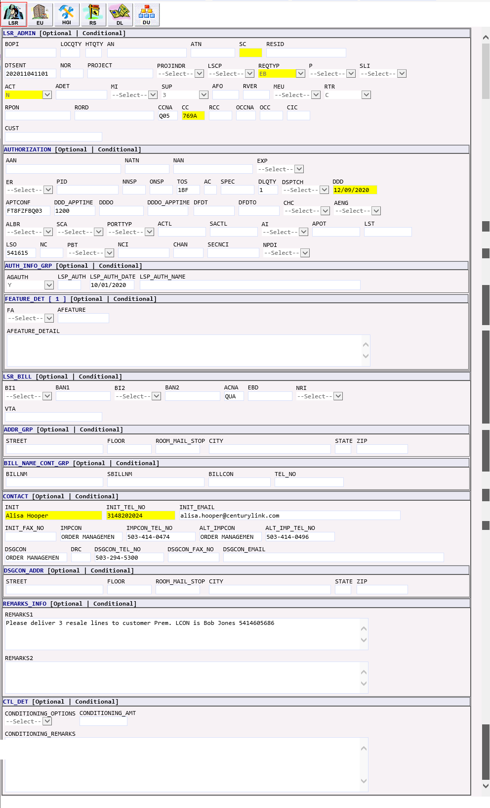

EU Form | 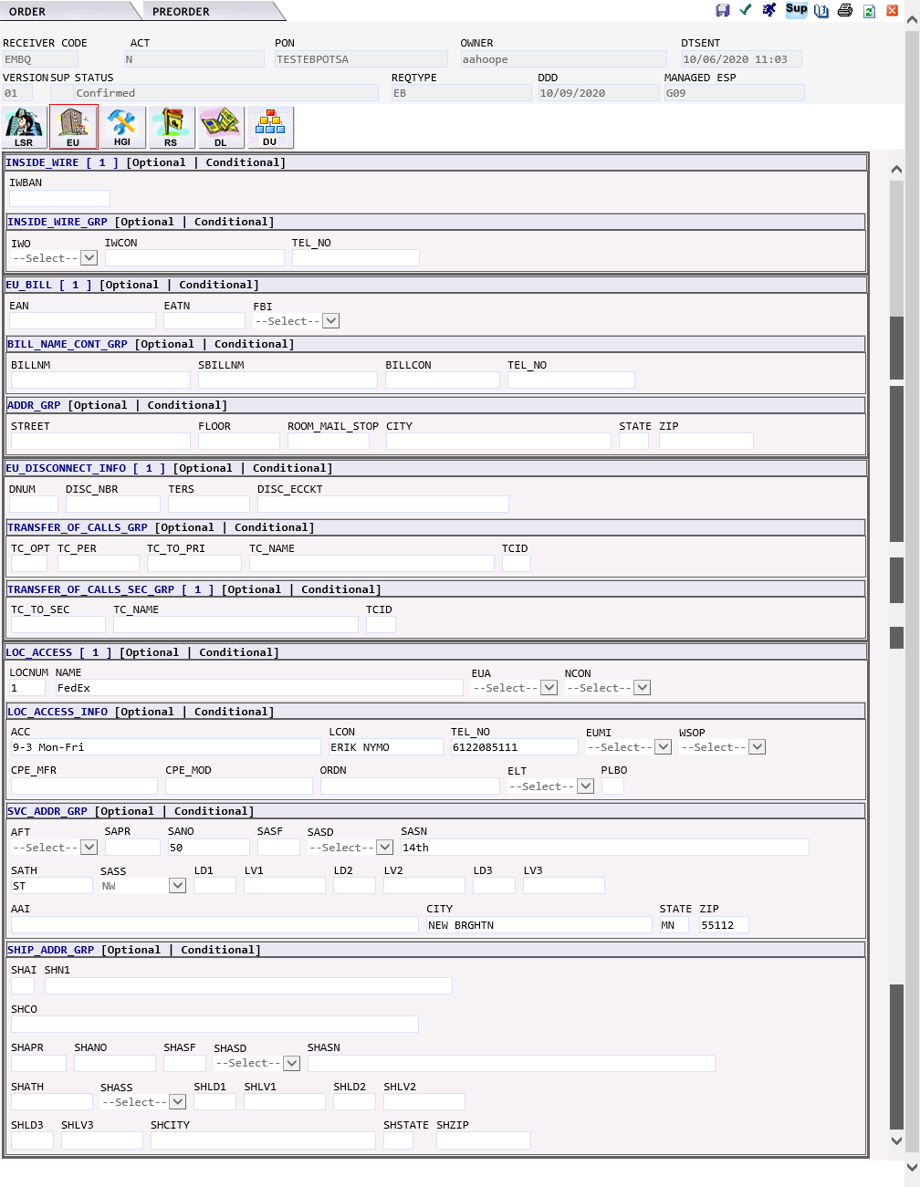

HGI Form | 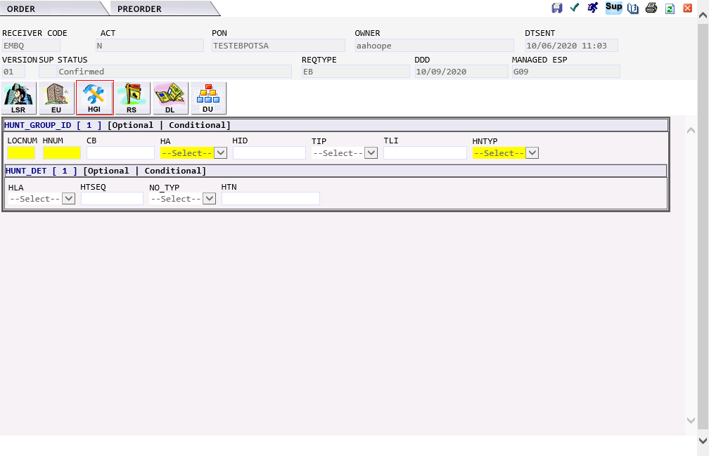

RS Form | 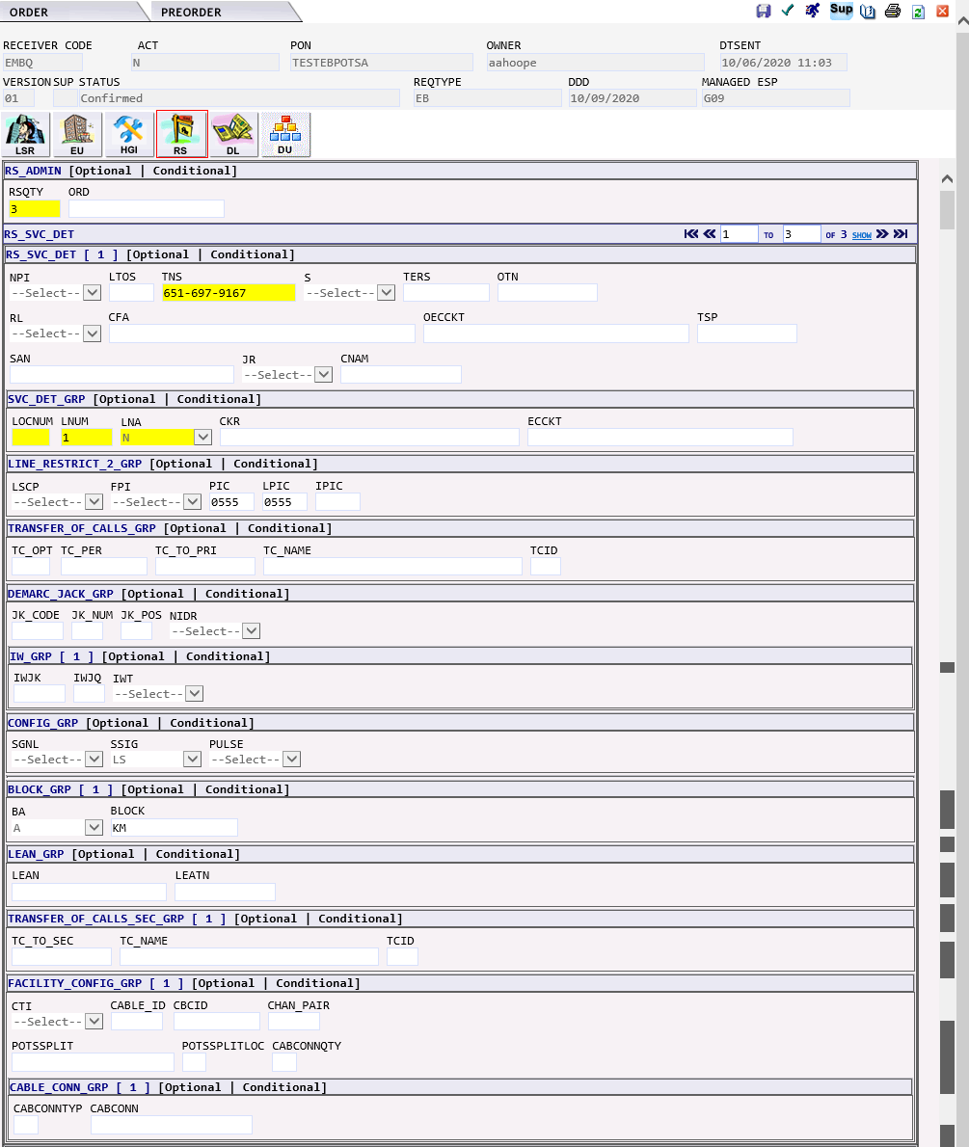  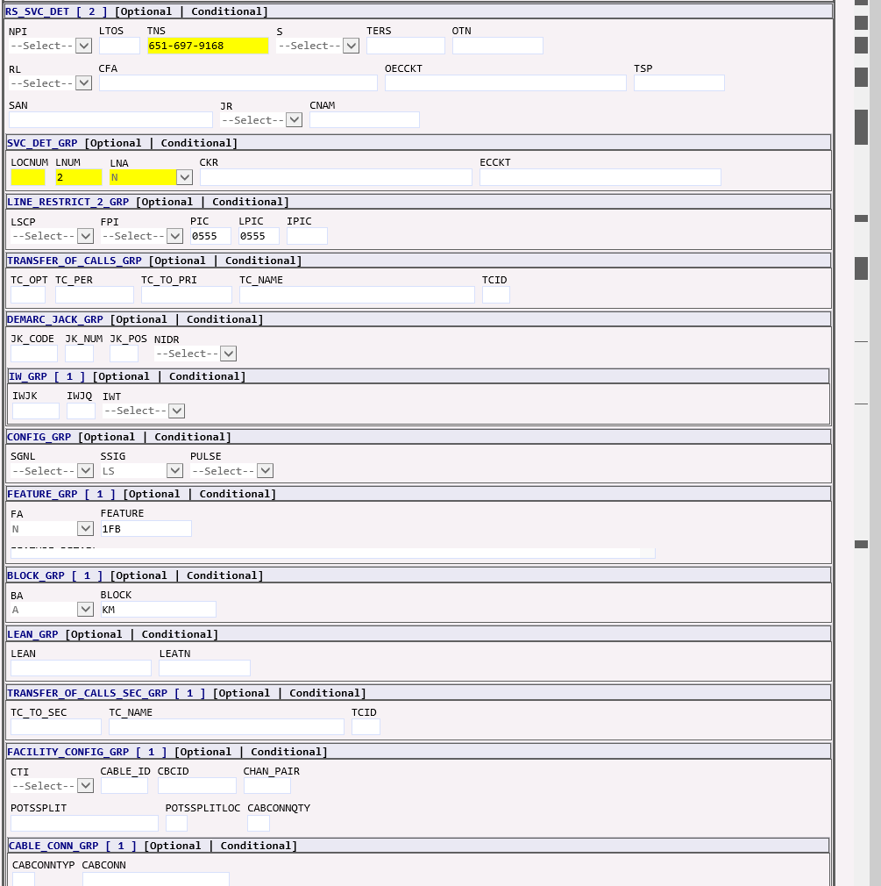  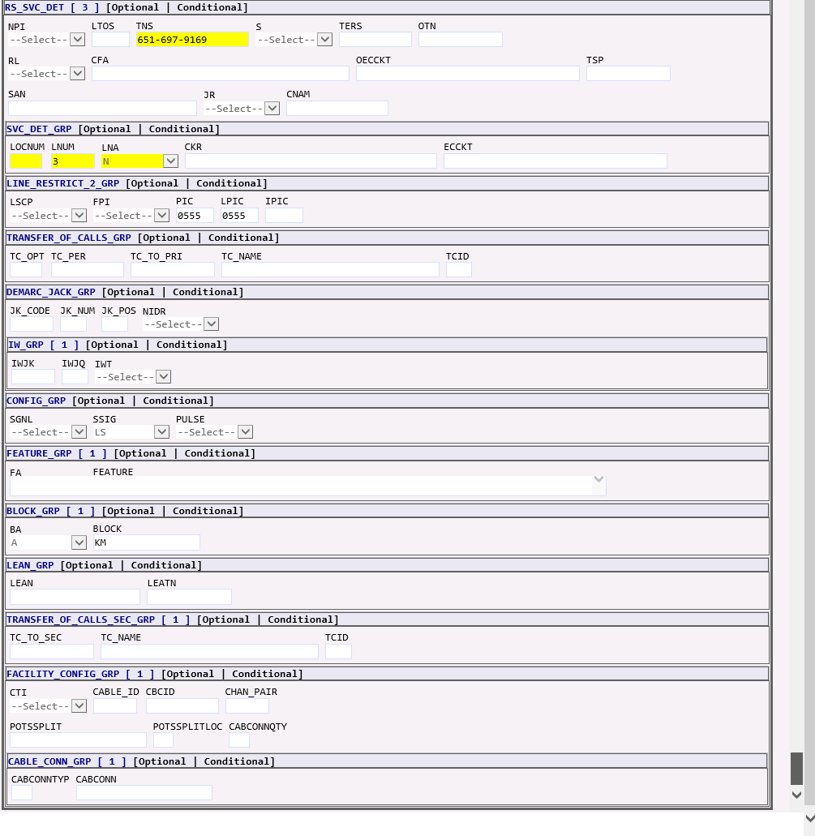

DL Form | 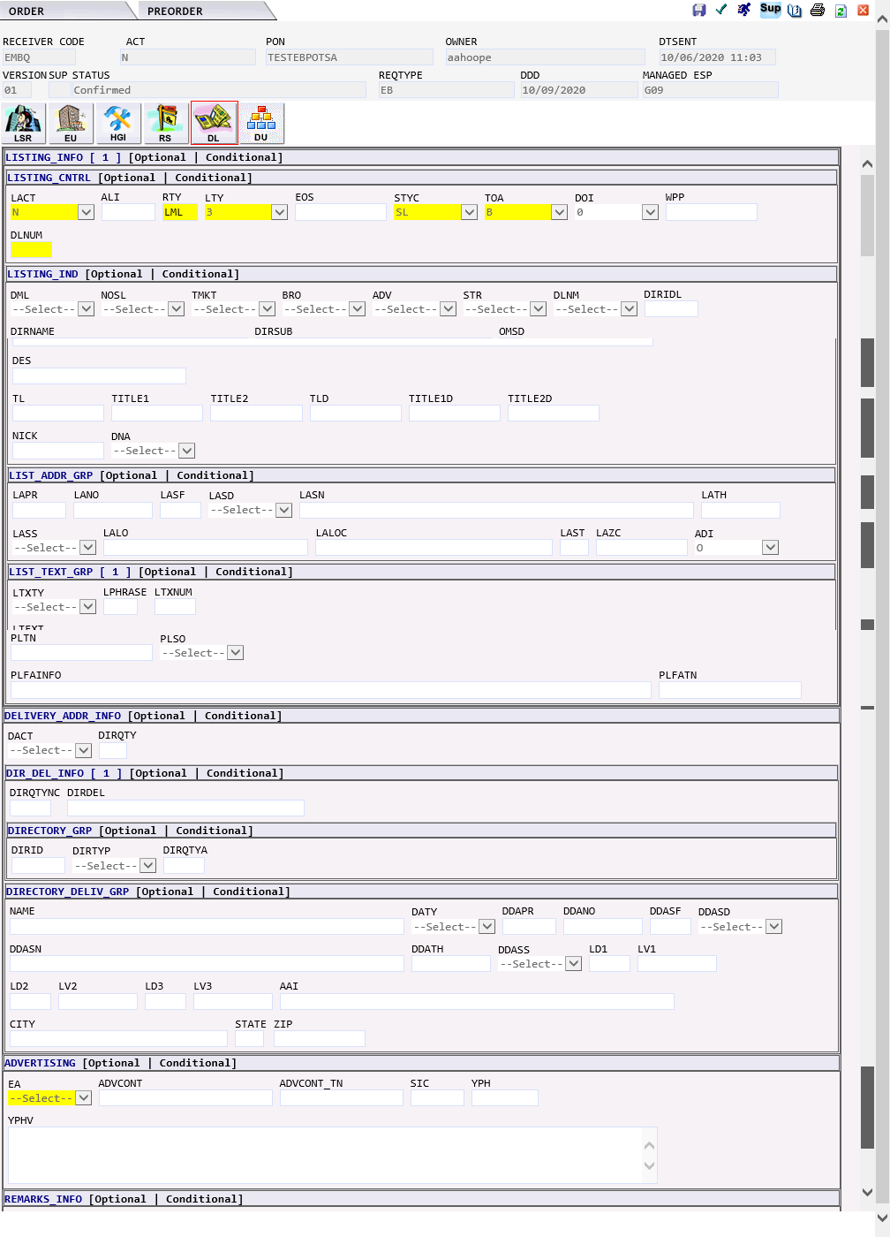

JB - Directory listing and assistance | The JB - Directory listing and assistance request would generate the following forms in EASE:  - LSR  - EU – END USER  - DL – DIRECTORY LISTING

LSR Form | 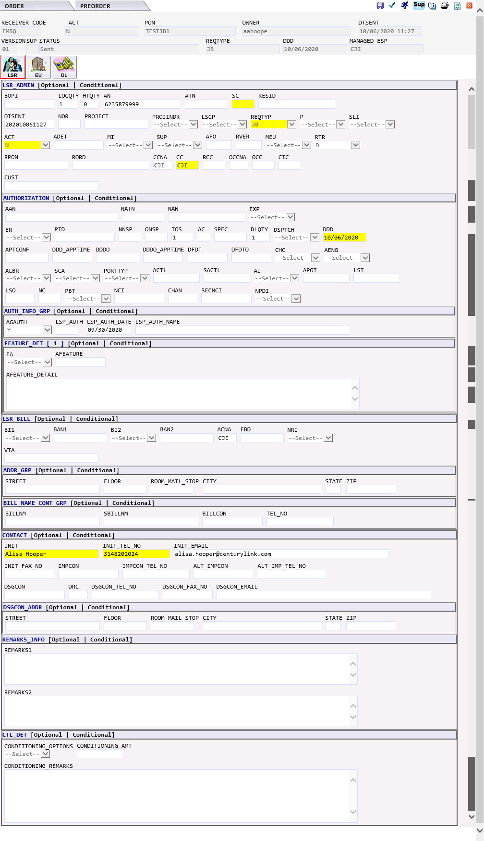

EU Form | 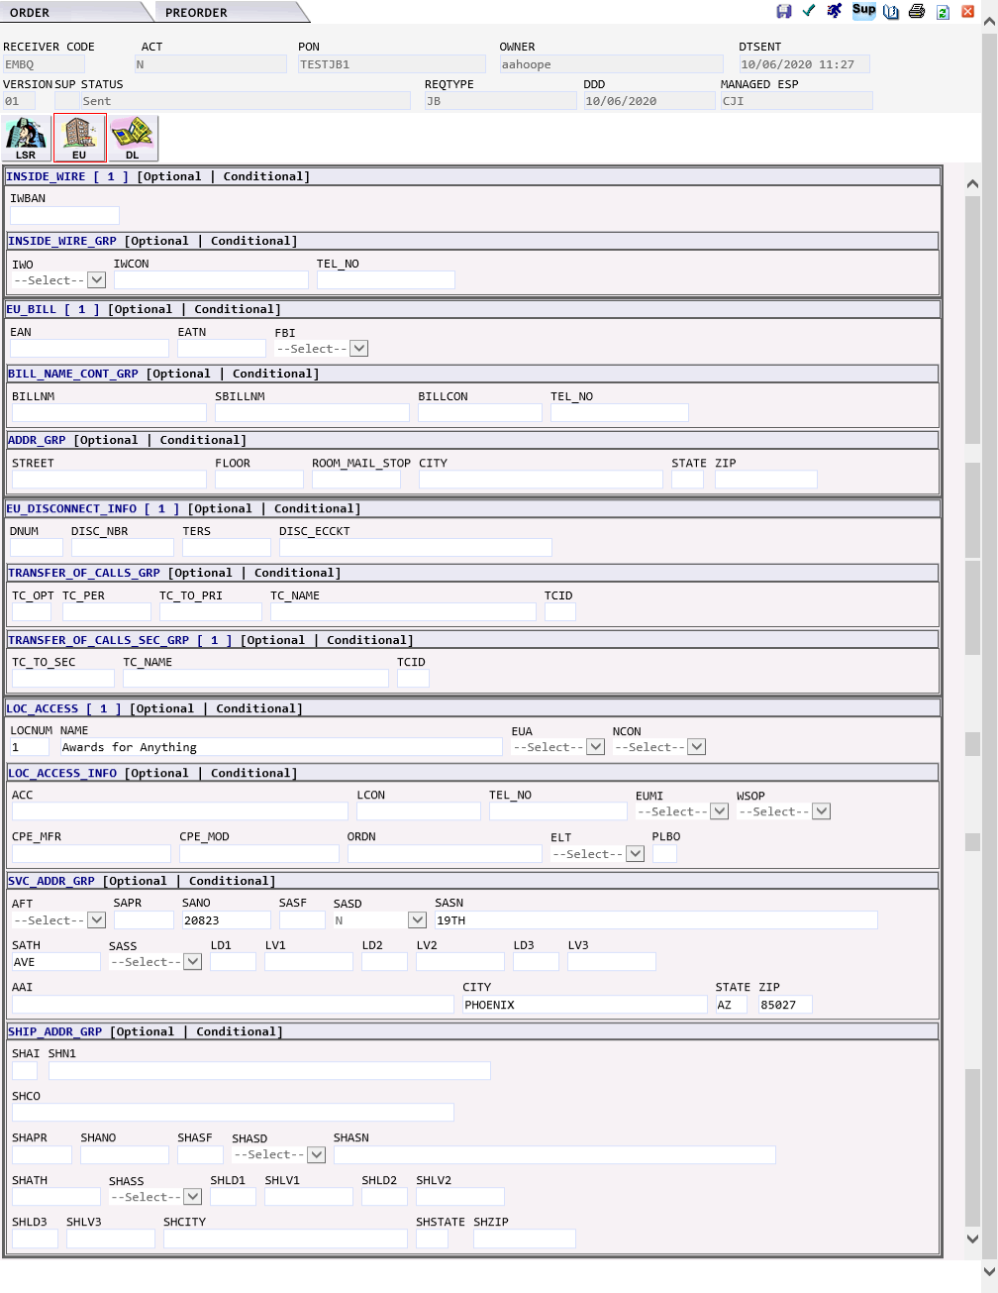

DL Form | 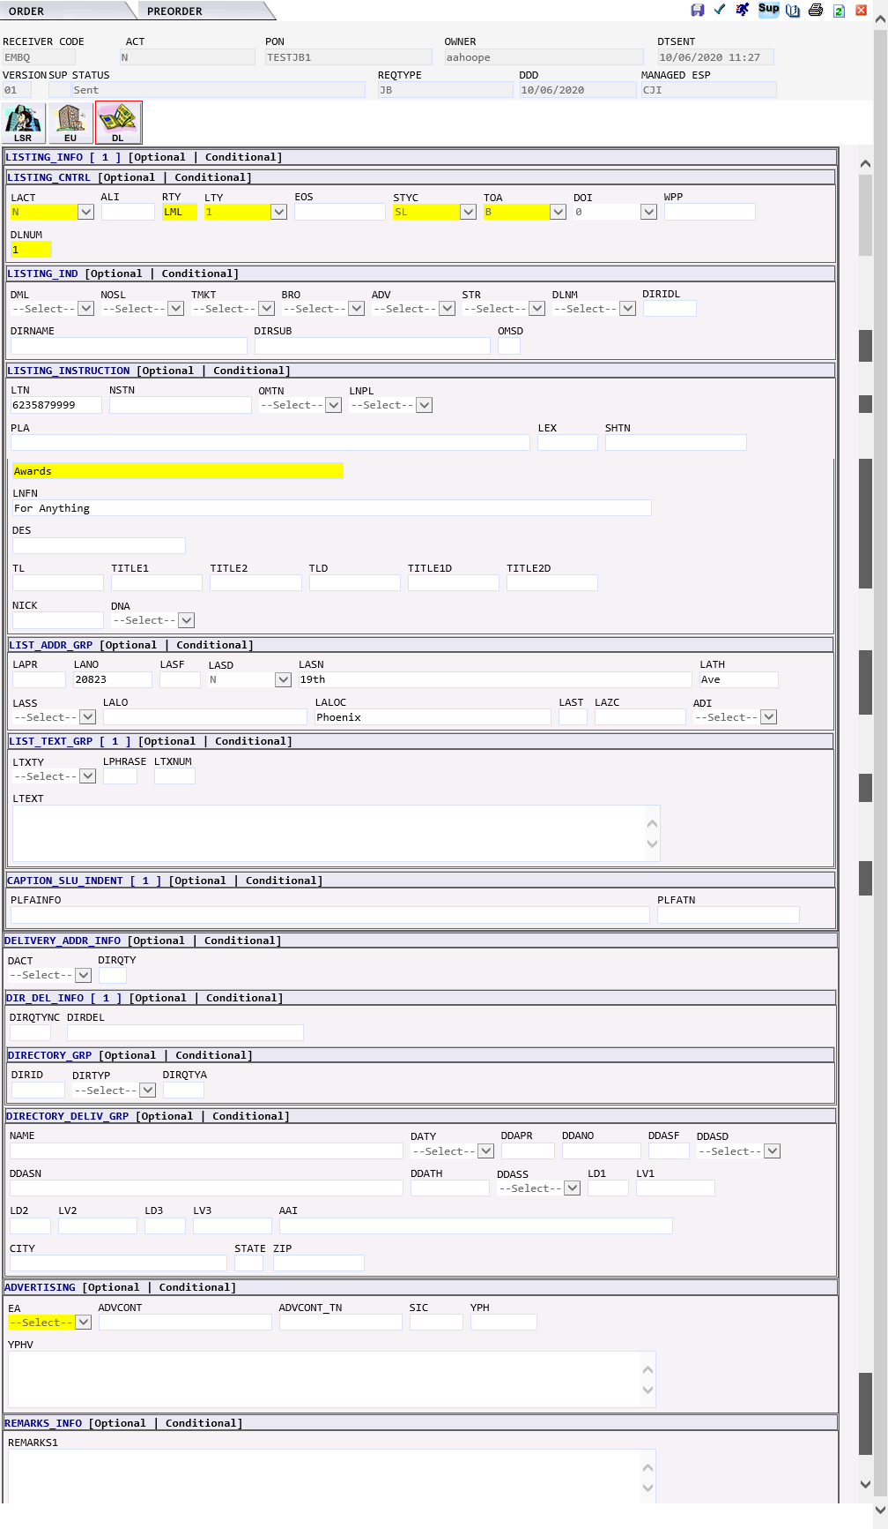

KB - Resale private line | The KB Resale Private Line request would generate the following forms in EASE:  - LSR  - EU – END USER  - RPL – RESALE PRIVATE LINE  - DL – DIRECTORY LISTING  IMA Field EASE Form EASE Field MODIFICATION TO ORDER  NAME EU NAME  NCON EU NCON  ADDRESS INFORMATION CAN BE PLACED IN EITHER: EU PRILOC/ SECLOC  RPL 1ST OCCURANCE IS PRILOC 2ND OCCURANCE IS SECLOC

LSR Form | 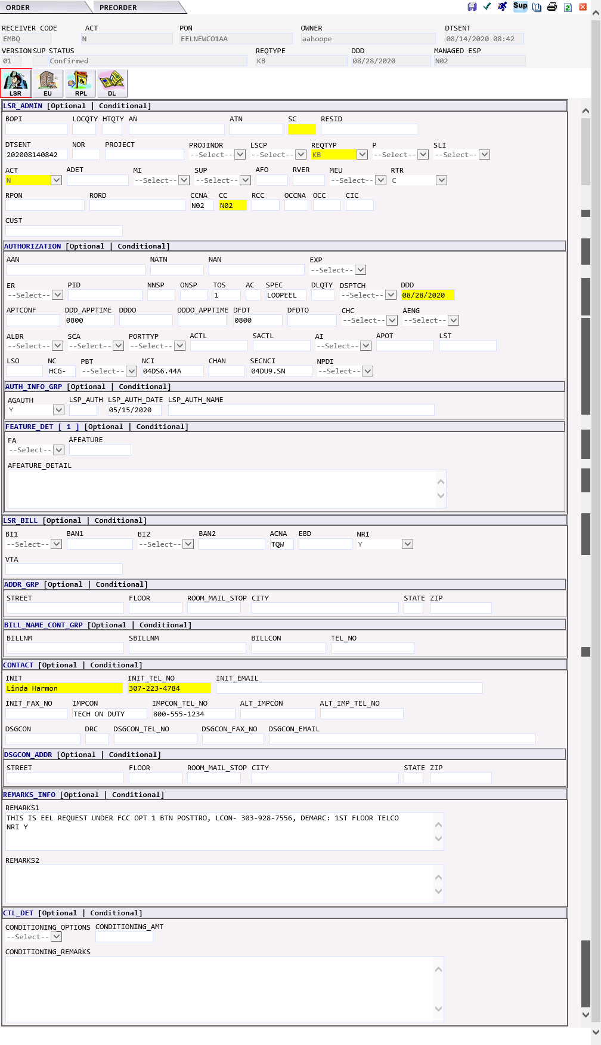

EU Form | 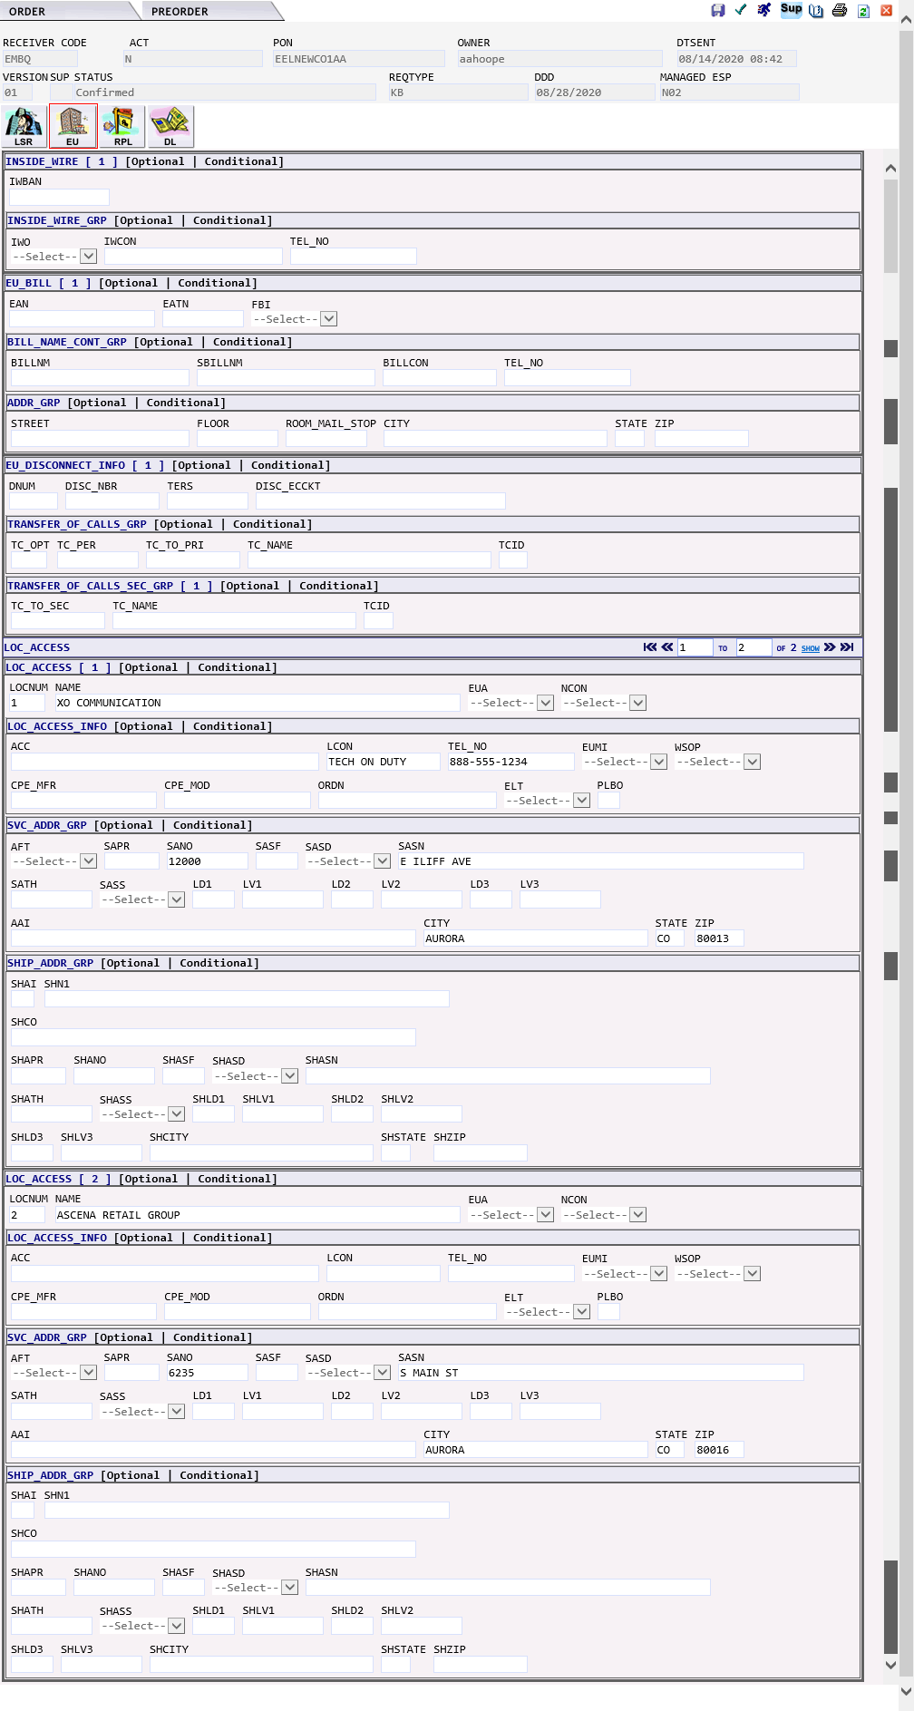

RPL Form | 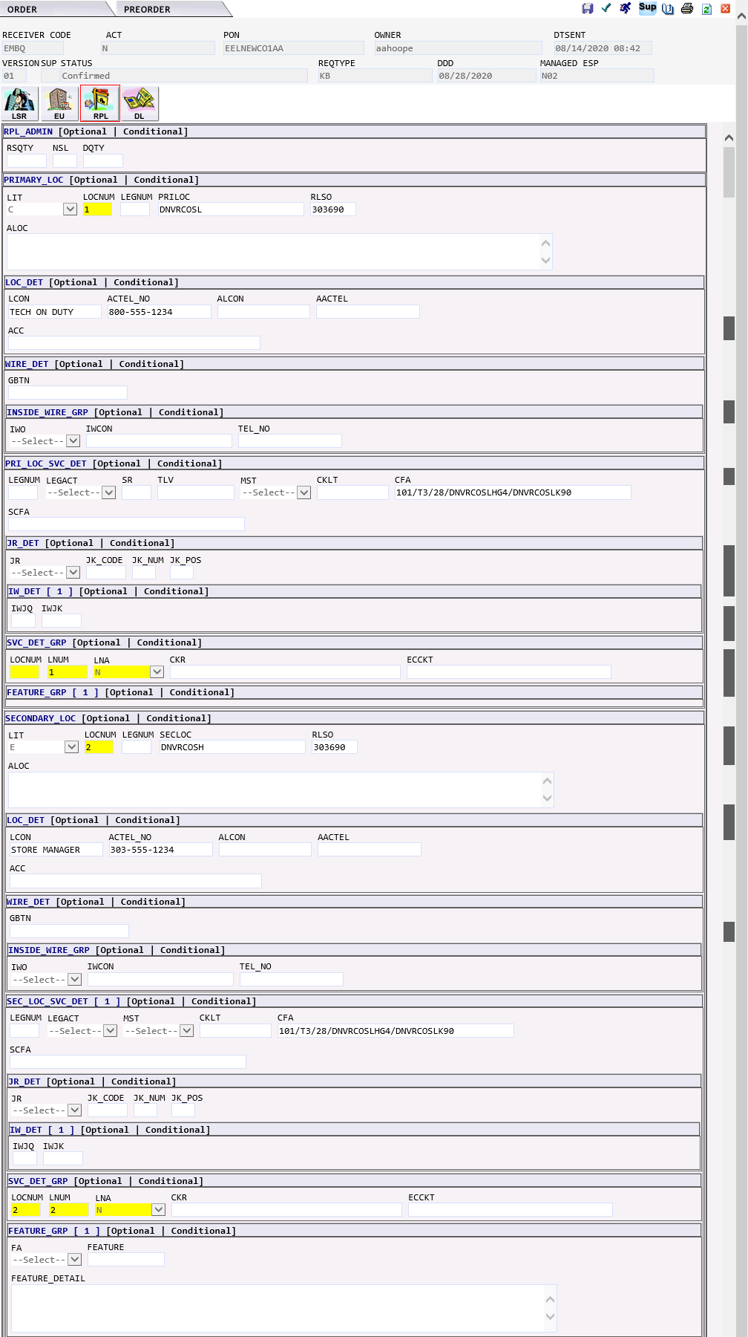  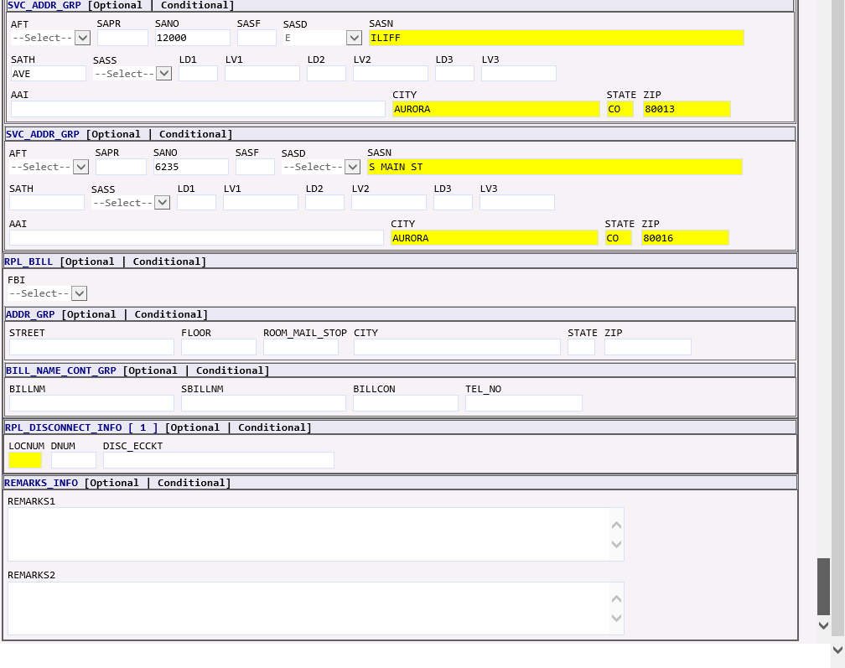

DL Form | 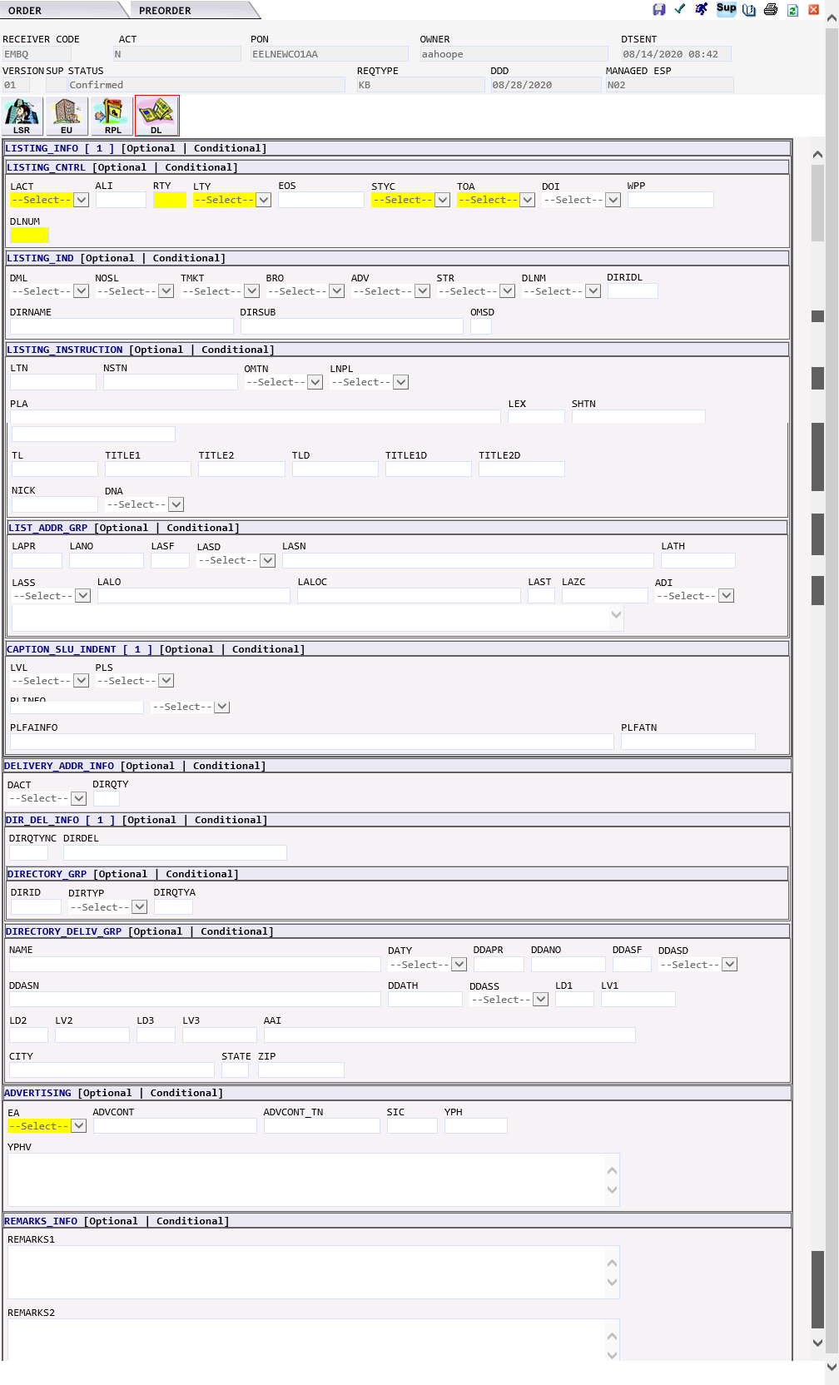

MB – Centrex 21 | The MB Combined Loop and Unbundled local switching (Port) request would generate the following forms in EASE:  - LSR  - EU – END USER  - HGI – HUNT GROUP INFORMATION  - RS – RESALE SERVICE  - CRS – CENTREX RESALE SERVICE  - DL – DIRECTORY LISTING

LSR Form | 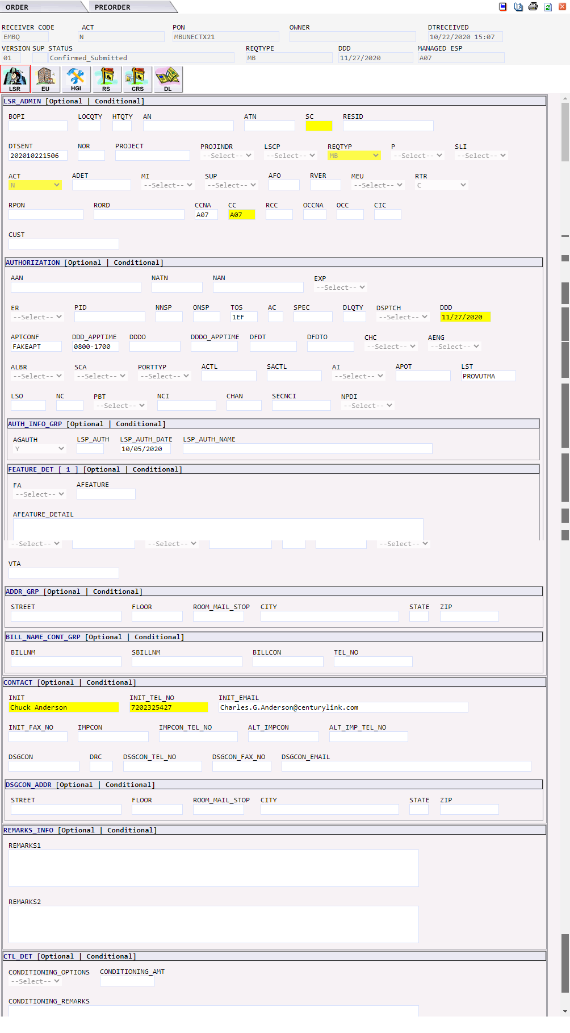

EU Form | 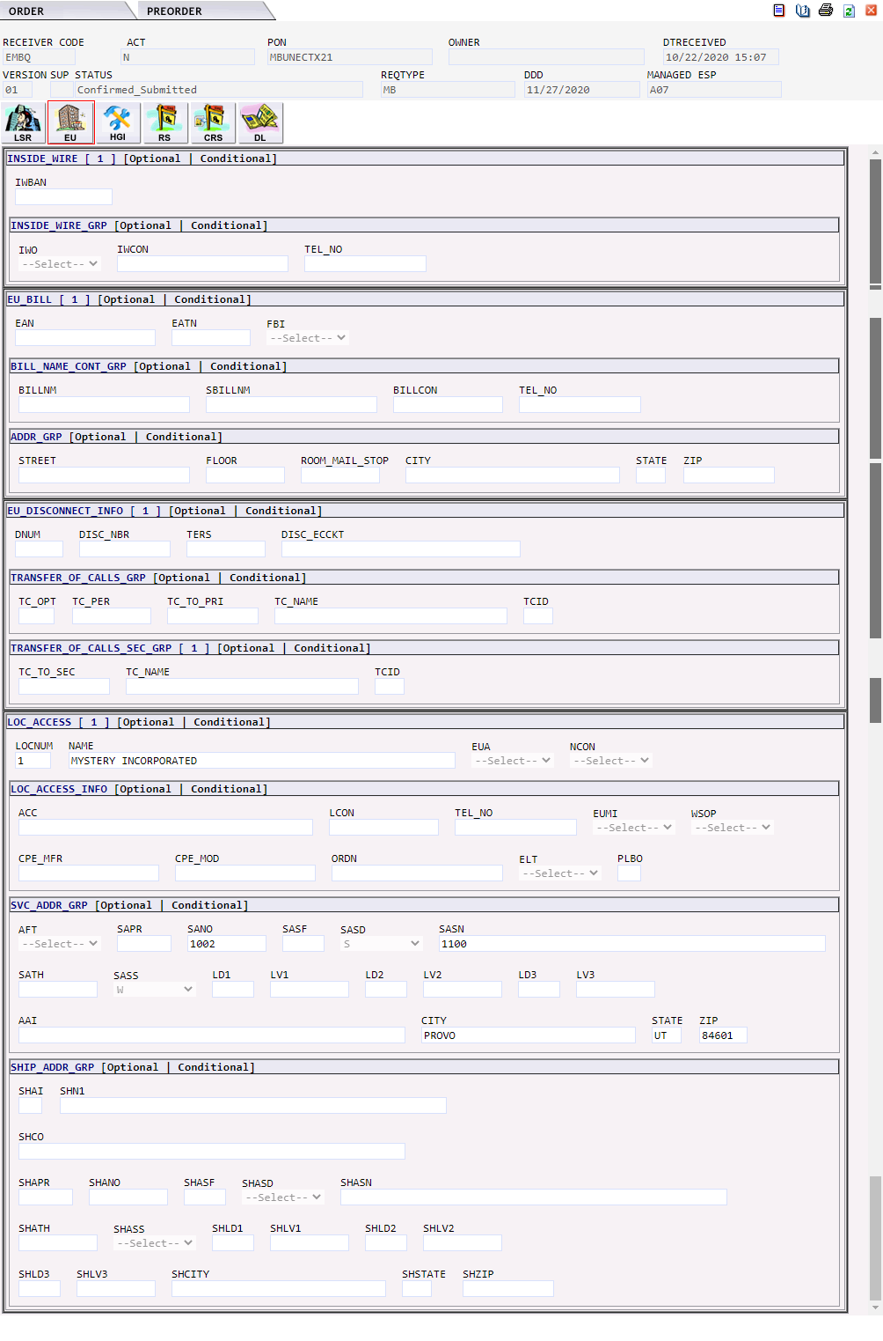

HGI Form | 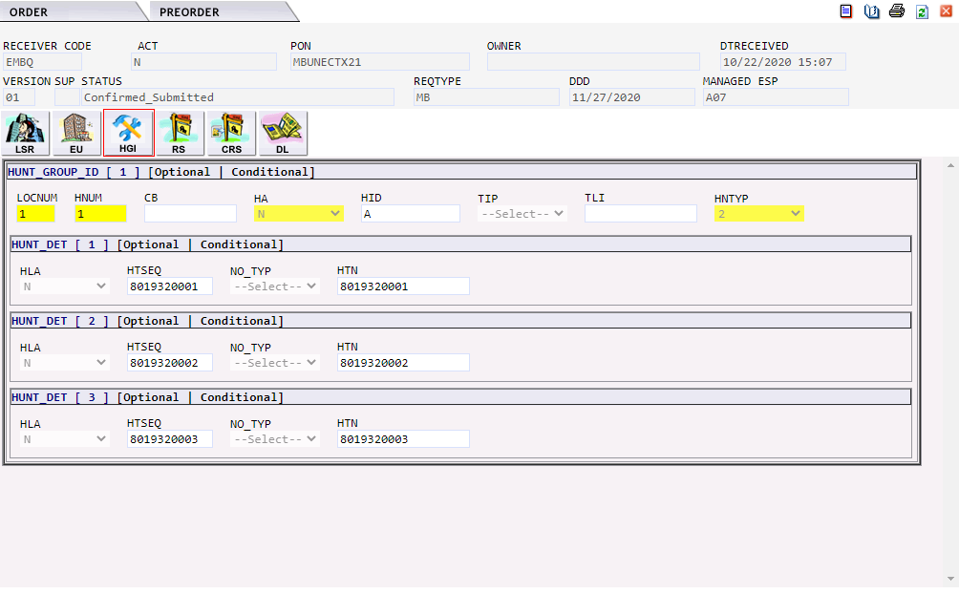

RS Form | 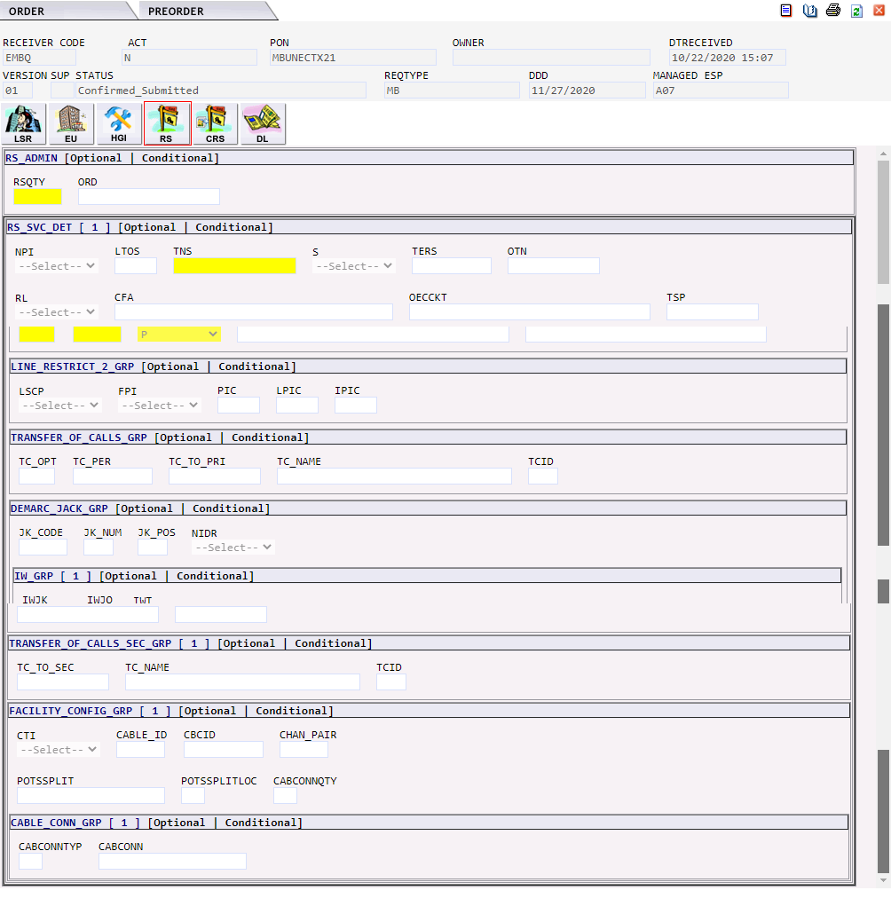

CRS Form | 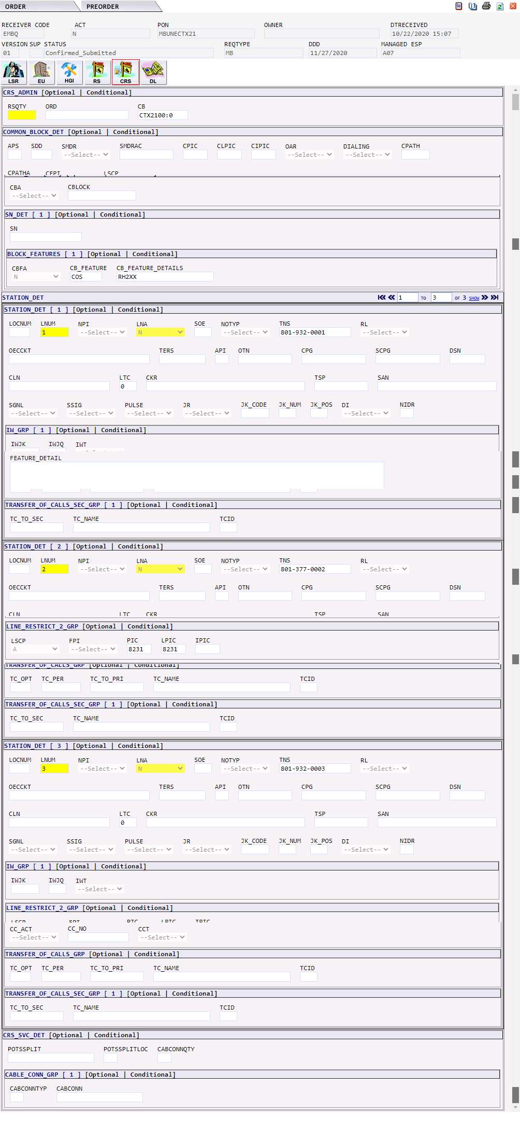

DL Form | 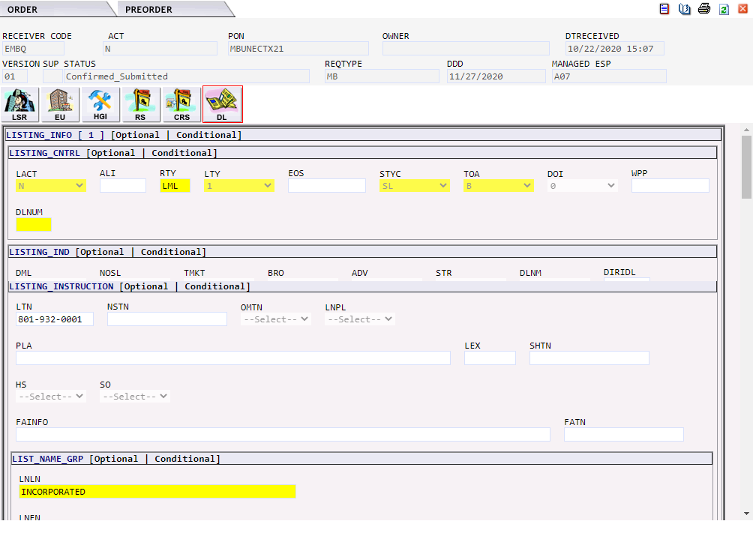

MB – UNE POTS | The MB Combined Loop and Unbundled local switching (Port) request would generate the following forms in EASE:  - LSR  - EU – END USER  - HGI – HUNT GROUP INFORMATION  - RS – RESALE SERVICE  - CRS – CENTREX RESALE SERVICE  - DL – DIRECTORY LISTING

LSR Form | 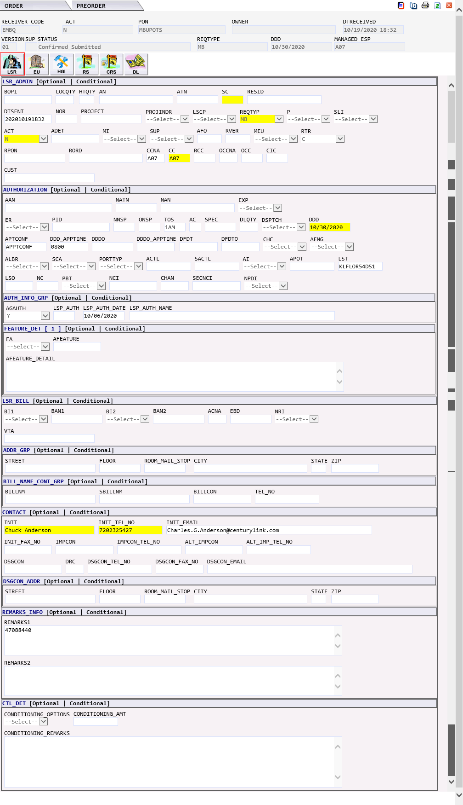

EU Form | 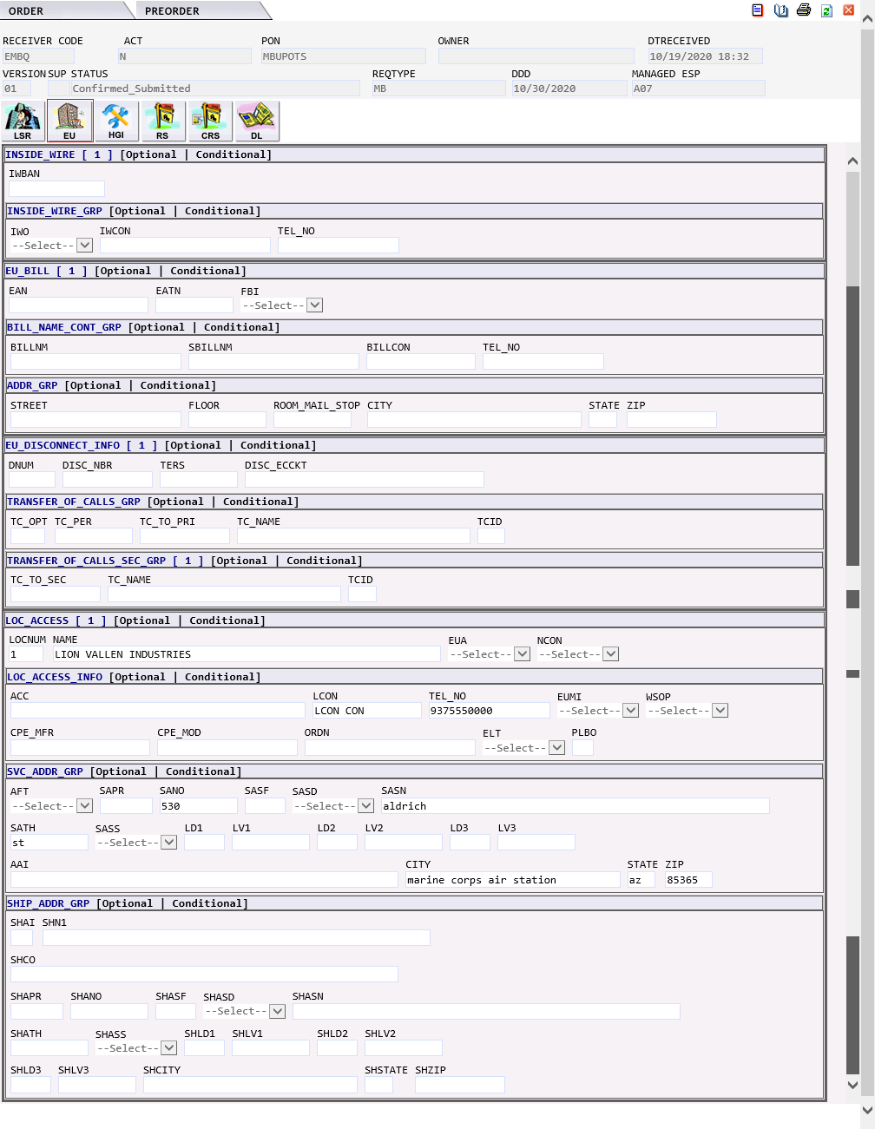

HGI Form | 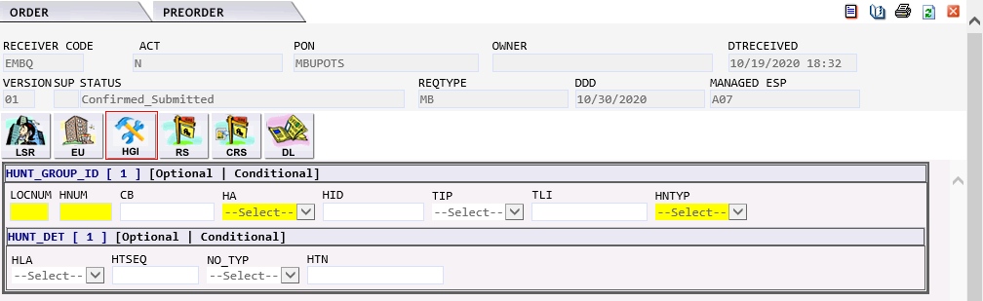

RS Form | 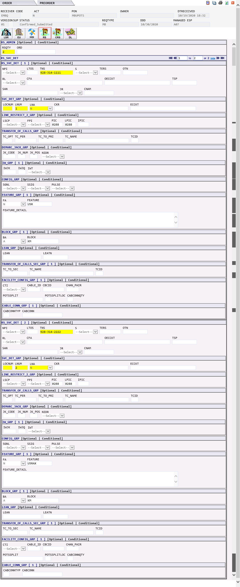

CRS Form | 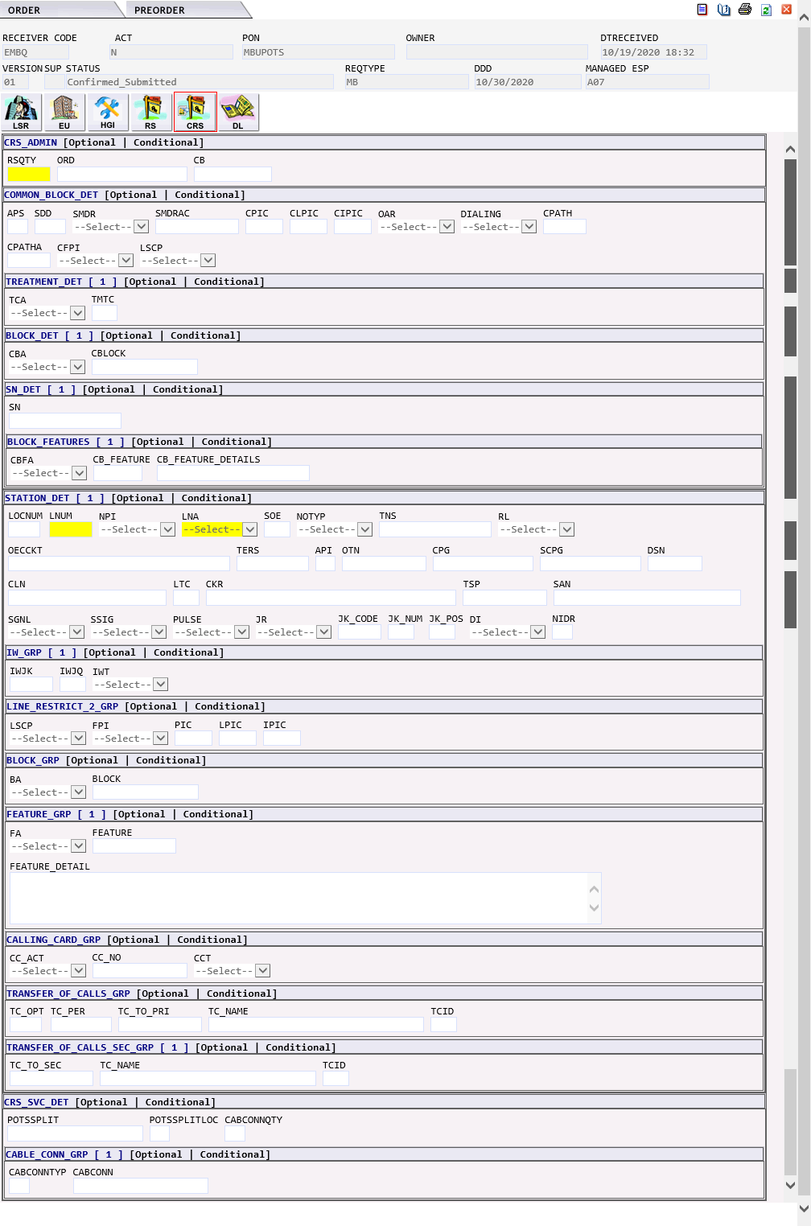

DL Form

NB - DID/DOD/PBX | The NB DID/DOD/PBX request would generate the following forms in EASE:  - LSR  - EU – END USER  - HGI – HUNT GROUP INFORMATION  - DDPS – DID/DOD/PORT SERVICE  - DL – DIRECTORY LISTING  Modifications for NB orders:  IMA EASE Modification  Field Form Field  LNUM RS RNUM Value is placed in the RNUM field on the RS form.  BA DDPS BA IMA value of E will become value of A  DGOUT DDPS DO Replaced by DO field  DIDNUM DDPS RNUM RNUM defines set of USOCs for that line (FEATURE GRP(s) defines USOC needed for that one line)  DPULSE DDPS PULSE Replaced by PULSE field  DRTI DDPS RIN Replaced by RIN field  DSGNL DDPS SSID Replaced by SSIG field (email sent)  DTGN DDPS TGN Replaced by TGN field  DTK DDPS TKQ Replaced by TKQ field  DTKACT DDPS TACT Replaced by TACT field  DTKID DDPS TKID Replaced by TKID field  DTLI DDPS LTLI Replaced by LTLI field  DTNR DDPS TNS Replaced by TNS field  DTNRACT DDPS TNA Replaced by TNA field  DTNRQ DDPS QN Replaced by QN field  LNA DDPS TNA DID/DOD GROUP  LNA DDPS TACT TRUNK GROUP  NPI DDPS NPI IMA value of Z now value of E for Port Within

LSR Form | 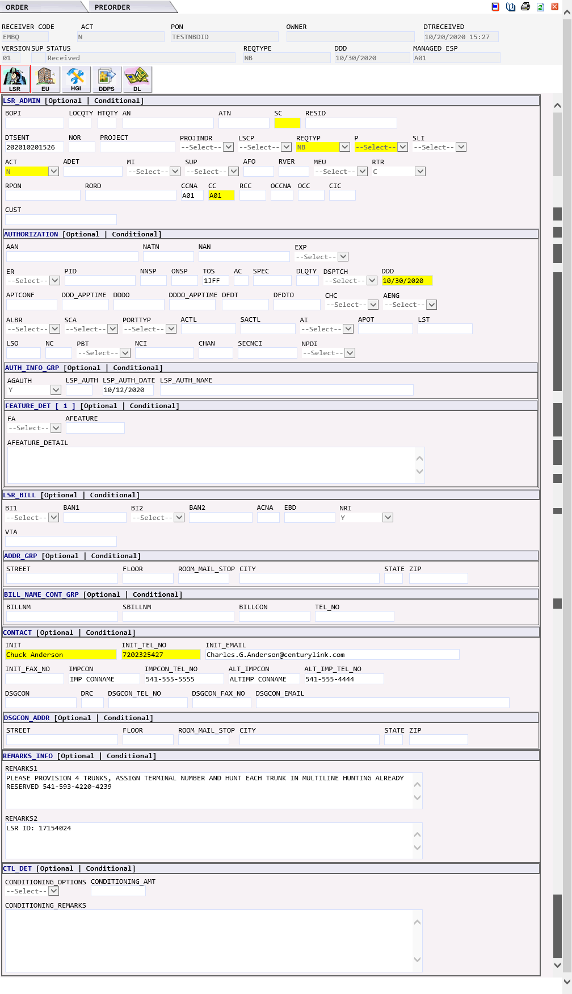

EU Form | 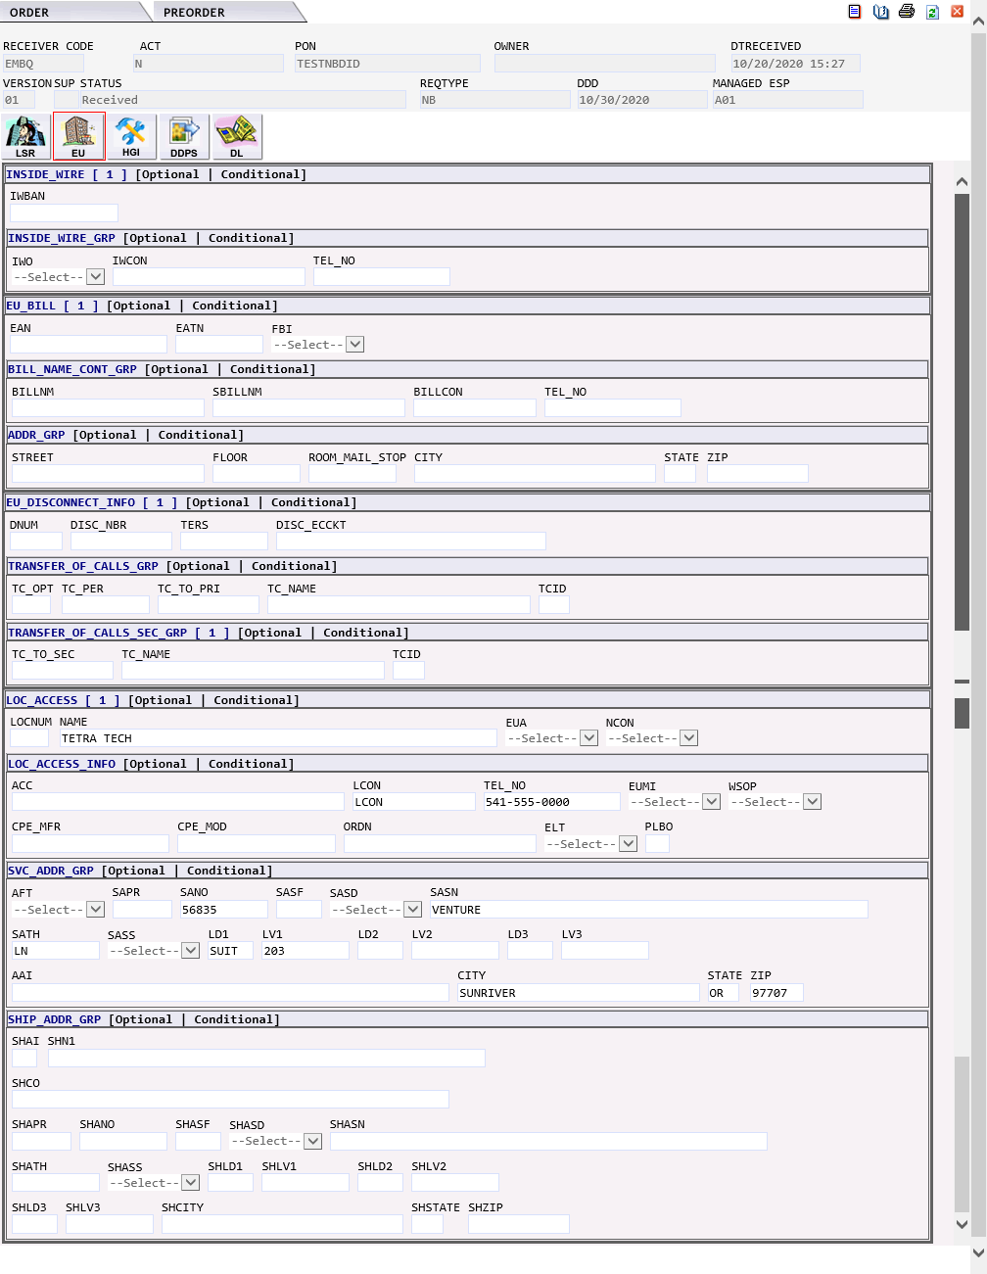

HGI Form | 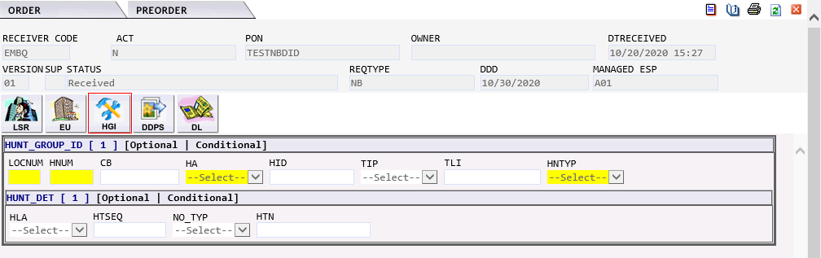

DDPS Form | 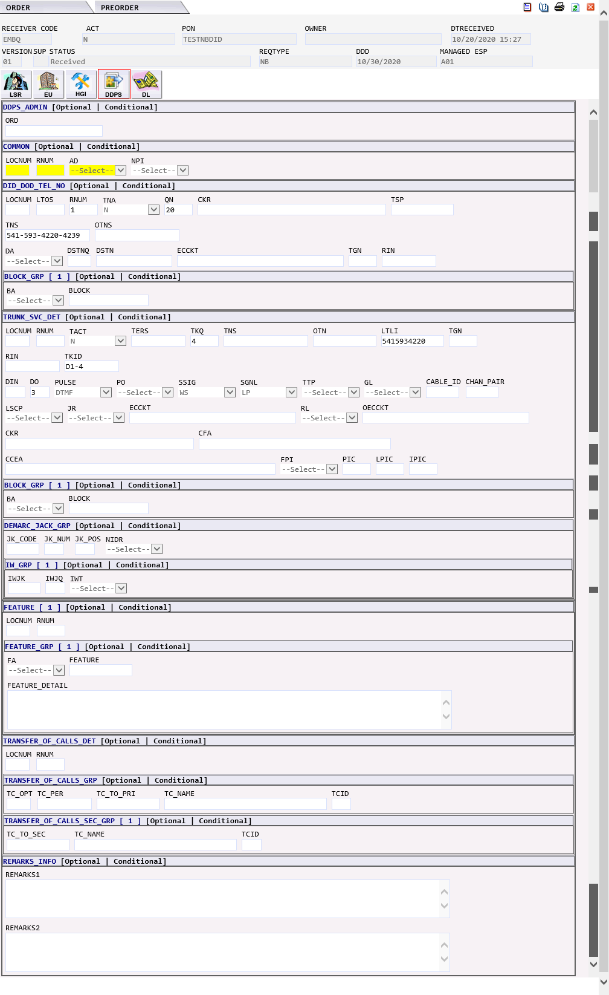

DL Form | 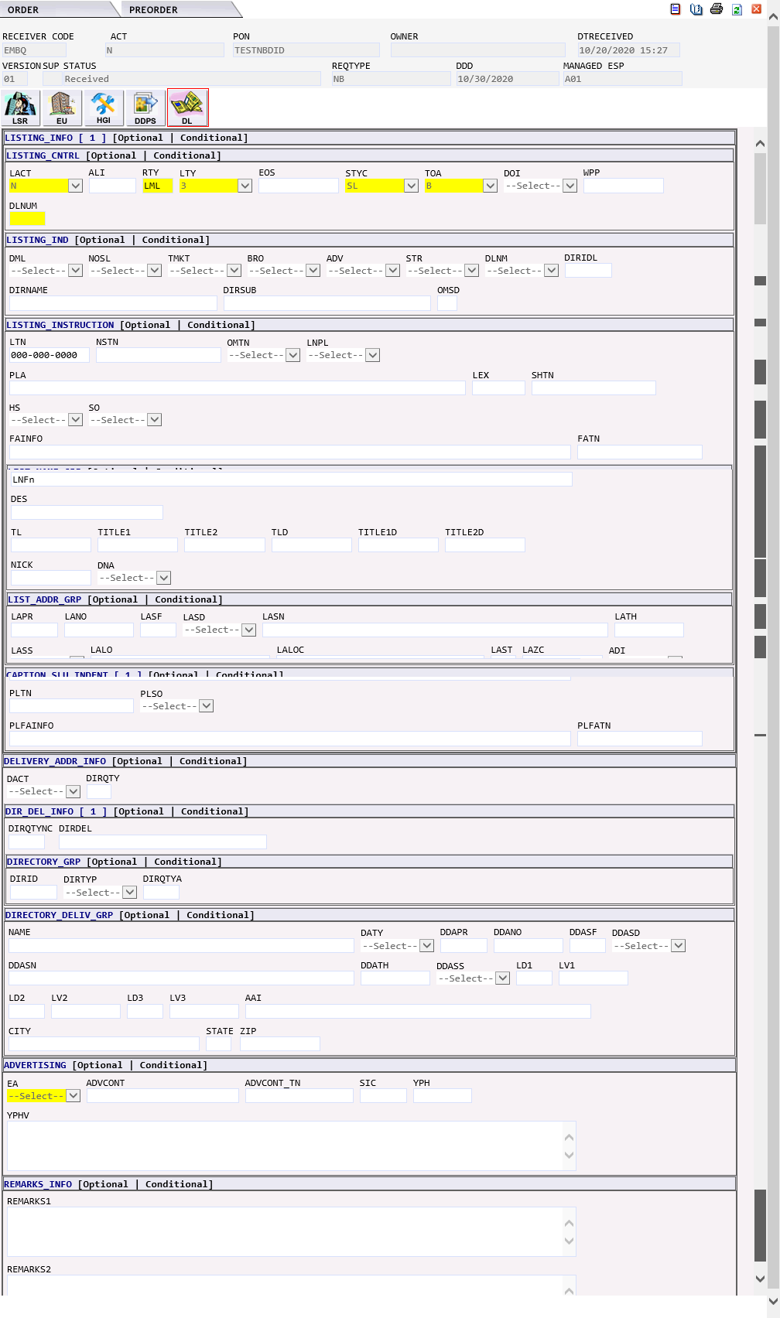

PB - CENTREX RESALE | The PB CENTREX Resale request would generate the following forms in EASE:  - LSR  - EU – END USER  - HGI – HUNT GROUP INFORMATION  - CRS – CENTREX RESALE SERVICE  - DL – DIRECTORY LISTING

LSR Form | 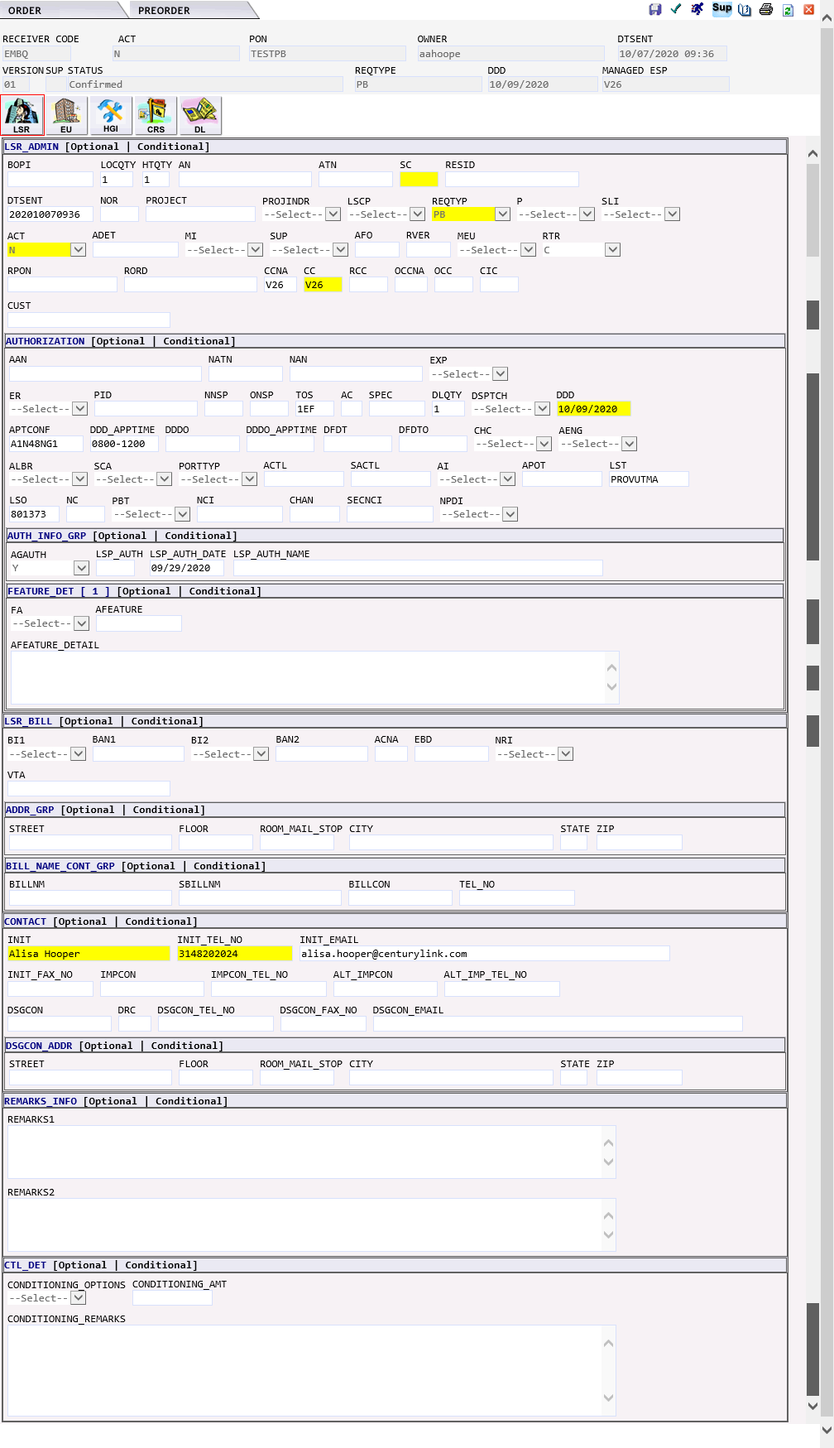

EU Form | 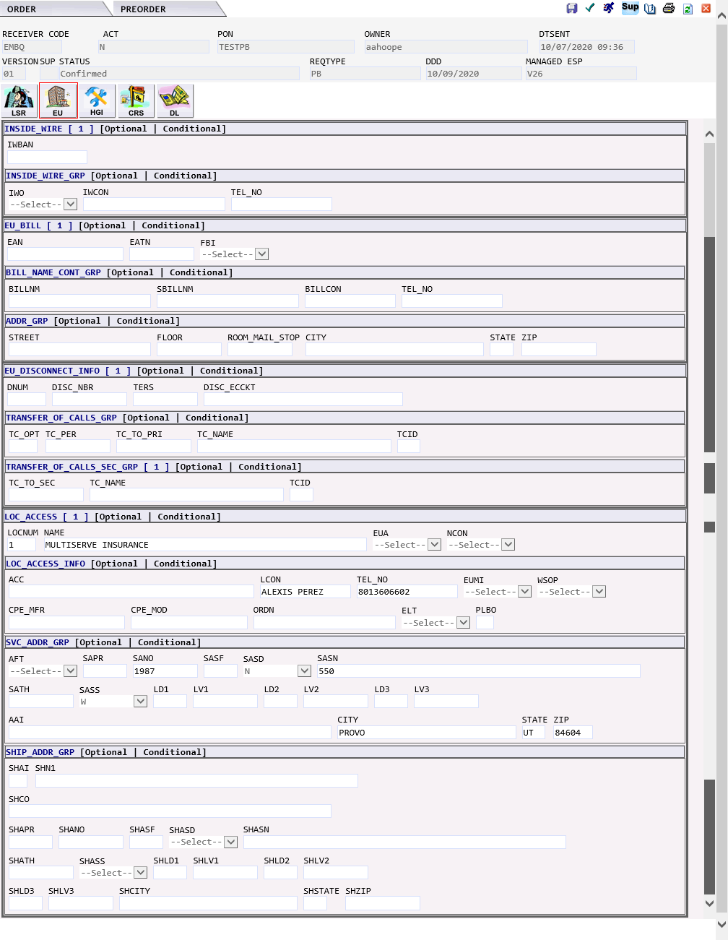

HGI Form | 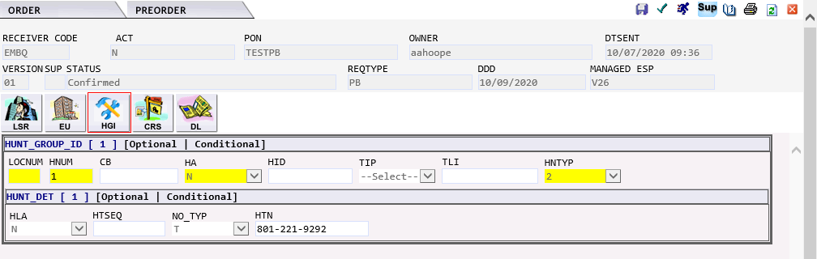

CRS Form | 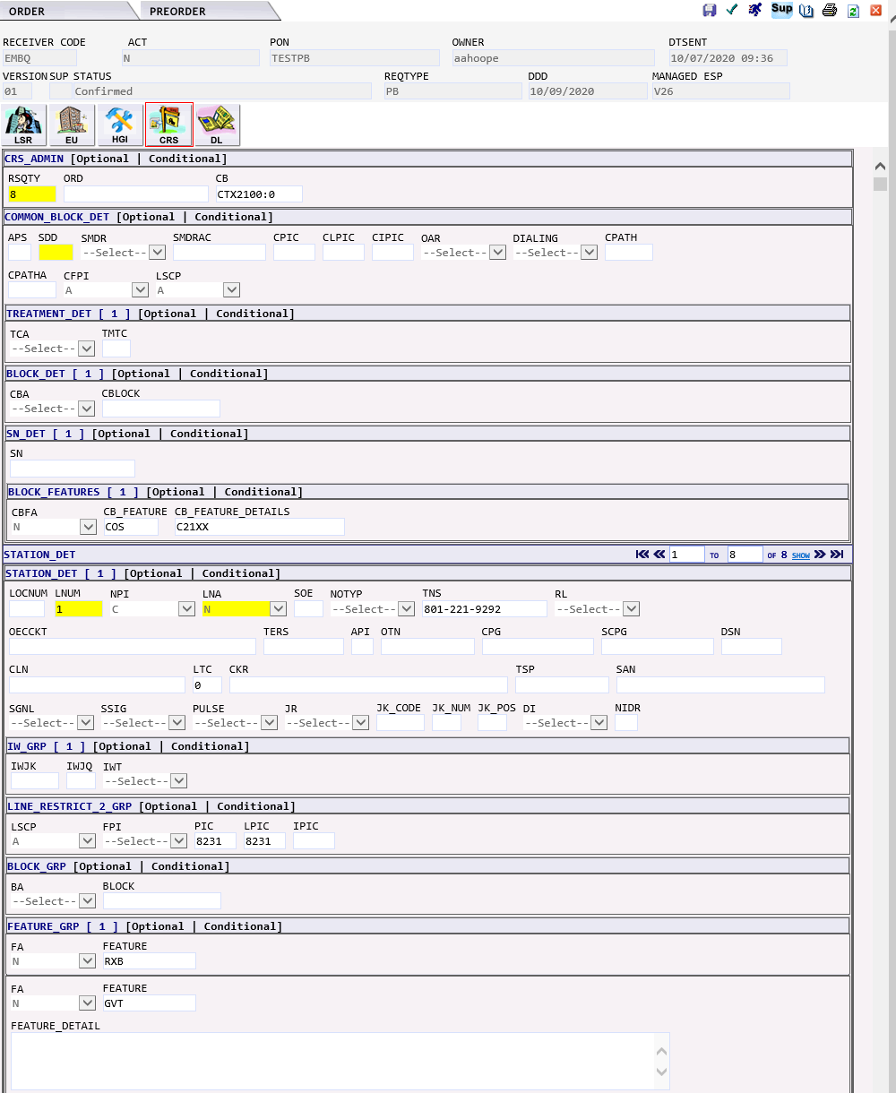  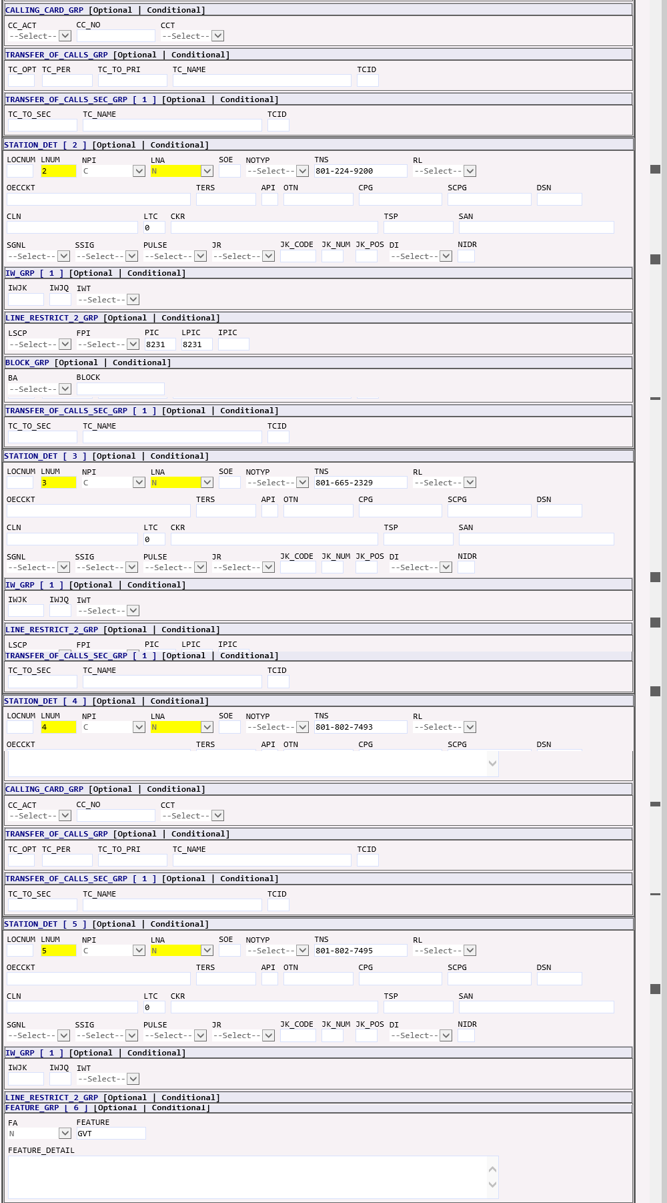  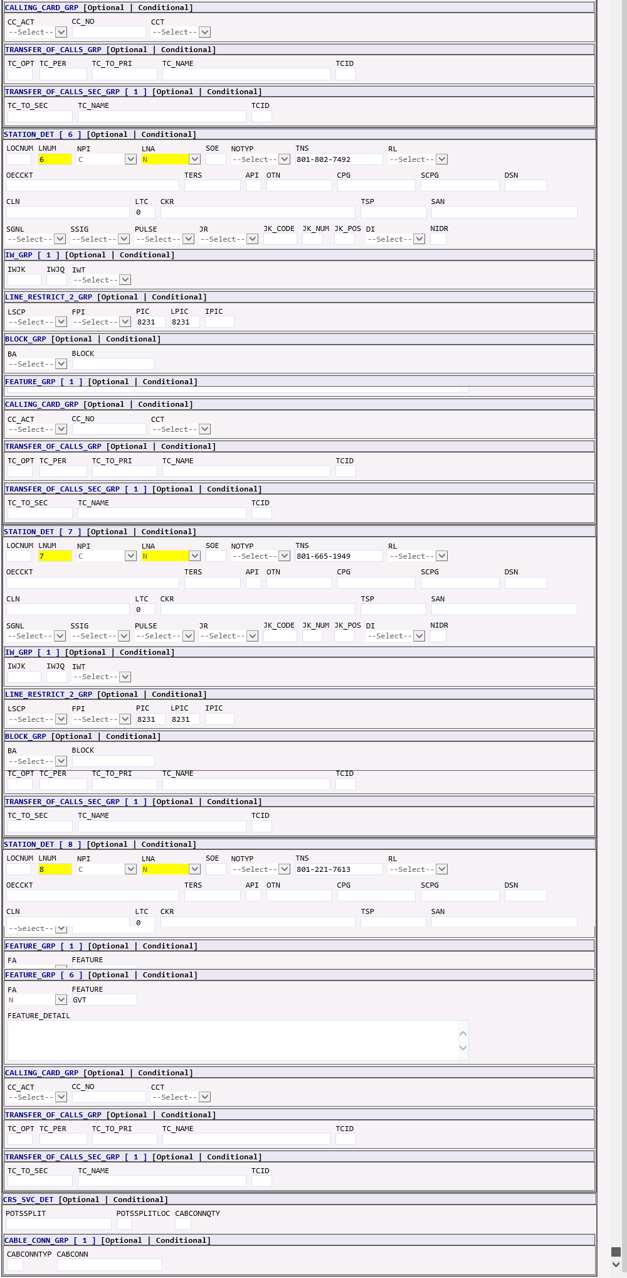

DL Form | 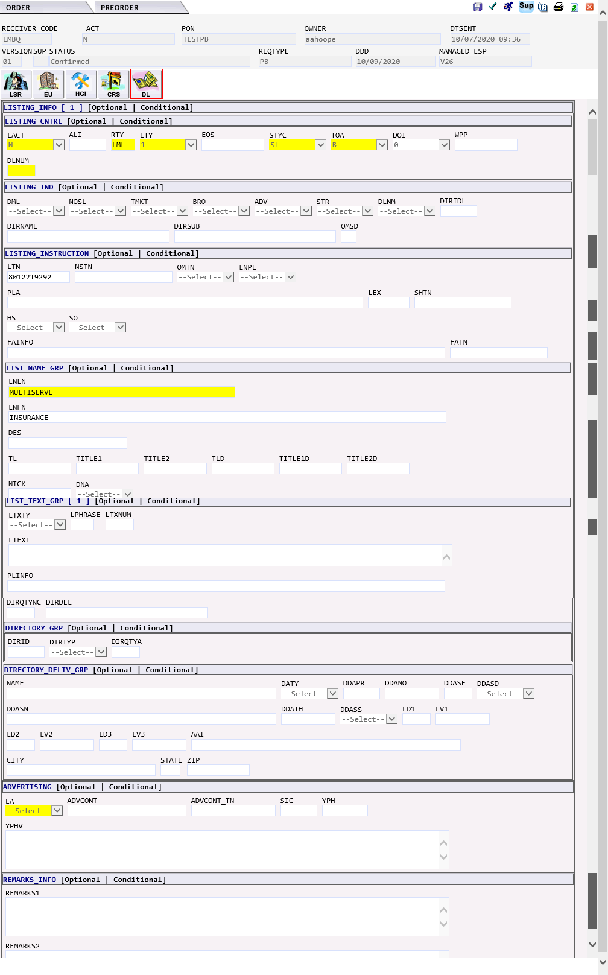

QB - ISDN | The QB ISDN request would generate the following forms in EASE:  - LSR  - EU – END USER  - HGI – HUNT GROUP INFORMATION  - IBPS – ISDN BRI PRI SERVICES  - DL – DIRECTORY LISTING

LSR Form | 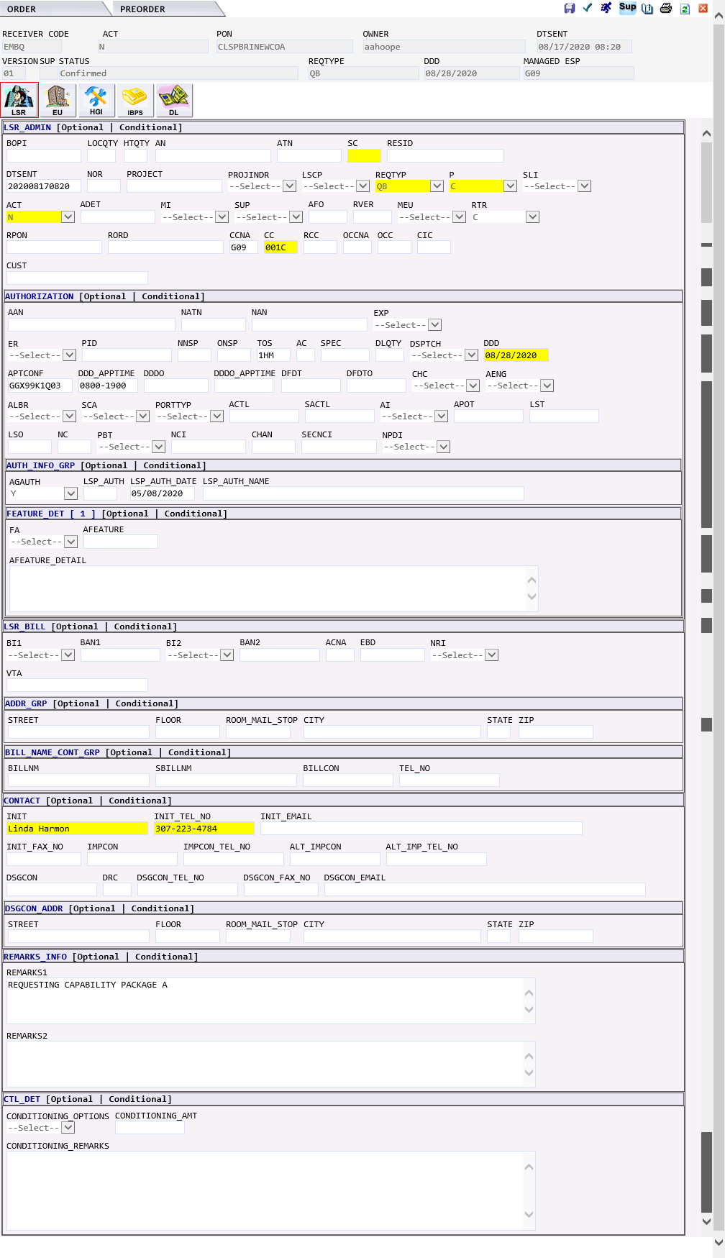

EU Form | 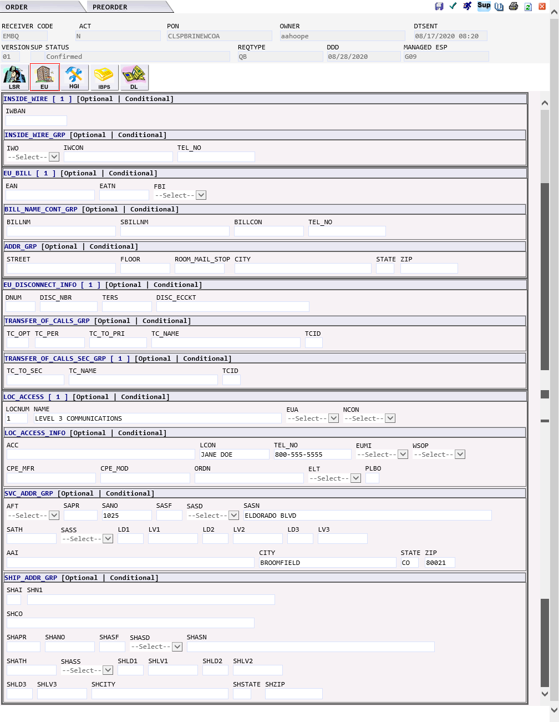

HGI Form | 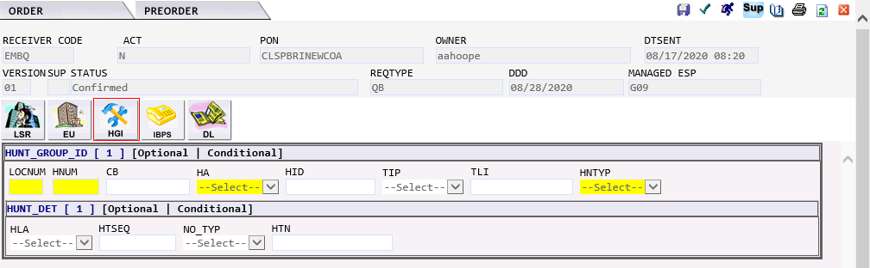

IBPS Form | 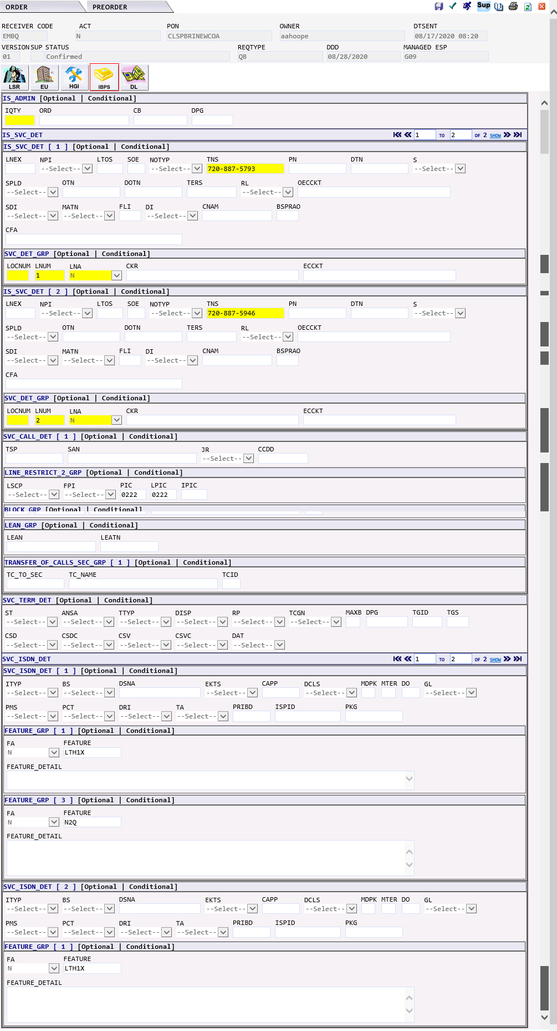

DL Form | 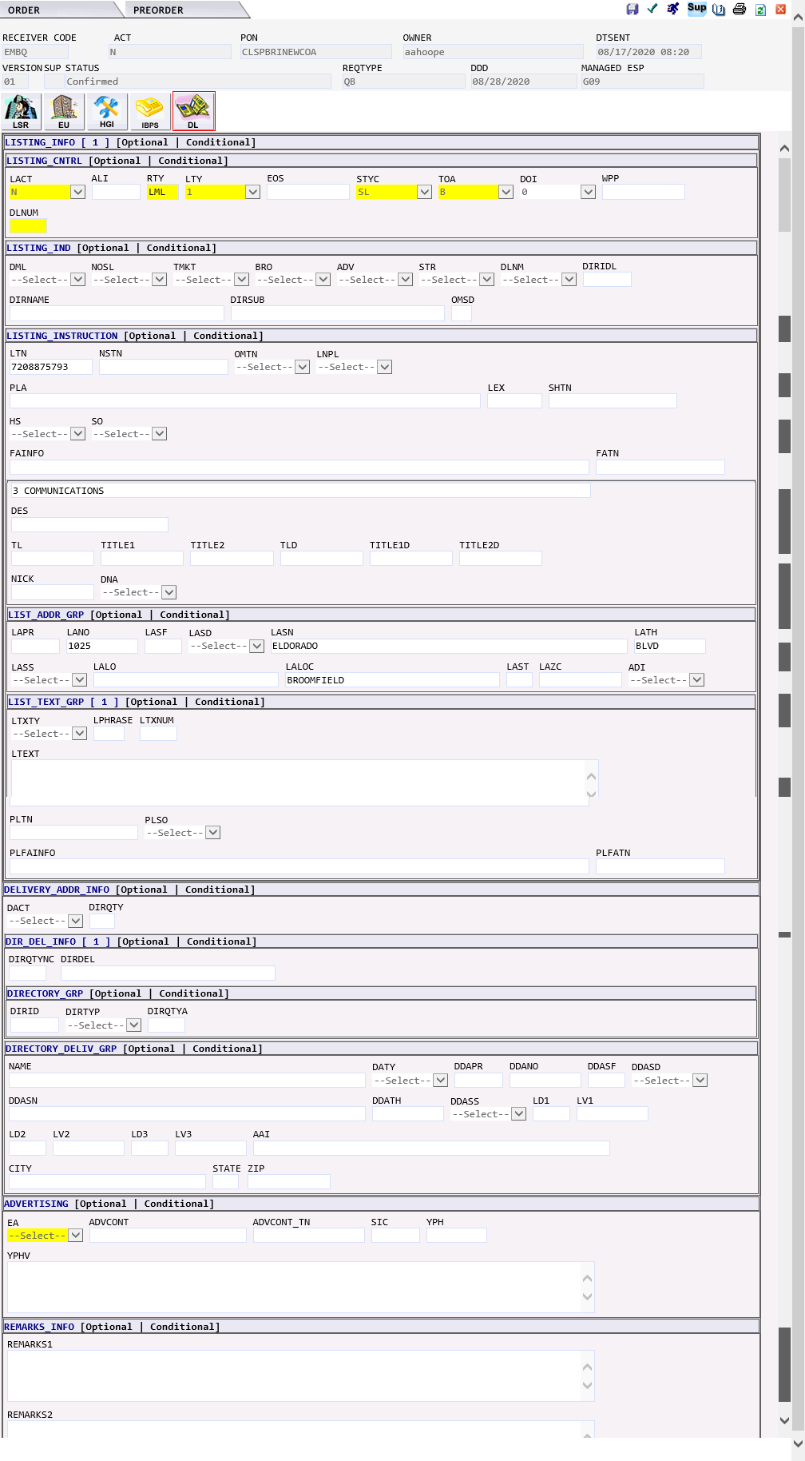

ZB - Bulk | The ZB BULK request would generate the following forms in EASE:  - LSR  - EU – END USER  - RS – RESALE SERVICE  IMA Field EASE Form EASE Field MODIFICATION TO ORDER  LSR CCNA RSID/OCN  LSR CC OCN (selected when order is created)  CONTACT CONTACT Limited to 15 characters

LSR Form | 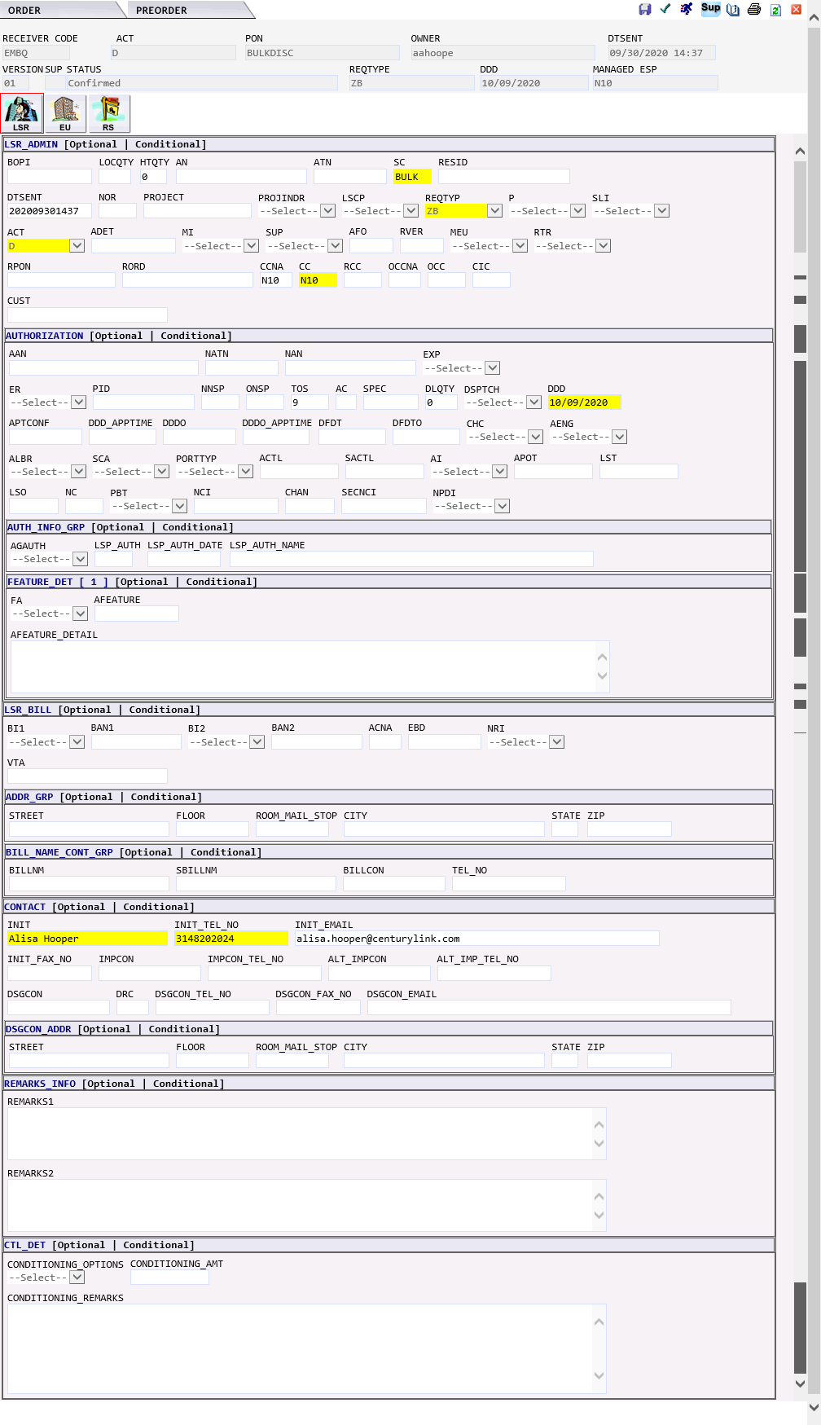

EU Form | 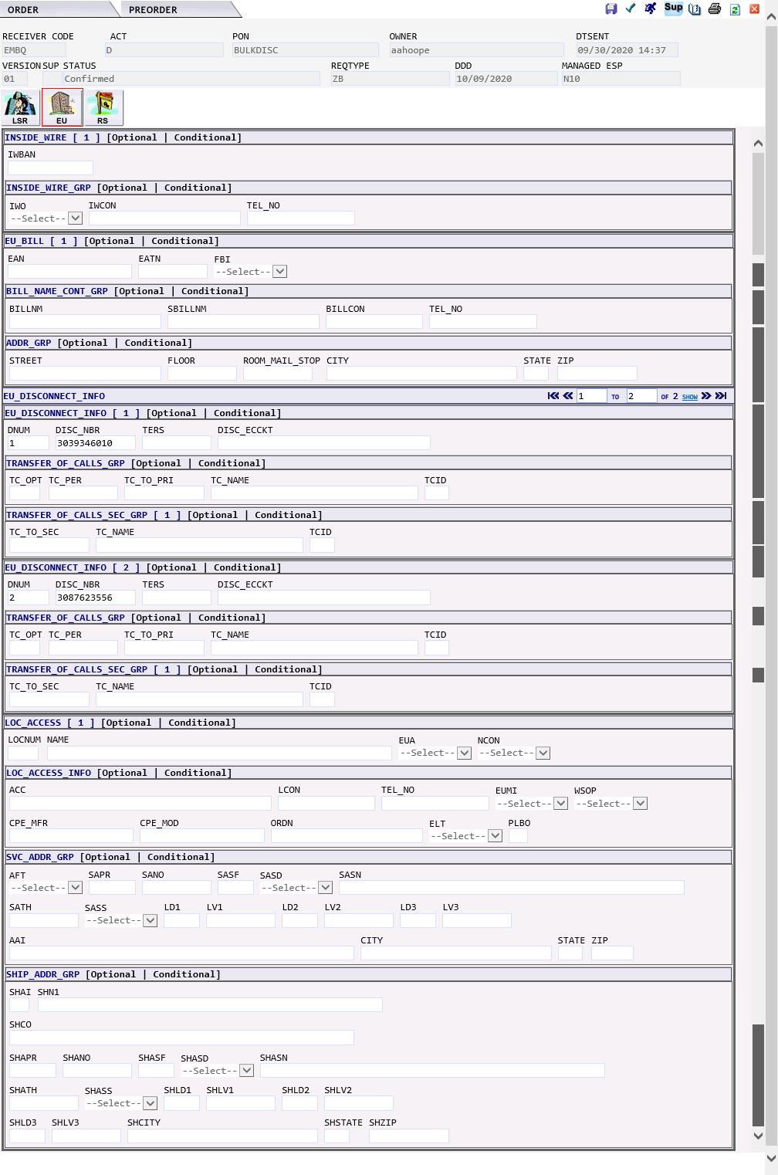

RS Form | 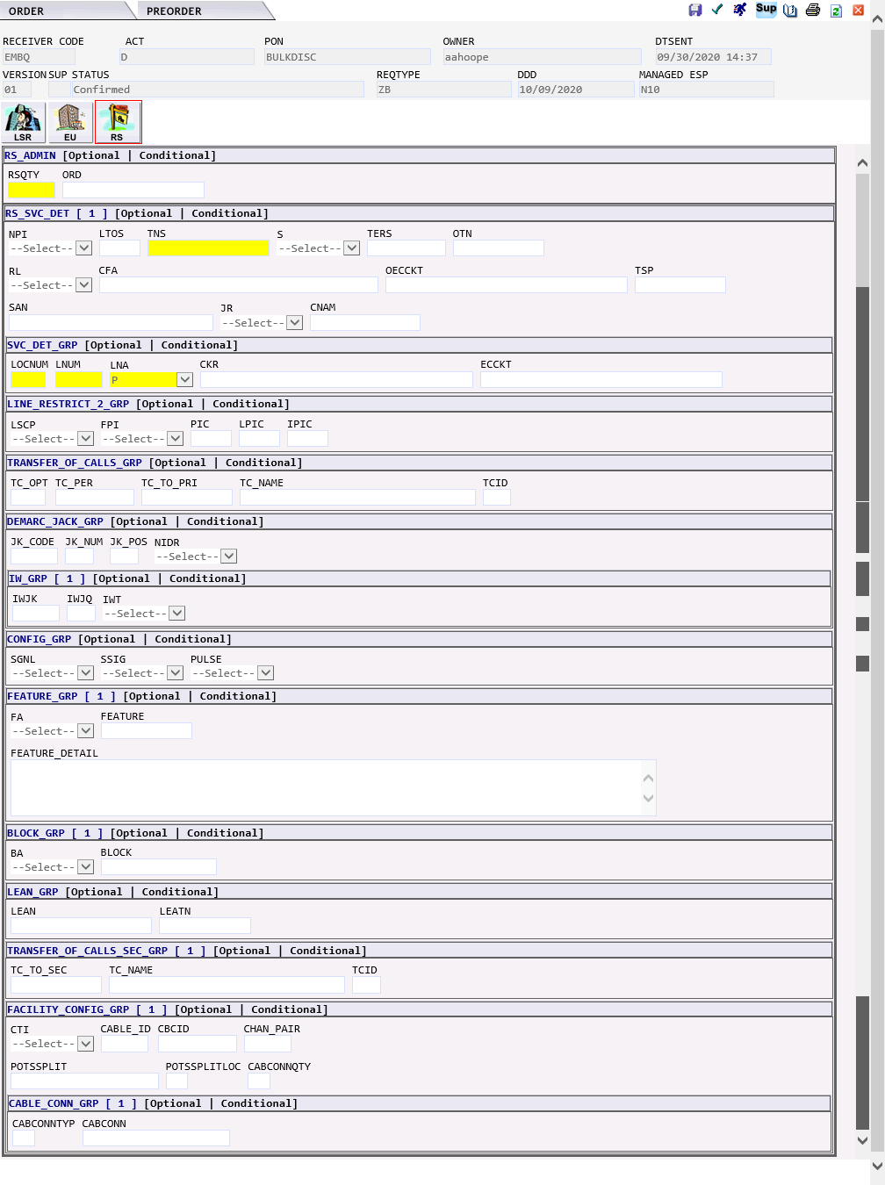

ZB - Bulk | The ZB BULK request would generate the following forms in EASE:  - LSR  - EU – END USER  - RS – RESALE SERVICE  - DL – DIRECTORY LISTING  - DU – DATA UNIFIED (NOT USED)  IMA Field EASE Form EASE Field MODIFICATION TO ORDER  LSR CCNA RSID/OCN  LSR CC OCN (selected when order is created)  CONTACT CONTACT Limited to 15 characters

LSR Form | 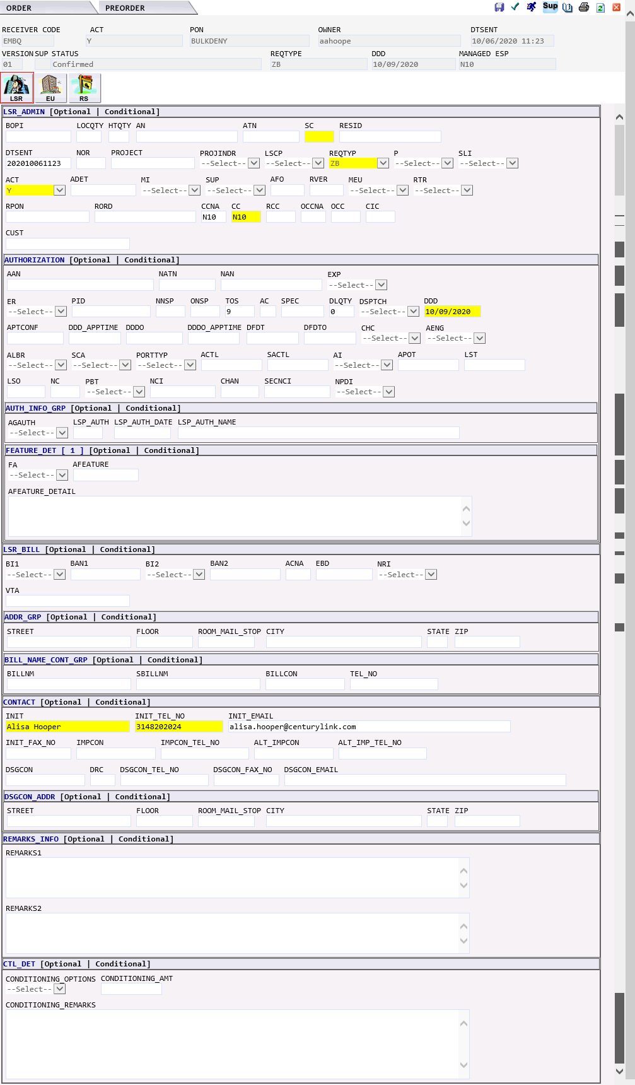

EU Form | 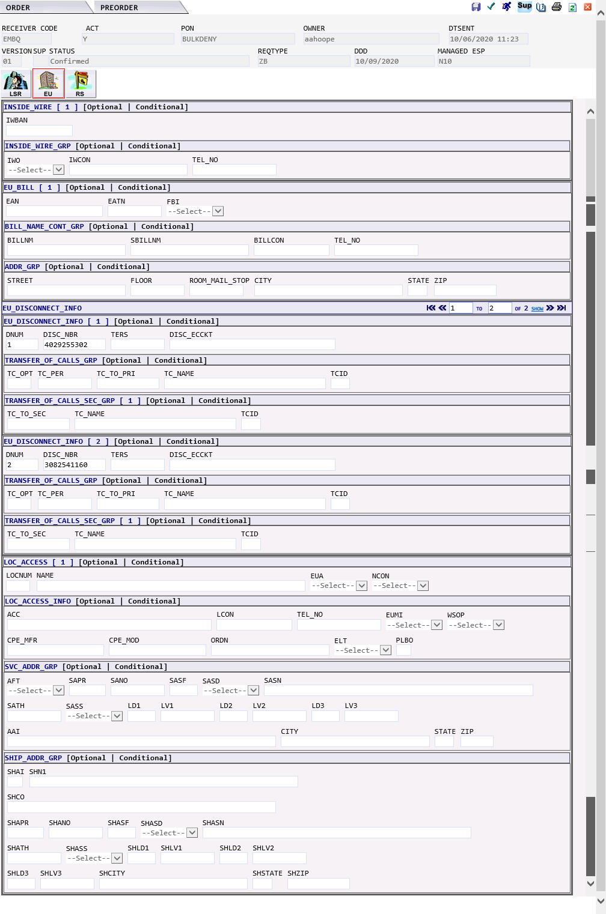

RS Form | 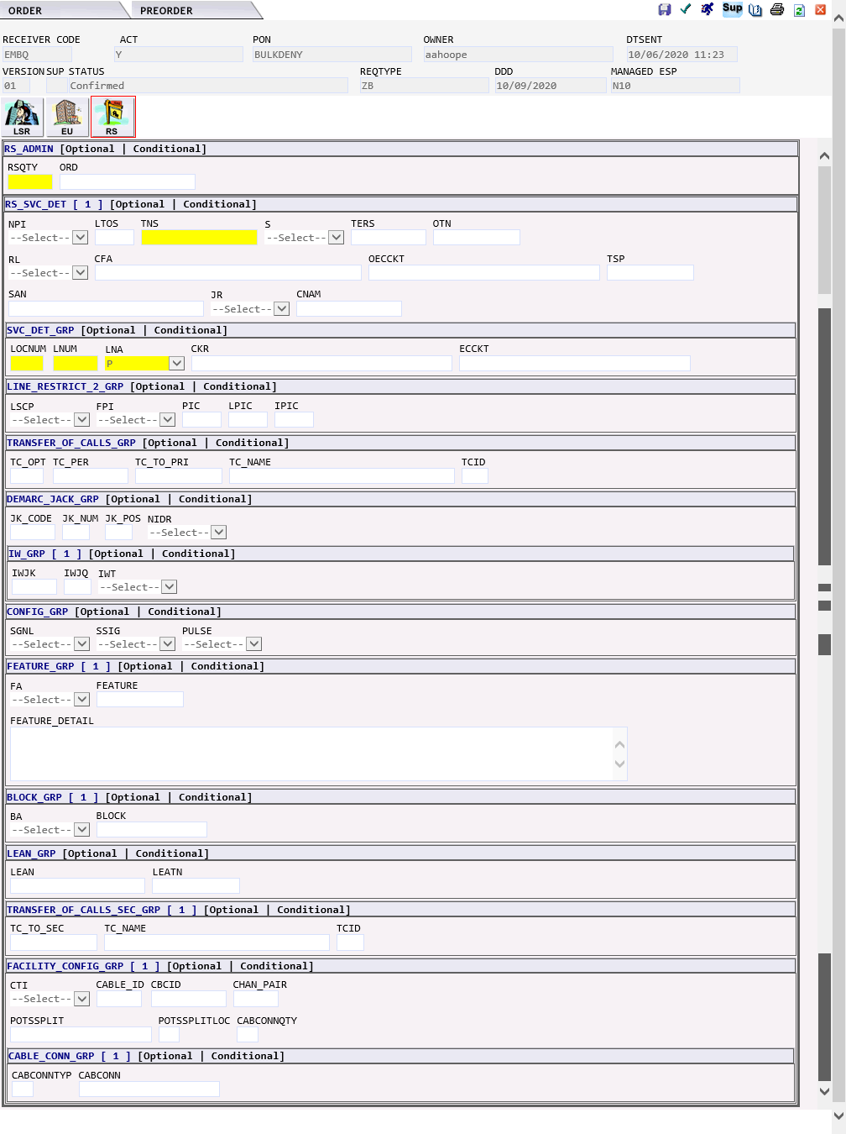

Response Type Matrix
Below is a mapping of the Response Type between IMA and EASE.

EASE |  | IMA
LSOG 2Q19 RESPONSE |  | Directory Listing (JB) Orders |  |  |  | Local Response (Non-Directory Listing (JB) ) Orders
RT | RT Detail | RT | RT Detail | LRC | LRCD | RT | RT Detail | LRC | LRCD
B | Firm order with facility information |  |  |  |  | B | Firm Order with Facility Information (72 Hour FOC)
C | Firm order confirmation | C | Acknowledge - With Detail NOChange (AC - Processed with Changes/Errors - CenturyLink Follow Up) | ULAC0C | Processed with Changes/ Errors - Qwest Follow Up | C | Firm Order Confirmation (FOC)
C | Firm order confirmation | W | Acknowledge - With Detail and Change (AC - Processed with Changes/Errors - CenturyLink Follow Up) | ULAD0C | Processed With Changes/Errors - Providcer Follow up | W | Bulk LSR Confirmation (CenturyLink specific value. GUI only)
D | Confirmation and DLR (private line) | n/a |  |  |  | D | Confirmation and DLR
D | Confirmation and DLR (private line) | n/a |  |  |  | X | Confirmation, DLR, and CDLR (CenturyLink specific value)
E | Errors only | E | Reject with Exception Detail only (RF-Initial Fatal Update on PON) | UL999F  ULRF0F | Listing Update Canceled  Fatal Update On PON | E | Errors Only
E | Errors only | N | Reject with Cancel (RF - Subsequent Fatal Update On PON) | UL999F  ULRF0F | Listing Update Canceled  Fatal Update On PON | Z | Reject Notice generated after the LSR is accepted by the IMA system (CenturyLink specific value)
I | LIDB confirmation | n/a |  |  |  | n/a
J | Jeopardy notice |  |  |  |  | J | Jeopardy Notice
L | Directory only completion | n/a |  |  |  | n/a
N | Confirmation of customer requested cancellation |  |  |  |  | N | Confirmation of customer requested cancellation (CenturyLink specific value)
P | Provider initiated | n/a |  |  |  | n/a
S | Provider initiated cancellation of the service request | n/a |  |  |  | S | Verbal Cancel
V | (CenturyLink specific value) Reject before acceptance - UOM ONLY VALUE | n/a |  |  |  | V | Reject Notice generated before the LSR is accepted by IMA system (CenturyLink specific value)
W | Post to billing system | n/a |  |  |  | n/a
Z | Completion | L | Accepted (AT - Confirmed Update On PON) | UL000C  ULAT0C | Confirmed Update on Listing, no error.  Confirmed Update on PON | A | Completion
 | NOT SUPPORTED AT CONVERSION | n/a |  |  |  | Y | FAX to FAX Gateway Confirmation |  | This will be grandfathered since FAX GATEWAY will be decommissioned

TOS Matrix
Below is a listing of existing TOS values from IMA.

Service, Product | TOS Value
Business | 1
Multi-line, Measured | 1AM
Multi-line, Flat Rate | 1AF
Single-Line, Measured | 1BM
Single-Line, Flat Rate | 1BF
Coin, Measured | 1CM
Coin, Flat Rate | 1CF
Advanced Services, Measured | 1DM
Advanced Services, Flat Rate | 1DF
CENTREX Resale, Measured | 1EM
CENTREX Resale, Flat Rate | 1EF
ISDN - BRI | 1H
ISDN - BRI, Measured | 1HM
ISDN - BRI, Flat Rate | 1HF
ISDN - BRI, Measured, Customer Requested FSO | 1HMF
ISDN - BRI, Flat Rate, Customer Requested FSO | 1HFF
PBX, Measured | 1JM
PBX, Flat Rate | 1JF
PBX, Message | 1JG
PBX, Measured, Customer Requested FSO | 1JMF
PBX, Flat Rate, Customer Requested FSO | 1JFF
PBX, Message, Customer Requested FSO | 1JGF
ISDN (PRI), Measured | 1KM
ISDN (PRI), Flat | 1KF
ISDN (PRI), Message | 1KG
ISDN (PRI), Measured, FX | 1KMF
ISDN (PRI), Flat, FX | 1KFF
ISDN (PRI), Message, FX | 1KGF
Qwest DSL, Flat Rate | 1MF
Loop Splitting | 1N
Unbundled Feeder Loop | 1O
Unbundled Distribution Loop | 1P
Shared Loop | 1R
Line Splitting | 1S
Residence | 2
Multi-line, Measured | 2AM
Multi-line, Flat Rate | 2AF
Single-Line, Measured | 2BM
Single-Line, Flat Rate | 2BF
Advanced Services, Measured | 2DM
Advanced Services, Flat Rate | 2DF
CENTREX Resale, Measured | 2EM
CENTREX Resale, Flat Rate | 2EF
ISDN - BRI | 2H
ISDN - BRI, Measured | 2HM
ISDN - BRI, Flat Rate | 2HF
ISDN - BRI, Measured, Customer Requested FSO | 2HMF
ISDN - BRI, Flat Rate, Customer Requested FSO | 2HFF
POTS PBX, Measured | 2JM
POTS PBX, Flat Rate | 2JF
Qwest DSL, Flat Rate | 2MF
Loop Splitting | 2N
Unbundled Feeder Loop | 2O
Unbundled Distribution Loop | 2P
Shared Loop | 2R
Line Splitting | 2S
Government | 3
Multi-line, Measured | 3AM
Multi-line, Flat Rate | 3AF
Single-Line, Measured | 3BM
Single-Line, Flat Rate | 3BF
Coin, Measured | 3CM
Coin, Flat Rate | 3CF
Advanced Services, Measured | 3DM
Advanced Services, Flat Rate | 3DF
CENTREX Resale, Measured | 3EM
CENTREX Resale, Flat Rate | 3EF
ISDN - BRI | 3H
ISDN - BRI, Measured | 3HM
ISDN - BRI, Flat Rate | 3HF
ISDN - BRI, Measured, Customer Requested FSO | 3HMF
ISDN - BRI, Flat Rate, Customer Requested FSO | 3HFF
PBX, Measured | 3JM
PBX, Flat Rate | 3JF
PBX, Message | 3JG
PBX, Measured, Customer Requested FSO | 3JMF
PBX, Flat Rate, Customer Requested FSO | 3JFF
PBX, Message, Customer Requested FSO | 3JGF
ISDN (PRI), Measured | 3KM
ISDN (PRI), Flat | 3KF
ISDN (PRI), Message | 3KG
ISDN (PRI), Message, FX | 3KMF
ISDN (PRI), Flat, FX | 3KFF
ISDN (PRI), Message, FX | 3KGF
Loop Splitting | 3N
Unbundled Feeder Loop | 3O
Unbundled Distribution Loop | 3P
Shared Loop | 3R
Line Splitting | 3S
Smart PAL | 4C
Basic PAL | 4L
Bulk | 9

BLOCK Value Matrix
Below is a listing of existing BLOCK values from IMA.
A = No collect and third party
B = No third party
C = No collect call
D = No 1+
E = No 0+ Local
F = No 1+ and 0+ Local
G = No 011 (International)
H = No Directory Assistance, Call Completion (DACC)
K = No 976
M = No 900
N = No casual calling
Q = No 411
0 = Screen 0+
2 = No call trace
3 = No continuos redial
4 = No continuos redial deluxe
5 = No I-Called – originating
6 = No I-Called – terminating
7 = No last call return
8 = No 3-Way calling
9 = Screen all casual calling

Custom BRMS Rules
Below is a listing of additional edits that have been added to support the entry of IMA orders in EASE.

LSR FORM | FIELD | BRMS ERROR | ERROR DETAIL | BRMS ENGLISH EXPLAINATION
LSR | CC | EQL4 | CENTURYLINK REQUIRES CC, AND THE CC MUST BE ENTERED IN UPPERCASE | CC field must be populated
LSR | INIT | EQL860 | MAXIMUM LENGTH FOR INIT IS 15 CHARACTERS. | Field length limited to 15 characters
LSR | LSP AUTH NAME | EQL861 | MAXIMUM LENGTH FOR LSP AUTH NAME IS 15 CHARACTERS. | Field length limited to 15 characters
CRS | CBFA | QW001 | CBFA MUST BE POPULATED. | Field must be populated if the CB FEATURE or CB FEATURE DETAIL fields are populated
CRS | CB FEATURE | QW002 | CB FEATURE MUST BE POPULATED. | Field must be populated if the CBFA or CB FEATURE DETAIL fields are populated
CRS | CB FEATURE DETAIL | QW003 | CB FEATURE DETAIL MUST BE POPULATED. | Field must be populated if the CBFA or CB FEATURE fields are populated
DL | LD2 | QW004 | INVALID ENTRY IN LD2: CAN ONLY BE FLR. | Correct value to FLR
EU | LD2 | QW004 | INVALID ENTRY IN LD2: CAN ONLY BE FLR. | Correct value to FLR
EU - SHIPPING | SHLD2 | QW004 | INVALID ENTRY IN LD2: CAN ONLY BE FLR. | Correct value to FLR
LSR | MI | QW005 | MI FIELD MUST BE POPULATED WITH A OR B WHEN ACT= T. | MI field must be populated with A or B on ACT = T
CRS | TC OPT | QW006 | INVALID ENTRY: TC OPT MUST BE A SINGLE CHARACTER AND CANNOT BE O. | Allow 1 character and prohibit value of O
DDPS - Transfer of Calls Details | TC OPT | QW006 | INVALID ENTRY: TC OPT MUST BE A SINGLE CHARACTER AND CANNOT BE O. | Allow 1 character and prohibit value of O
EU - DISCONNECT INFORMATION | TC OPT | QW006 | INVALID ENTRY: TC OPT MUST BE A SINGLE CHARACTER AND CANNOT BE O. | Allow 1 character and prohibit value of O
IS | TC OPT | QW006 | INVALID ENTRY: TC OPT MUST BE A SINGLE CHARACTER AND CANNOT BE O. | Allow 1 character and prohibit value of O
LS | TC OPT | QW006 | INVALID ENTRY: TC OPT MUST BE A SINGLE CHARACTER AND CANNOT BE O. | Allow 1 character and prohibit value of O
NP | TC OPT | QW006 | INVALID ENTRY: TC OPT MUST BE A SINGLE CHARACTER AND CANNOT BE O. | Allow 1 character and prohibit value of O
RS | TC OPT | QW006 | INVALID ENTRY: TC OPT MUST BE A SINGLE CHARACTER AND CANNOT BE O. | Allow 1 character and prohibit value of O
CRS | TERS | QW007 | MAXIMUM LENGTH FOR TERS IS 4 CHARACTERS. | Field length limited to 4 characters
DDPS - Trunk Service Detail | TERS | QW007 | MAXIMUM LENGTH FOR TERS IS 4 CHARACTERS. | Field length limited to 4 characters
EU - DISCONNECT INFORMATION | TERS | QW007 | MAXIMUM LENGTH FOR TERS IS 4 CHARACTERS. | Field length limited to 4 characters
HGI | TLI | QW007 | MAXIMUM LENGTH FOR TERS IS 4 CHARACTERS. | Field length limited to 10 characters
IS | TERS | QW007 | MAXIMUM LENGTH FOR TERS IS 4 CHARACTERS. | Field length limited to 4 characters
RS | TERS | QW007 | MAXIMUM LENGTH FOR TERS IS 4 CHARACTERS. | Field length limited to 4 characters
DL | DDAPR | QW008 | MAXIMUM LENGTH FOR DDAPR IS 5 CHARACTERS. | Allow maximum of 5 characters
DL | LTEXT | QW009 | MAXIMUM LENGTH FOR LTEXT IS 100 CHARACTERS. | Field length limited to 100 characters
LSNP | PORTED NBR | QW010 | MAXIMUM LENGTH FOR PORTED NBR IS 12 CHARACTERS. | Field length limited to 12 characters
DDPS - Trunk Service Detail | OTN | QW011 | MAXIMUM LENGTH FOR OTN IS 12 CHARACTERS IN FORMAT ***-***-****. | Field length limited to 12 characters including dashes in positions 4 and 8
DDPS - DID/DOD Telephone Number Section | OTNS | QW012 | MAXIMUM LENGTH FOR OTNS IS 12 CHARACTERS IN FORMAT ***-***-****. | Field length limited to 12 characters including dashes in positions 4 and 8
CRS | TNS | QW013 | MAXIMUM LENGTH FOR TNS IS 12 CHARACTERS IN FORMAT ***-***-****. | Field length limited to 12 characters including dashes in positions 4 and 8
DDPS - DID/DOD Telephone Number Section | TNS | QW013 | MAXIMUM LENGTH FOR TNS IS 12 CHARACTERS IN FORMAT ***-***-****. | Field length limited to 12 characters including dashes in positions 4 and 8
DDPS - Trunk Service Detail | TNS | QW013 | MAXIMUM LENGTH FOR TNS IS 12 CHARACTERS IN FORMAT ***-***-****. | Field length limited to 12 characters including dashes in positions 4 and 8
IS | TNS | QW013 | MAXIMUM LENGTH FOR TNS IS 12 CHARACTERS IN FORMAT ***-***-****. | Field length limited to 12 characters including dashes in positions 4 and 8
RS | TNS | QW013 | MAXIMUM LENGTH FOR TNS IS 12 CHARACTERS IN FORMAT ***-***-****. | Field length limited to 12 characters including dashes in positions 4 and 8
EU  DL | NAME | QW014 | MAXIMUM LENGTH FOR NAME IS 25 CHARACTERS. | Field length limited to 25 characters
RPL | DQTY | QW015 | MAXIMUM LENGTH FOR DQTY IS 3 CHARACTERS. | Field length limited to 3 characters
DDPS - Common Section | RNUM | QW016 | MAXIMUM LENGTH FOR RNUM IS 3 CHARACTERS. | Field length limited to 3 characters
DDPS - DID/DOD Telephone Number Section | RNUM | QW016 | MAXIMUM LENGTH FOR RNUM IS 3 CHARACTERS. | Field length limited to 3 characters
DDPS - Feature Section | RNUM | QW016 | MAXIMUM LENGTH FOR RNUM IS 3 CHARACTERS. | Field length limited to 3 characters
DDPS - Trunk Service Detail | RNUM | QW016 | MAXIMUM LENGTH FOR RNUM IS 3 CHARACTERS. | Field length limited to 3 characters
DL | AAI | QW017 | MAXIMUM LENGTH FOR AAI IS 30 CHARACTERS. | Field length limited to 30 characters
LS | CKR | QW018 | MAXIMUM LENGTH FOR CKR IS 36 CHARACTERS. | Field length limited to 36 characters
LSNP | CKR | QW018 | MAXIMUM LENGTH FOR CKR IS 36 CHARACTERS. | Field length limited to 36 characters
CRS | LNUM | QW019 | MAXIMUM LENGTH FOR LNUM IS 4 CHARACTERS. | Allow a maximum of 4 characters
IS | LNUM | QW019 | MAXIMUM LENGTH FOR LNUM IS 4 CHARACTERS. | Field length limited to 4 characters
LS | LNUM | QW019 | MAXIMUM LENGTH FOR LNUM IS 4 CHARACTERS. | Field length limited to 4 characters
LSNP | LNUM | QW019 | MAXIMUM LENGTH FOR LNUM IS 4 CHARACTERS. | Field length limited to 4 characters
NP | LNUM | QW019 | MAXIMUM LENGTH FOR LNUM IS 4 CHARACTERS. | Field length limited to 4 characters
RS | LNUM | QW019 | MAXIMUM LENGTH FOR LNUM IS 4 CHARACTERS. | Field length limited to 4 characters
LSR | PG_of_ | QW020 | MAXIMUM LENGTH FOR PG_OF_ IS 4 CHARACTERS. | Field length limited to 4 characters
DDPS - DID/DOD Telephone Number Section | RIN | QW021 | MAXIMUM LENGTH FOR RIN IS 4 CHARACTERS. | Field length limited to 4 characters
DDPS - Trunk Service Detail | RIN | QW021 | MAXIMUM LENGTH FOR RIN IS 4 CHARACTERS. | Field length limited to 4 characters
CRS | FEATURE | QW022 | MAXIMUM LENGTH FOR FEATURE IS 5 CHARACTERS. | Field length limited to 5 characters
DDPS - Feature Section | FEATURE | QW022 | MAXIMUM LENGTH FOR FEATURE IS 5 CHARACTERS. | Field length limited to 5 characters
IS | FEATURE | QW022 | MAXIMUM LENGTH FOR FEATURE IS 5 CHARACTERS. | Field length limited to 5 characters
RPL Primary Location Service Details | FEATURE | QW022 | MAXIMUM LENGTH FOR FEATURE IS 5 CHARACTERS. | Field length limited to 5 characters
RPL Secondary Location Service Details | FEATURE | QW022 | MAXIMUM LENGTH FOR FEATURE IS 5 CHARACTERS. | Field length limited to 5 characters
RS | FEATURE | QW022 | MAXIMUM LENGTH FOR FEATURE IS 5 CHARACTERS. | Field length limited to 5 characters
DL | LAPR | QW023 | MAXIMUM LENGTH FOR LAPR IS 5 CHARACTERS. | Field length limited to 5 characters
EU - SHIPPING | SHZIP | QW024 | ENTRY IN SHZIP MUST BE 5 CHARACTERS. | Field length limited to 5 characters
DL | ZIP | QW025 | ENTRY IN ZIP IS MUST BE 5 CHARACTERS. | Field length limited to 5 characters
EU - Bill section | ZIP | QW025 | ENTRY IN ZIP IS MUST BE 5 CHARACTERS. | Field length limited to 5 characters
LSR - bill section | ZIP | QW025 | ENTRY IN ZIP IS MUST BE 5 CHARACTERS. | Field length limited to 5 characters
LSR - INIT | ZIP | QW025 | ENTRY IN ZIP IS MUST BE 5 CHARACTERS. | Field length limited to 5 characters
RPL Bill Section | ZIP | QW025 | ENTRY IN ZIP IS MUST BE 5 CHARACTERS. | Field length limited to 5 characters
RPL Primary Location Section | ZIP | QW025 | ENTRY IN ZIP IS MUST BE 5 CHARACTERS. | Field length limited to 5 characters
RPL Secondary Location Section | ZIP | QW025 | ENTRY IN ZIP IS MUST BE 5 CHARACTERS. | Field length limited to 5 characters
HGI | HID | QW026 | INVALID ENTRY IN HID: CANNOT EQUAL N OR GREATER THAN 5 CHARACTERS. | Field length limited to 5 characters and prohibit value of N
DL | DDASN | QW027 | MAXIMUM LENGTH FOR DDASN IS 50 CHARACTERS. | Field length limited to 50 characters
DL | LASN | QW028 | MAXIMUM LENGTH FOR LASN IS 50 CHARACTERS. | Field length limited to 50 characters
EU | SASN | QW029 | MAXIMUM LENGTH FOR SASN IS 50 CHARACTERS. | Field length limited to 50 characters
RPL Primary Location Section | SASN | QW029 | MAXIMUM LENGTH FOR SASN IS 50 CHARACTERS. | Field length limited to 50 characters
RPL Secondary Location Section | SASN | QW029 | MAXIMUM LENGTH FOR SASN IS 50 CHARACTERS. | Field length limited to 50 characters
DL | DDANO | QW030 | MAXIMUM LENGTH FOR DDANO IS 8 CHARACTERS. | Field length limited to 8 characters
DL | LANO | QW031 | MAXIMUM LENGTH FOR LANO IS 8 CHARACTERS. | Field length limited to 8 characters
LS | TERS | QW032 | MAXIMUM LENGTH FOR TERS IS 8 CHARACTERS. | Field length limited to 8 characters
CRS | TC PER | QW033 | MAXIMUM LENGTH FOR TC PER IS 8 CHARACTERS. | Field length limited to 8 characters
DDPS - Transfer of Calls Details | TC PER | QW033 | MAXIMUM LENGTH FOR TC PER IS 8 CHARACTERS. | Field length limited to 8 characters
IS | TC PER | QW033 | MAXIMUM LENGTH FOR TC PER IS 8 CHARACTERS. | Field length limited to 8 characters
LS | TC PER | QW033 | MAXIMUM LENGTH FOR TC PER IS 8 CHARACTERS. | Field length limited to 8 characters
RS | TC PER | QW033 | MAXIMUM LENGTH FOR TC PER IS 8 CHARACTERS. | Field length limited to 8 characters
LSNP | CFTN | QW034 | MAXIMUM LENGTH FOR CFTN IS 12 CHARACTERS. | Allow a maximum of 12 characters
DL | LD1 | QW035 | INVALID ENTRY IN LD1: MUST BE APT, LOT, RM, SLIP, SUIT, OR UNIT. | Entry must be ONE of the following: APT, LOT, RM, SLIP, SUIT, UNIT
EU | LD1 | QW035 | INVALID ENTRY IN LD1: MUST USE APT, LOT, RM, SLIP, SUIT, OR UNIT. | Entry must be ONE of the following: APT, LOT, RM, SLIP, SUIT, UNIT
EU - SHIPPING | SHLD1 | QW035 | INVALID ENTRY IN LD1: MUST USE APT, LOT, RM, SLIP, SUIT, OR UNIT. | Entry must be ONE of the following: APT, LOT, RM, SLIP, SUIT, UNIT
DL | LD3 | QW036 | INVALID ENTRY IN LD3: CAN ONLY BE BLDG, PIER, OR WNG. | Allow ONE of the following: BLDG, PIER, WNG
EU | LD3 | QW036 | INVALID ENTRY IN LD3: CAN ONLY BE BLDG, PIER, OR WNG. | Allow ONE of the following: BLDG, PIER, WNG
EU - SHIPPING | SHLD3 | QW036 | INVALID ENTRY IN LD3: CAN ONLY BE BLDG, PIER, OR WNG. | Allow ONE of the following: BLDG, PIER, WNG
CRS | TC TO SEC | QW037 | TC TO SEC MUST BE POPULATED WHEN TC OPT EQUALS T. | Field required when TC OPT value is T
DDPS - Transfer of Calls Details | TC TO SEC | QW038 | MUST POPULATE TC TO SEC WHEN TC OPT EQUALS T. | When TC OPT is T then TC TO SEC must be populated
EU - DISCONNECT INFORMATION | TC TO SEC | QW038 | MUST POPULATE TC TO SEC WHEN TC OPT EQUALS T. | When TC OPT is T then TC TO SEC must be populated
IS | TC TO SEC | QW038 | MUST POPULATE TC TO SEC WHEN TC OPT EQUALS T. | When TC OPT is T then TC TO SEC must be populated
LS | TC TO SEC | QW038 | MUST POPULATE TC TO SEC WHEN TC OPT EQUALS T. | When TC OPT is T then TC TO SEC must be populated
NP | TC TO SEC | QW038 | MUST POPULATE TC TO SEC WHEN TC OPT EQUALS T. | When TC OPT is T then TC TO SEC must be populated
RS | TC TO SEC | QW038 | MUST POPULATE TC TO SEC WHEN TC OPT EQUALS T. | When TC OPT is T then TC TO SEC must be populated
EU | ELT | QW039 | INVALID ENTRY IN ELT: CANNOT EQUAL C. | Value of C not permitted
EU | IWO | QW040 | INVALID ENTRY IN IWO: CANNOT EQUAL B, N, R, T, V, OR Y. | Will prohibit values of B, N, R, T, V or Y
EU - SHIPPING | SHANO | QW041 | MAXIMUM LENGTH FOR SHANO IS 8 CHARACTERS. | Field length limited to 8 characters
RPL Primary Location Section | SAPR | QW042 | MAXIMUM LENGTH FOR SAPR IS 5 CHARACTERS. | Field length limited to 5 characters
RPL Secondary Location Section | SAPR | QW042 | MAXIMUM LENGTH FOR SAPR IS 5 CHARACTERS. | Field length limited to 5 characters
EU - SHIPPING | SHAPR | QW043 | MAXIMUM LENGTH FOR SHAPR IS 5 CHARACTERS. | Field length limited to 5 characters
EU - SHIPPING | SHASN | QW044 | MAXIMUM LENGTH FOR SHASN IS 50 CHARACTERS. | Field length limited to 50 characters
RPL Primary Location Section | SANO | QW045 | MAXIMUM LENGTH FOR SANO IS 8 CHARACTERS. | Field length limited to 8 characters
RPL Secondary Location Section | SANO | QW045 | MAXIMUM LENGTH FOR SANO IS 8 CHARACTERS. | Field length limited to 8 characters
CRS | ORD | QW046 | MAXIMUM LENGTH FOR ORD IS 9 CHARACTERS. | Field length limited to 9 characters
LSNP | LQTY | QW047 | MAXIMUM LENGTH FOR LQTY IS 4 CHARACTERS. | Field length limited to 4 characters
CRS | RSQTY | QW048 | MAXIMUM LENGTH FOR RSQTY IS 3 CHARACTERS. | Field length limited to 3 characters
LSR | VER | QW049 | VER FIELD MUST BE POPULATED. | VER field must be populated
LSR | CCNA | QW050 | CCNA MUST BE POPULATED | CCNA must be populated
DU | PON | QW052 | INVALID PRODUCT FOR DU FORM. PON MUST START WITH DSL. OCN MUST START WITH C. PLEASE VOID PON AND RESTART PON USING LSR EU AND RS FORMS. | INVALID PRODUCT FOR DU FORM. PON MUST START WITH DSL. OCN MUST START WITH C. PLEASE VOID PON AND RESTART PON USING LSR EU AND RS FORMS.
LS | CCEA | QW053 | CCEA IS PROHIBITED | CCEA IS PROHIBITED
LSNP | CCEA | QW053 | CCEA IS PROHIBITED | CCEA IS PROHIBITED
LSR | ACT | QW055 | ACT OF Z IS NOT SUPPORTED | ACT OF Z IS NOT SUPPORTED
LSR | CC | QW056 | CC is Required | Rule requires SUP 1 with PONs containing version 00 to populate the CC field
LSR | SASN | QW059 | NO SERVICES ALLOWED AT MCCARREN AIRPORT. | NO SERVICES ALLOWED AT MCCARREN AIRPORT
LSR | CCNA | QW061 | CCNA IS INVALID. PLEASE USE RSID AS CCNA. | CCNA IS INVALID. PLEASE USE RSID AS CCNA
EU/EU_DISCONNECT_INFO | DNUM | QW064 | MAXIMUM LENGTH FOR DNUM IS 4 CHARACTERS. | MAXIMUM LENGTH FOR DNUM IS 4 CHARACTERS
LS | LNUM | QW068 | LS LNUM MUST BE POPULATED | LS LNUM must be populated on REQTYP AB with activity of N/C
CRS | CB FEATURE | QW073 | CB Feature must equal COS | CB Feature must equal COS
CRS | CBFA | QW074 | CBFA must equal N | CBFA must equal N
LSR | AN | QW075 | AN must be populated. | AN must be populated
LSR | ATN | QW078 | ATN must be all numeric values | ATN must be all numeric
EU | BILL: TEL_NO | QW079 | TEL_NO must be all numeric values | TEL_NO must be all numeric
DL | LALO | QW080 | LALO CAN ONLY BE POPULATED IN OR OR WA | For REQTYP JB, CB, the LALO field can only be populated in the states of Oregon or Washington

